# MISSION STATEMENT

To provide exceptional eye care through delivery of modern methods with empathy, compassion and transparency; education and grooming of future eye care professionals and to be the leaders in research and innovation.

# PURPOSE

The purpose of this document is to provide faculty, residents, and staff with a road map for their development and for providing optimal eye care.

# REPORTING LAWS

Physicians who suspect that a patient has been physically or sexually abused or who has suffered from negligence **MUST** report this to the Child Protection and Welfare Bureau (1122) or other appropriate state agency.

* Child Abuse
* Domestic abuse
* Reportable diseases

# LICENSURE BODIES

Pakistan Medical and Dental Council (PMDC) College of Physician and Surgeons of Pakistan

# POLICY ON RESIDENT RECRUITMENT

Residents will be eligible for induction after clearing FCPS part 1 or FRCS part 1 or FRC ophth part 1

# PRESCRIPTIONS

All medical prescriptions must include your signature (written legibly), your printed name (printed legibly), your medical license number (printed legibly).

# PROCEDURE FOR NEEDLE STICKS or OTHER ACCIDENTAL EXPOSURES TO BLOODBORNE PATHOGENS

Any exposure to needleprick or blood borne pathogen is to be reported to the hospital admin within 24 hours.

# PROBATION, SUSPENSION, & TERMINATION FOR DELINQUENT MEDICAL RECORDS AT AFFILIATED HOSPITALS

1. A resident who is identified as having incomplete patient medical records (any record greater than 7 days past hospital discharge) by any of the Record Departments of the affiliated hospitals will be notified by the respective Medical Records department and given 7 days to complete the records in question. At that time, the resident will also be notified that if he/she does not complete the medical records within 7 days that he/she will be recommended to be placed on probation.
2. If at the end of the 14 day period the records have not been completed, the resident will be placed on probation. The resident will be notified in writing of the probationary status.
3. Once placed on probation, the resident will be given 14 additional days to complete all additional records and notified that if records are not completed at the end of 14 days (now a "delinquent" record over 30 days post discharge), the resident will then be recommended to be suspended.
4. The individual resident will be notified of the suspension in writing.
5. Suspension will include the following conditions:
   1. The resident will be relieved of all clinical duties.
   2. The resident will receive no credit for training while in suspended status.
   3. The resident will receive no pay while in suspended status.
   4. The suspension will continue until all delinquent medical records are completed.
6. If at the end of the 30 days suspension period the resident has failed to comply, the resident can be terminated/dismissed from the training program.
7. All available medical records should be completed prior to a resident departing for a vacation, leave of absence, or any rotation since the above probation, suspension, and dismissal process will apply in these cases.
8. Prior to a resident departing from a program and receiving any credit or certification for the period of training, all medical records must be completed.

# BLS POLICY FOR RESIDENTS

All residents / fellows must have Basic Life Support (BLS) certification by the end of the first year of residency. Documentation and record keeping will be the responsibility of each program.

Departments may require recertification.

# IMMUNIZATION & SKIN TEST REQUIREMENTS FOR RESIDENTS

All health care providers should have an up to date record of their immunization and an annual medical fitness certificate.

# LEAVE POLICY FOR RESIDENTS

## SICK LEAVE

* + Sick leave shall be defined as any medical condition, which necessitates an absence from work, including complications of pregnancy up to time of delivery.
  + All paid sick leave, beginning with the first day of leave, shall utilize unused

educational leave (maximum 14 calendar days) and vacation days (maximum 14 calendar days) and will require approval of the Academic supervisor and Chief consultant.

* + The Ophthalmology Resident Physician is required to call the Registrar and the senior faculty member(s) associated with the assignment for that day, of the assigned clinic any time he or she will be absent because of illness.
  + Ophthalmology Resident Physicians are not to call in requesting a sick day for personal time off, mental-health day, doctor appointments, children/spouse doctor appointments, or a day of relaxation because they are tired. Any such absences are to be taken from vacation leave. These should be scheduled in advance when possible.
  + Residents on sick leave for more than seven (7) consecutive calendar days must furnish a physician's statement that he/she cannot work for medical reasons upon commencement of the leave. The individual may be requested to provide

additional statements at any time during the leave and upon return should furnish a physician's statement that he/she is medically fit to resume residency training.

* + An additional period of paid sick leave for any prolonged illness or injury may be requested in writing and submitted for approval.
  + After 28 days total sick leave, leave of absence without pay will begin.
  + Should the Institution’s Sick Leave Policy be in conflict with the respective training body requirements, the latter will take precedence. If residents are required to make-up missed time, that time must be covered.
  + Any modifications of duty assignment related to a medical condition, or returning to duty after illness, will be at the discretion of the Institution.
  + As a rule, each level is expected to cover illness occurring within their ranks; however, it is hoped other house staff will demonstrate mutual concern for their colleagues by helping out, especially in exceptional cases (not excluding the Registrar). The Registrar will attempt to arbitrate what is equitable to all concerned, and will arrange for other residents to substitute.
  + Ophthalmology Resident Physicians found to be in violation of this policy will be subject to disciplinary action.

## PERSONAL LEAVE TIME

Any time off other than sick leave shall be deemed as **PERSONAL LEAVE TIME** or **PERSONAL TIME OFF**, this shall include vacation, time off for interviews, and personal reasons, such as caring for a sick family member.

### EDUCATIONAL LEAVE

* + Residents receive up to 14 days educational leave, which includes time off to attend educational activities and meetings approved by the Program Director, and for exam preparation.
  + Educational leave requests will follow the same procedure as that of the Vacation Policy.
  + All requests should be made at least 90 days in advance of requested time off. However, allowances can be made at the Program Director’s discretion. You must also list the name of the meeting you are attending. Any variances must have approval from the Program Director.

### VACATION POLICY

* + Resident physicians are entitled to two (2) weeks personal leave during each twelve-month period of their residency.
  + Only one resident per rotation site may be on vacation at a time except during specially designated periods, as noted below. **Residents may not take vacation the last 2 weeks of January and August (**Time of induction of new residents)**.**
  + Vacation will be scheduled in one-week blocks only. **Only one week of vacation time may be split into one, two or three day requests each academic year.** Such days are to be used for personal time off such as interviews, or other emergencies.
  + Any time off will only be approved for one week at a time maximum. This includes educational & personal leave, or any combination of both.
  + Vacation week will commence at the completion of duties Friday afternoon and end with the beginning of responsibilities Monday morning a week later.
  + Time off during the subspecialty rotation block must be authorized by that attending(s). During any rotation of 8 weeks or less, only one week of leave is allowed. During any 16-week rotation, 2 one-week blocks are allowed.
  + **All requests for Vacation/Personal leave time must be made 90 days in advance of the requested time.** The residency program director’s office MUST receive and maintain all completed/approved requests for time off.
  + **All vacation for the academic year must be scheduled by November 30th. Otherwise, any days not scheduled will be lost. No days can be carried over to the next academic year.**
  + All requests will be honored on a first come/first serve basis. All exceptions must be approved by the Residency Program Director.
  + Requested time off can be changed if other desired dates are available. All such changes must be made through the Residency Program Director’s office at least 90 days in advance and must go through the same signatures as the initial vacation request.
  + Each resident will be responsible for notifying the Registrar and appropriate clinics immediately of vacation time, sick leave, personal leave or emergency leave to allow for appropriate coverage.
  + One resident at each level of training will be required to take 1 week either during the summer and winter break. No two residents may take the same holiday week. The vacation schedule for these times will be worked out among the residents, with final approval given by the Registrar and Program Director.
  + **National and/or Federal Holidays:** If a resident takes the day before or the day after any national or federal holiday, then that holiday is vacation time as well. **(Residents are not entitled to holidays off)**
  + **Protocol For Verifying Vacation Time**
    - The resident will first clear his/her intended vacation time through a written request to the Residency Program Director.
    - If the Residency Program Director determines that the proposed leave creates no obvious conflict with the overall schedule, the resident will then forward his/her proposal to the Registrar, then to the attending of the service from which he/she wishes to take his/her leave. In the case of the subspecialty rotations, the resident will approach the

appropriate faculty member.

* + - The resident applying for personal leave time is responsible for notifying all appropriate clinics, clinic directors, faculty and scheduling personnel of requested time off far enough in advance to allow for appropriate patient scheduling.
    - If the faculty member in charge determines that the proposed leave will create undue hardship, attempts at a remedy will be made through a dialogue between the residents and faculty, bringing the issue to faculty meeting if indicated.
    - Conflicts on this matter will be brought to the attention of the Residency Program Director, or in his absence, a member of the Residency Training Committee.

### LEAVE OF ABSENCE FOR RESIDENTS

* + All leaves of absence must be requested in writing by the resident to the Program Director. The Program Director must forward a copy of the resident's request along with a written request for approval to the Chief consultant. The request for approval must include the specific dates of the leave of absence and the reason the leave is required.
  + Residents must designate a person responsible for any medical records that need attention during the leave of absence. No leave of absence will be approved without this being accomplished

# DUTY HOURS POLICY FOR RESIDENTS

The educational goals of residency training programs and the learning objectives of residents must not be compromised by excessive clinical service obligations. Duty hours and night and weekend calls for residents must reflect the concept of responsibility for patients and provide for adequate patient care.

* + Resident duty hours must not exceed 80 hours per week averaged over four weeks. Duty hours are defined as all clinical and academic activities related to the residency program, i.e., patient care (both inpatient and outpatient), administrative duties related to patient care, the provision for transfer of patient care, time spent in-house during call activities, and scheduled academic activities such as conferences.
  + Residents should be given 10 hours off for rest and personal activities between duty periods and after 24 hour call (This does not apply to 12 hour calls).
  + In-house calls must occur no more frequently than every third night, averaged over a four-week period. Residents at all levels should, on average, have patient care activities no more often than every third night.
  + Resident assignments must not exceed 24 hours maximum continuous on-site duty with up to 6 additional hours permitted for patient transfer and other activities. There must be no new patients assigned after 24 hours of continuous duty.
  + Resident time spent in the hospital during at-home calls must be counted toward the 80 hours. At-home call, defined as a call taken from outside the assigned institution by phone, is not subject to the every 3rd night limitation. However,

at-home calls must not be so frequent as to preclude rest and reasonable personal time for residents.

* + Resident moonlighting must be approved in advance and monitored. It must be ensured that moonlighting does not interfere with the ability of the resident to achieve the goals and objectives of the educational program. Programs must implement mechanisms to monitor resident moonlighting to ensure compliance with both program and institutional policies. Moonlighting that occurs within the residency program and/or the sponsoring institution or the non-hospital sponsor’s

primary clinical site(s), i.e., internal moonlighting, must be counted toward the 80-hour weekly limit on duty hours.

* + All residents, including those assigned at-home call, must be provided with 1 day in 7 free from all educational and clinical responsibilities, averaged over a

four-week period, inclusive of call. One day is defined as one continuous 24-hour period free from all clinical, educational, and administrative activities.

* + Residents are required to enter hours weekly. Institutional mechanisms for monitoring duty hours will include the internal review process and review of weekly duty hours entered by the residents.
  + Programs must ensure that residents are provided appropriate back-up support when patient care responsibilities are particularly difficult or prolonged.
  + Residents must at all times have appropriate support and supervision.
  + Residents will mark their in and out biometric attendance daily.
  + Residents must not be required regularly to perform excessively difficult or prolonged duties.

# BENEFITS

Residents will be sponsored by the hospital to attend one national conference per year.

# DEPARTMENTAL RECOMMENDATION FOR OPHTHALMOLOGY CERTIFICATION EXAMINATION:

* + Satisfactory completion of all ophthalmology rotations.
  + Satisfactory completion of all prerequisite examinations.
  + Satisfactory completion of all surgical and clinical milestones.

Those PGY 4's who fail to meet the above criteria may have their residency extended in order to meet the requirements to sit for the certification examination. A resident may complete the residency program and yet fail to gain the Department's recommendation to sit for the Certification Examination. No residents shall be denied this recommendation without being placed on probation and written notice given that eligibility to sit for the certification examination is in jeopardy.

# RESIDENT STRESS AND FATIGUE MONITORING POLICY

Fatigue and its role in medical errors are regarded as a challenge to providing quality medical training and care. As such, prevention of fatigue, its recognition, and the early

recognition of professional and personal stress reactions are regarded as critical to the safe and effective practice of our specialty.

## PREVENTION STRATEGIES

* + Duty hours shall not exceed more than 80 hours in a week.
  + Moonlighting is not permitted with proper authorization.
  + Workplace harassment policies and procedures are reviewed.
  + The faculty promotes the culture of healthy lifestyle strategy and shared responsibility.

## MONITORING STRATEGIES

* + The Institution reviews planned work schedules to assure duty hour requirements are met.
  + Faculty or Resident direct observation of the signs and symptoms of fatigue, stress, substance abuse, or mental health disorder are discussed and confidentially addressed individually. Some examples include irritability, distractibility, social isolation, rapid weight shifts, excessive sleepiness; lack of interest in educational offerings; shift tardiness, acute clinical decision-making difficulty.
  + Direct resident feedback regarding resident stressors is sought via monthly evaluations of rotations.

# TARDINESS POLICY/ DELINQUENT MEDICAL RECORDS POLICY

* + All residents are expected to attend all and be on time for clinics, lectures, conferences, surgical cases, etc., unless they are:
    1. out on sick leave;
    2. on vacation;
    3. engaged in emergency surgery in which he/she is the primary surgeon or involved with an emergency patient.
  + In-house consults are **not** considered emergencies. Consults can be done before or after lectures.
  + Attendance is recorded in a log book which is closely monitored by the Registrar, who will note any unexcused absences and request an explanation of the resident involved.
  + If a resident is fifteen minutes late, unexcused, for any such event, he or she will be notified that they will receive one extra day of first call, regardless of their PGY level in the program or have a days salary cut. This day of first call will not be of their choice to select.
  + Delinquent medical records will follow the same remedial procedures. This policy is not negotiable.

# EMERGENCY NOTIFICATIONS

* + It is important that the Institution be notified of changes of home address, telephone number or e-mail address as soon as possible.
  + The resident is requested to provide the office with an address or telephone number where you can be reached while on *off site rotations, at medical/ophthalmic conferences, or during any leave time*.

In the past, relatives have called the program with family emergencies, and it was not possible for the program to assist them.

# DUTIES & RESPONSIBILITIES

## REGISTRAR

The Registrar will be selected by secret ballot from all clinical faculty members closely associated with the resident rotations, the current Registrar and the residents/fellows. The following duties and responsibilities of the Registrar’s position are:

* 1. The Registrar will be directly responsible to the Academic Supervisor and Chief Consultant or their nominee.
  2. The Registrar will attend all teaching committee meetings, or arrange for a senior resident to attend in his/her absence, and will report items of importance and interest to the residents.
  3. The Registrar, together with the Academic Supervisor or his nominee, will arrange and coordinate the resident didactic lecture schedules and resident teaching conferences including topic selection.
  4. The Registrar is expected to be aware of special seminars/events and notify the Office so the adjustments/cancellations are made in resident clinics.
  5. The Registrar will serve as a liaison between residents and faculty to assure special complaints/problems are dealt with appropriately and in a timely manner.
  6. The Registrar will monitor attendance and sign-ins at lectures and conferences.
  7. The Registrar will monitor all resident requests for time off, including vacation, interviews, educational, sick, or personal leave.
  8. The Registrar is to be available to all residents to answer questions regarding policies and/or procedures.
  9. The Registrar will schedule the order of rotations for all residents
  10. The Registrar will schedule the weekly clinic and OR assignments for the residents, based on the assigned rotations.
  11. The Registrar will make a resident on-call schedule for the first and second year residents for the first month. Thereafter, the residents are responsible for making their call schedules at least two weeks prior to the beginning of each month.
  12. The Registrar will coordinate the conference schedule, including inviting speakers for Grand Rounds

## ACADEMIC SUPERVISOR

Overall supervision of the residents is the responsibility of the Academic Supervisor.

## CHIEF CONSULTANT

The Chief Consultant oversees the Department as a whole and is ultimately responsible for decisions impacting patient care.

# HOUSE STAFF COUNCIL MEETINGS:

House Staff Council meetings are held the 2nd Wednesday of each month from 1:00 to 2:00 p.m. The department resident representative who is to attend all meetings will be chosen with a vote by the Ophthalmology residents at the start of the new academic year. The voting process will be initiated by the Registrar.

# SENIOR RESIDENT SURGERY ENDING DATE:

* 1. Senior Residents shall cease doing elective ocular surgery for the last 15 days of their residency, with the exception of the Pediatric ophthalmology rotation.
  2. For the 15 days preceding this, a Junior Resident shall be involved in the case as to be familiar with the patient and provide post-operative care.
  3. There will be some flexibility in this policy so that a case such as a complicated trauma can be handled by the more experienced resident surgeon.

# LEARNING RESOURCES

## CORE READING:

### OPTICS AND REFRACTION:

Residents must read the following (Purchase advised):

* + - American Academy of Ophthalmology Basic and Clinical Science Course, Section 03: Clinical Optics
    - Clinical Optics by A.R. Elkington, H.J. Frank and M.J. Greaney

### CLINICAL OPHTHALMOLOGY:

* Residents must read the following (Purchase advised):
  + Ophthalmology Explained by Mohammad Ali Ayaz Sadiq
  + Kanski’s Clinical Ophthalmology by John F. Salmon
  + Oxford Handbook of Ophthalmology by Alastair K.O. Denniston and Philip I. Murray
* Residents should go through following volumes of American Academy of Ophthalmology (Purchase Optional):
  + Practical Ophthalmology: A manual for beginning Residents
  + Basic and Clinical Science Course, Section 01
  + Basic and Clinical Science Course, Section 04: Ophthalmic Pathology and Intraocular Tumors
  + Basic and Clinical Science Course, Section 05: Neuro-Ophthalmology
  + Basic and Clinical Science Course, Section 06: Pediatric Ophthalmology and Strabismus
  + Basic and Clinical Science Course, Section 08: External Disease and Cornea
  + Basic and Clinical Science Course, Section 09: Uveitis and Ocular Inflammation
  + Basic and Clinical Science Course, Section 10: Glaucoma
  + Basic and Clinical Science Course, Section 11: lens and Cataract
  + Basic and Clinical Science Course, Section 12: Retina and Vitreous

. Wills Eye Manual

* + Basic and Clinical Science Course, Section 07: Oculofacial Plastic and Orbital Surgery
  + Basic and Clinical Science Course, Section 02: Fundamentals and Principles of Ophthalmology
  + Basic and Clinical Science Course, Section 13: Refractive Surgery

## SUPPLEMENTARY READING:

### OPTICS AND REFRACTION:

· Last-Minute Optics by David G. Hunter and Constance E. West

## ONLINE RESOURCES:

**Following online resources can be used effectively:**

* [EyeWiki (aao.org)](https://eyewiki.aao.org/Main_Page)
* [https://medscaope.orgg](https://medscaope.orgg/)
* [Wikipedia](https://www.wikipedia.org/)
* [https://pubmed.ncbi.nlm.nih.gov](https://pubmed.ncbi.nlm.nih.gov/)
* [https://scholar.google.com](https://scholar.google.com/)
* <https://medicine.uiowa.edu/eye>

## JOURNALS:

* American Journal of Ophthalmology
* Ophthalmology
* Archives of Ophthalmology
* The New England Journal of Medicine
* Journal of American Association of Pediatric Ophthalmology and Strabismus (JAAPOS)

# INSTRUMENTS

**Your call bag should include:**

* Near vision card
* +3.00 “over the counter” reading glasses
* Vision occluder with pinhole
* Penlight(s)
* Scleral Depressors
* Cobalt blue filter
* Fluorescein strips
* 20D lens
* 90D lens
* Direct ophthalmoscope
* Stethoscope
* Tape (preferably Micropore)
* Eye patches
* Fox Shield
* Lid speculum
* 2% xylocaine
* Roll of pH paper (supplied by most ER’s)
* Drug bag (anesthetic, mydriacyl, phenylephrine,, pilocarpine, fluoroquinolone drops, eyewash, suture {Prolene 6-0, Silk 6-0, Vicryl 6-0, Plain gut 6-0, Chromic gut 6-0}, and a bandage contact lens).

# ATTIRE

Residents are to wear white coats at all times during clinics. Men are to wear ties or waist coats.

# TRAINING SITES

## SARDAR TRUST EYE HOSPITAL

Located on 28 Canal Bank Scheme of Larechs, Allama Iqbal Road, LAhore; main operator 92-42-36311494; Mobile. +92-342-4317202.

This hospital provides the bulk of the emergencies, everything from gunshot wounds to corneal abrasions.

## FACULTY PRIVATE PRACTICES

* + **THE EYE ASSOCIATES**

Located 2 Justice Sardar Iqbal road, Gulberg V, Lahore; main operator

+92-42-35775704, +92-42-35775705; ER +92-308-4667639; After-Hours

Clinic +92-308-4667639.

# SUPERVISION POLICIES

## INITIAL PATIENT ENCOUNTER:

* + Many patients are first seen by a technician, who performs a screening history and who measures visual acuity and, in some instances, intraocular pressure (patients dilated by the technician, should be seen previously only by 2nd and 3rd year residents).
  + As a rule, a resident then sees the patient, performs the evaluation, and formulates a treatment plan.
  + All patients are then presented to and examined by an attending faculty member (direct faculty supervision).
  + The resident who performs the initial evaluation is also responsible for preliminary disposition, although ancillary personnel, such as ophthalmic technicians or nurses, may assist.

As a general guideline, residents should always seek assistance whenever they feel uncertain of their ability to diagnose or manage a patient. The first recourse for assistance should be a more senior resident, followed by consulting the faculty member on site.

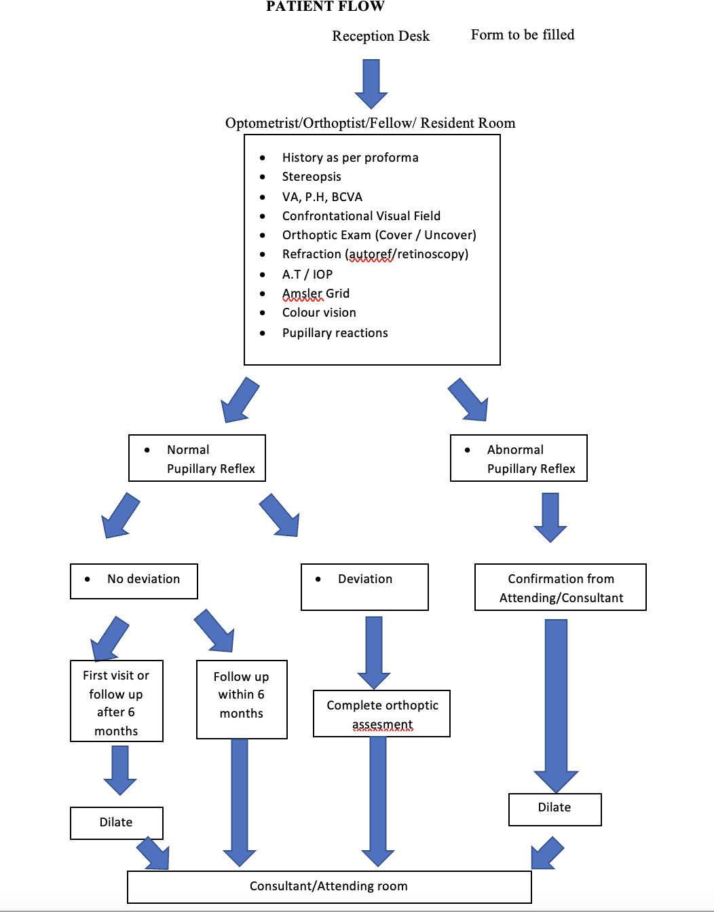

## FACULTY COVERAGE OF INPATIENTS:

* + The attending on call needs to be notified immediately about any new patient admissions. In addition, the attending on call also needs to be notified about any significant change in the condition of any inpatient.
  + All inpatients need to be presented to the attending during regular inpatient rounds.

## FACULTY COVERAGE OF SPECIALTY CLINICS:

* + All specialty clinics are staffed by clinical or full-time faculty. Each patient is seen by the attending faculty (direct faculty supervision) along with a resident.
  + When a patient presents features that may prove especially educational, all residents (both junior and senior) are encouraged to share in the examination and discussion of this patient.
  + The schedule for staffing includes both full-time and volunteer faculty with appropriate subspecialty training who serve at regular intervals (usually once or twice a month) for a year at a time.

## FACULTY COVERAGE OF GENERAL CLINICS:

* + For general clinics, there is an assigned faculty member to see all patients with the residents.
  + Whenever possible, especially instructive patients are discussed and/or examined by all residents on site.
  + On many occasions, patients with complex problems appear in general clinic. When the expertise of a sub-specialist is required, the resident or attending will immediately contact the appropriate faculty member. For urgent problems that cannot be resolved by phone consultation, the faculty member will come to see the patient. Patients with less urgent problems will be scheduled for a later appointment with the appropriate sub-specialist.

## FACULTY COVERAGE OF EMERGENCIES

* + For the sites that have emergency rooms, coverage is provided by a single "team."
  + The on-call resident responds to all initial calls. Each resident will use his or her judgment concerning the need to respond in person to a call from the ER. If there is the possibility of a serious injury or disease, if the resident is uncertain, or if the calling physician requests assistance, the resident **must** appear in person to examine the patient. If there is any

uncertainty, the resident should request the patient to enter the ER at the appropriate site for direct examination.

* + Backup to the resident on first call is provided by a senior resident on second call, who is in turn backed up by a clinical or full-time faculty member. In rare instances when the assigned faculty member is unavailable, the senior resident is to contact an appropriate member of the full-time faculty.
  + If emergency surgery is necessary, the attending faculty member is responsible for staffing. Occasionally, however, surgery will require special training, and it may be necessary to call in one of the specialty services, such as Surgical Retina or Ophthalmic Plastic Surgery. For routine cases, surgery will be performed by the on-call senior resident with assistance from the on-call junior resident with staff coverage by the faculty member on call. For specialty cases, the surgery may be performed by the resident on the corresponding specialty rotation with supervision by the appropriate sub-specialist, who in most instances will be a member of the full-time faculty.

## FACULTY COVERAGE OF ELECTIVE SURGERY:

* + At all sites, when surgery is performed in the operating room, a clinical or full-time faculty member must provide staff coverage and be present in the operating room (direct faculty supervision).
  + At some sites, minor procedures performed in the clinic are supervised by senior residents, and the on-site faculty member.
  + It is the responsibility of the faculty member to determine if the resident is ready to move on to the phacoemulsification and other technique variations. The well being of the patient must be the primary objective regardless of personal preferences or training considerations. A step-wise transition is strongly advised when new techniques are adopted.

# FACULTY EVALUATION

## ANNUAL REVIEW

* + Each resident completes a written evaluation for each faculty member annually. The residents are encouraged by the Program Director to be frank and honest in the completion of these faculty evaluations. The importance of these evaluations in maintaining quality education for the resident program is emphasized.
  + The resident evaluation includes questions on the faculty member’s clinical and surgical teaching abilities, commitment to resident education and the program, clinical knowledge, professionalism and scholarly activities. Residents are

instructed to only complete those questions about which they have direct knowledge.

* + The results from the evaluations are confidential and only reviewed by the Program Director and the Chief Consultant.
  + The annual confidential resident evaluations are collated yearly and shared with the Chief Consultant. Each faculty member should be required to have an

Annual Review with the Chief consultant. The aggregated results from these resident evaluations are included in the Annual Review and are an important part of the overall faculty evaluation.

* + Care is taken to maintain the confidentiality of the resident evaluations. It is important that the faculty have no way of identifying how any individual resident evaluated them. The faculty members are allowed to view only aggregated results. Narrative comments may be included as long as identifying information has been removed. In addition, the results of these evaluations are also communicated directly to faculty members.
  + The faculty Annual Review will also include a separate review of his/her
    - scholarly activities including publications and presentation,
    - commitment to the educational program including attendance at Grand Rounds and participation in the resident lecture schedule, and
    - clinical knowledge and professionalism.

## CONTINUOUS QUALITY IMPROVEMENT

* + The residency program is driven by Continuous Quality Improvement. Faculty performance is reviewed on a regular and ongoing basis. This occurs during scheduled meetings of the residents with the Program Director. During this meeting the residents are routinely asked to comment on their rotations and the quality and quantity of faculty for teaching, surgery, etc.
  + In addition, one hour resident meetings are held regularly, during scheduled conference time. All residents are required to attend these meetings.
  + The Registrar has an essential role in assessing in real time the residents’ perception of the quality of the faculty teaching and overall faculty performance and areas that may need improvement.
  + If such areas are identified, the Program Director may recommend that adjustments be made and with the permission of the involved resident, may engage in a discussion with the faculty member.
  + Residents are also instructed that the Program Director is available to meet with them at any time. In this way, improvements can be made in real time, if felt to be necessary.

# CHAIN OF COMMAND

* + At each site, day-to-day responsibilities of the clinic are assigned to the most senior resident, who retains this position during his/her entire rotation at this site. All problems that arise are to be presented initially to this resident, who will present difficult problems through an appropriate line of authority.
  + In most instances, the appropriate course of action will involve a faculty member who is attending the clinic at that moment, the site director, or the senior resident.
  + Problems that cannot be resolved at this level are generally brought to the attention of the Program Director.

# SPECIFIC RESPONSIBILITIES:

## FOURTH YEAR RESIDENTS

* + Oversee performance of junior residents in the clinic.
  + Back-up Emergency Call: Oversee actions of the resident on 1st call, provide consultation over the phone. Problem patients and patients that need to go to the OR, need to be examined in person.
  + Liaison between attending faculty and Program Director concerning surgery cancellations, problem patients (especially on-call), schedule changes, etc.

## THIRD YEAR RESIDENTS

* + Assist the fourth year resident in overseeing the first and second year resident's performance.
  + Arrangements for patient follow-up during off hours, including both hospitalized and outpatients.

## SECOND YEAR RESIDENTS

* + Minor operative procedures done in the clinic.
  + Assist third or fourth year residents in elective and emergency surgery.
  + Care of emergency patients (this includes unscheduled patients seen during regular hours at individual sites and emergency consults on-call for all sites)
  + Present patients to more senior residents or staff when appropriate.

## FIRST YEAR RESIDENT

1. Screening of patients
2. Assist senior residents in Operative procedures
3. Assist senior year resident in care of Emergency patients
4. Present patients to more senior residents or staff when appropriate

# POLICY FOR SURGERY

## PRIVILEGES FOR PROCEDURES PERFORMED WITHOUT DIRECT FACULTY SUPERVISION

* + The operating resident has to evaluate the patient at least one day before the day of surgery, except in emergencies.
  + The resident is also responsible for the post-operative care. The patient has to be seen from postoperative day #1 until their condition is stable. Not until then can the care be transferred to another resident. In the case of cataract surgery, this means until the patient has a dilated fundus exam and received a prescription for glasses.

### 1ST YEAR RESIDENTS:

Performance of any procedure only with supervision by an upper level resident.

### 2ND YEAR RESIDENTS:

* + Local Anesthesia; Retrobulbar or Peribulbar
  + Repair of simple lid lacerations not involving the eyelid margins
  + Conjunctival and corneal foreign body removal.
  + Anterior chamber and vitreous tap with or without injection of intraocular antibiotics.
  + Tarsorrhaphy.
  + Minor operative procedures

### 3RD YEAR RESIDENTS:

* + Any surgery that has to be performed in the operating room, including any intraocular surgery, eye muscle surgery, or ruptured globe repair, can only be performed under direct faculty supervision.
  + Laser surgery can also only be performed under direct faculty supervision**.**

### 4TH YEAR RESIDENTS:

* + Any surgery that has to be performed in the operating room, including any intraocular surgery, eye muscle surgery, or ruptured globe repair, can be performed without direct faculty supervision.
  + Laser surgery can also be performed without direct faculty supervision**.**

1. BOOKING OF OPERATIVE PATIENTS

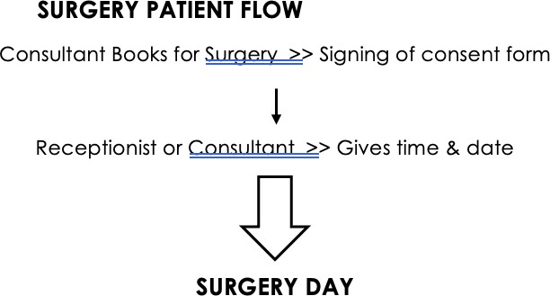

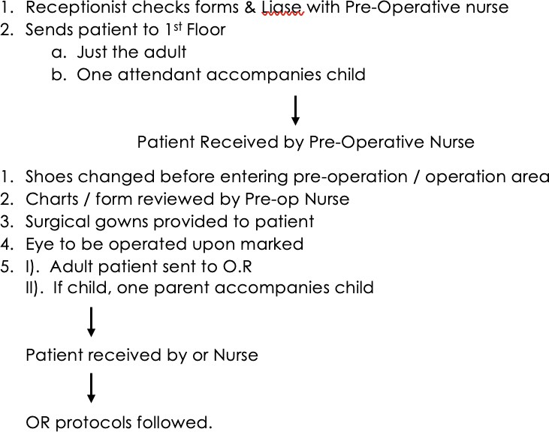

## OPERATIVE REPORTS

All Operative Reports by the resident MUST be done the same day of the procedure in the hospital before the resident leaves. Additionally, if the attending physician was present for the entire length of the procedure, and if he or she performed any portion of the surgery, the resident surgeon will also state that "the attending physician (state their name) was present for the entire procedure and that he/she performed part of the procedure."

### SAMPLE OPERATIVE NOTE

**The following sample copy is to be followed by residents when writing patient operative notes:**

* + Patient name and ID#
  + Date of surgery
  + Attending physician
  + Pre-op diagnosis **(which eye?)**
  + Post-op diagnosis **(which eye?)**
  + Procedure: **(which eye?)**
  + Surgeon:
  + 1st assistant:
  + 2nd assistant:
  + Anesthesia: e.g., general ET, topical, retrobulbar, local
  + Complications: e.g., posterior capsule tear, corneal burn, hemorrhage
  + Blood loss:
  + Specimen:
  + Indication for procedure: **including the risks, benefits and alternatives and the surgery site being identified.**
  + Procedure: Pre-op area, iv access, cardiopulmonary monitoring devices block? solution? concentrations?, amount? Honan balloon?

The patient was brought into the OR, placed in a supine position and prepped and draped in the usual sterile fashion for ophthalmic surgery. A “Lieberman” lid speculum was inserted to achieve adequate exposure.

**Mention every step of the procedure. including portions the attending or other residents performed. Mention model and serial number of implants and any injections at end (route, dose).**

Lid speculum and drapes were removed. The eye was covered with a gauze pad and metal shield for protection.

* + The patient tolerated the procedure very well and was brought to the postoperative recovery area in stable condition.
  + The faculty surgeon, Dr was present and scrubbed during the entire

procedure.

* + Written by: Dr. ...

### EXAMINATION UNDER ANAESTHESIA

* **PATIENT PROFILE:**
  + Name:
  + S/O,D/O,W/O:
  + Age/Gender:
  + Occupation:
  + MRN:
  + Phone no:
  + Date:
  + Address:
  + Initial Exam:
  + Date of Last Exam:
* **DIAGNOSIS/PROVISIONAL DIAGNOSIS:**
* **GROSS EXAMINATION:**
* **DIGITAL TONOMETRY**
* **REGURGITATION TEST**
* **PUPILLARY LIGHT TEST**
  + Direct
  + Consensual
  + Swinging flash light test
* **LIDS**
* **LASHES**
* **SCLERA**
* **CONJUNCTIVA**
* **CORNEA**
* **CORNEAL DIAMETER**
* **IRIS**
* **ANTERIOR CHAMBER**
* **LENS**
* **VITREOUS**
* **IOP BY APPLANATION**
* **RETINOSCOPY:**
* **BIOMETRY:**
  + K1
  + K2
  + AXIAL LENGTH
  + IOL POWER
* **GONIOSCOPY:**
* **POSTERIOR SEGMENT EXAM:**
* **DIAGNOSIS:**
* **PROCEDURE DONE:**
* **PLAN:**
* **FOLLOW UP DATE:**

## OPERATIVE SURGICAL LOG

* + Residents are required to enter all surgical procedures via the Internet to their personal Residency Audit or CPSP Data Collection System - Resident Case Logs, for their operative experiences by residency code.
  + This will include all outpatient minor surgical procedures, all laser procedures, and any surgical procedures at any hospital whereby the resident is either the primary surgeon or first surgical assistant to any faculty member.
  + The Academic supervisor will be able to monitor each resident’s surgical experiences via the Internet.
  + The residents will be required to turn in a copy of two operative notes of surgeries selected by the Program Director at the end of each semester for verification of entered procedures.

# DOCUMENTATION

* + For all resident clinics, the resident will be responsible for making complete examination documentation in patient medical records.
  + Residents may also be required to keep a daily patient log, documenting the diagnosis of each patient seen and if a refraction was performed.
  + Additionally, residents are to maintain a surgery log on-line.
  + The attending faculty member will sign the resident's complete write-up for that visit in the patient's chart as well as make his/her own notes. For elective or emergency surgery, the attending will sign the operative note and whatever additional documentation is required (this varies somewhat from site to site).

# ON-CALL

## DUTIES

* + **"On-Call"** is defined as the coverage of all resident clinics and emergency rooms between the hours of 2 p.m. and 8:00 a.m. weekdays, and 24 hours a day on weekends and holidays.
  + The person on-call is responsible for all calls coming to him or her starting at 2 p.m. and ending at 8:00 a.m.
  + There is a certain amount of flexibility in the rules. For example, if you are called at 7:50 a.m. by the ER and the call is non-emergent, it is reasonable to call the people who cover the ER during the day and to inform them of the case. If you are going off-call and the problem is

non-emergent, it is reasonable to pass the problem, **if the on-coming**

**on-call resident accepts the responsibility for the patient**. **However,** if you get called for a **vision-threatening emergency** at any time, **you** are responsible for seeing the patient quickly or for getting someone to see that patient quickly. If you are unable to arrange to have that patient seen quickly, call the Registrar. The overriding principle is that if you receive the call, **you** are responsible for arranging a response. Patient care should always come first.

* + **No request for patient consultation should be refused.**
  + A monthly call schedule is distributed indicating which resident is on 1st call and which resident is on back-up call. In addition, a schedule is distributed for attending trauma call and consult coverage.
  + Remember, every blurred vision is not secondary to a refractive error. Any patient with suspected cataracts should be scheduled for follow-up as soon as possible.
  + Once you have answered the call, the patient’s care is your responsibility. If there is any doubt, GO SEE THE PATIENT.
  + If the call is in regard to a patient admitted for any other reason complaining of visual symptoms, please evaluate the patient, unless the physician requesting the consultation is only asking for your clearance to send this patient to the clinic in the morning.
  + The Registrar must consult with an attending in his/her service before communicating a denial decision to a transferring facility representative. The Registrar and attending must also make written notations in a timely manner of all communications between them and the transferring facility representative(s) when a denial is issued. Any transfer denial must be reported to the Institution within 24 hours and include the written notations of communications. Any denial of a patient transfer **must** involve the Registrar in consultation with the Attending. If the Registrar in consultation with the Attending decides that the transfer is **not** medically necessary, he or she must be precise about the medical reasons for denial with the transferring physician.
  + Any elective transfer must be coordinated with the Institution for availability.
  + If requested by the transferring facility, the Registrar in consultation with the Attending should offer consultative advice regarding management of the patient and offer to reevaluate acceptance, if the patient’s condition changes.
  + If the doctor agrees to accept any patient transfer, he/she notifies the Administrative Supervisor for bed availability and possible placement.

## SO NOW YOU'RE ON CALL

The most important thing to grasp is that now you are part of a consult service. Doctors will be calling you because they know very little about ophthalmology, and you are supposed to know a lot.

* + Once you pick up the phone, you are now directly involved in that patient's care. Telephone consults are OK but can be dangerous (read: potential blindness). Giving advice over the telephone without actually examining a patient is NEVER recommended.
  + 99% of the time that you are called, you will have to go in. Even if you are taking a call from home, you are the person covering the service, and are expected to take appropriate care of the patients about whom you are called.
  + There is a logical process of determining if a patient requires immediate treatment by an ophthalmologist. You accomplish this by asking directed questions concerning the patient's symptoms, his/her vision (you want a number, not just "good"), his/her pupils, etc. It helps to run through a complete exam in your head so that you won't skip anything.
  + If you are certain that you don't need to see the patient, ask the doctor if he/she wants you to see the patient; if he/she answers in the affirmative, you still must oblige him/her. For most of your first and second year, you will need to see everyone you are called about.
  + Some patients should be seen automatically no matter what the problem, no matter what the hour. The following list is probably not complete, but it gives you a good starting point.
    - **Any patient operated upon by us who presents with a red eye**
    - **Any one-eyed patient with a problem serious enough to warrant an ER visit**
    - **Any patient complaining of acute onset of loss of vision, even if the doctor is sure he/she is malingering. It is your job to prove that the patient can see.**
    - **Any patient with a pre-existing eye problem (e.g. diabetic retinopathy, glaucoma, keratoconus) who presents with a new problem (red eye, decreased vision, eye pain).**
    - **Any patient with a diagnosis requiring the use of steroids.**
    - **Any patient with head trauma. A ruptured globe may be missed for two days because the eyelid was swollen shut and no one bothered to open it.**

With the above list you now realize that it is difficult to dispense ophthalmologic care over the phone. In the rare instance that you encounter a patient that can be evaluated over the phone, get the appropriate clinic to follow up.

* + Now that you realize that you have to go in to see the patient, there are several questions you can ask to make your life easier:
    - **Is this an absolute emergency or an urgency? Is the patient's eye protruding from the orbit or in imminent danger? Is some emergency intervention indicated while you are on your way in?**
    - **Is there a suspicion of a ruptured globe? If so, have a shield placed over the eye until you see the patient.**
    - **Is the patient being admitted?**
    - **Is the patient going to be whisked away for some diagnostic test or to the OR? Have all appropriate films been ordered?**
    - **Can the patient's eyes be dilated (closed head injury)? Clear through Neurosurgery if involved in the case or if in your opinion should they be involved?**
    - **What other services are involved?**
    - **Who is requesting the consult in case some info needs to be relayed? Good rule of thumb, avoid taking consults from Medical Students, Nurses or Secretaries.**
    - **What is the reason for the consult? What specific question(s) need to be addressed by ophthalmology?**

## THE CONSULT

Formal consultations should contain several parts.

* + You should outline parts of the history not found on the rest of the chart, namely the ophthalmological history and other details.
  + **Best corrected vision on a wall chart thru a pinhole or on a near card (with a +3.00 lens if presbyopic or highly hyperopic). A pinhole also works for a near card. If the patient is intubated but conscious, a visual acuity can still be obtained. Please place all your effort in obtaining a visual acuity because it might be crucial if vision deteriorates in the future.**
  + **Pupils. Record each pupil's size before and after shining a light into it, the briskness of the reaction, and if there is an afferent pupillary defect.**
  + **EOM. Record all deficits in motility. Document deviations in primary field of gaze or all fields of gaze if needed.**
  + **IOP.** Ideally, you should check pressures at the slit lamp (applanation). Next best is the Tonopen, then the Schiotz tonometer, which won't clinch the diagnosis of a borderline glaucoma, but even digital tonometry will definitely tell you if the eye has no pressure (i.e. ruptured globe) or if it has a very high pressure (i.e retrobulbar hemorrhage). If there is any suspicion of a ruptured globe at the beginning of your exam, it would be wise to delay checking the IOP until either your suspicion diminishes as a result of your exam or until you speak to your backup. If the globe is obviously ruptured, do not obtain pressure.
  + **External Exam.** Examine orbits, lids, and eyelashes for abnormalities. Note any cranial nerve deficits of the face. Hint: for routine "red, painful eye" exams, check the corneal reflex before you put topical anesthetic in the eye.
  + **Slit lamp (SLEX) or pen light exam (PLEX) of both eyes. Examine conjunctiva, cornea (including fluorescein), anterior chamber, iris, and lens.**
  + **Dilated fundus exam**. It should be done **on everyon**e unless the patient is getting Neuro checks for his closed head injury. If you can't dilate the patient, do your best to get some view of the fundus either with the indirect

(through that blown pupil) or with the direct. Make sure to arrange for a DFE at a later date if one cannot be done at that time (i.e. when more

stable). Even through undilated pupils you should at least be able to tell if the posterior pole is attached.

* **Pertinent radiology or lab results. (i.e. CT Scans, or Sed Rate, etc.) Look at all CT/MRI Scans yourself. Review them with the radiologist.**
* **Diagnostic impressions.** Try to answer the main questions (Is the globe ruptured? Why can't the patient see?). You need to explain any vision that is not 20/20 (even if you suspect refractive error).
* **Recommendations.** What to do, what to be on the lookout for, and when to follow up.
* **Your signature.** If your signature is illegible, print your last name under it. And in front of your signature it is good to get in the habit of writing "thank you".

Once you have completed your consult, you are still responsible for the patient’s follow-up. For patients that were discharged, ensure you have clearly stated when they need follow-up in the clinic.

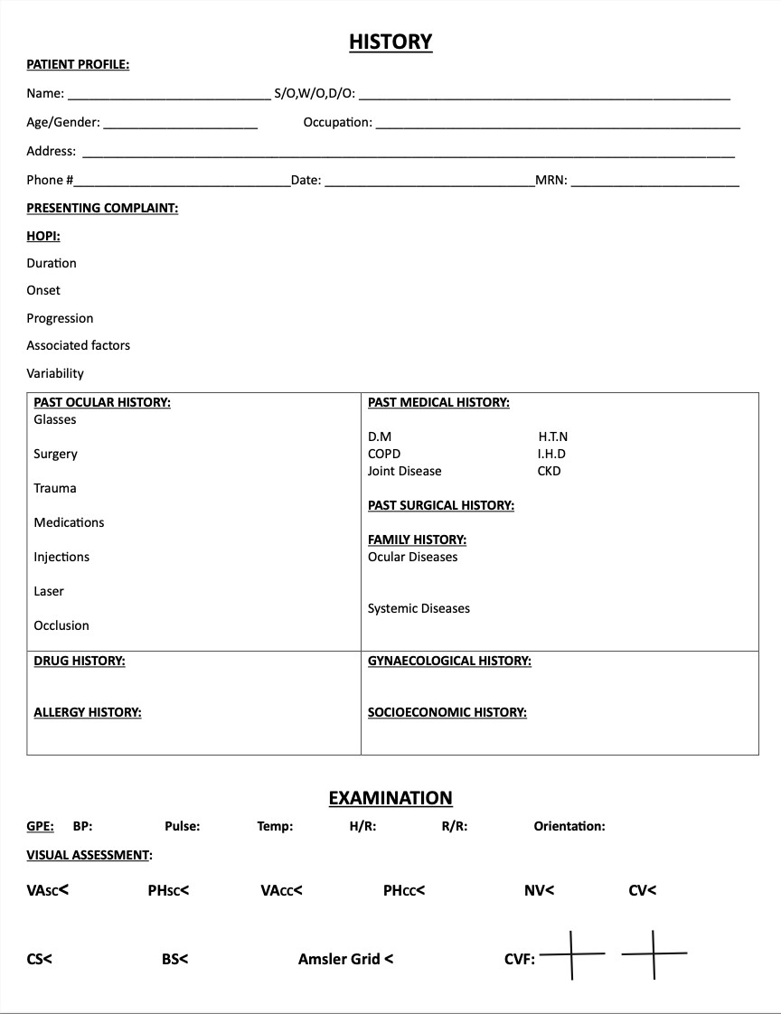

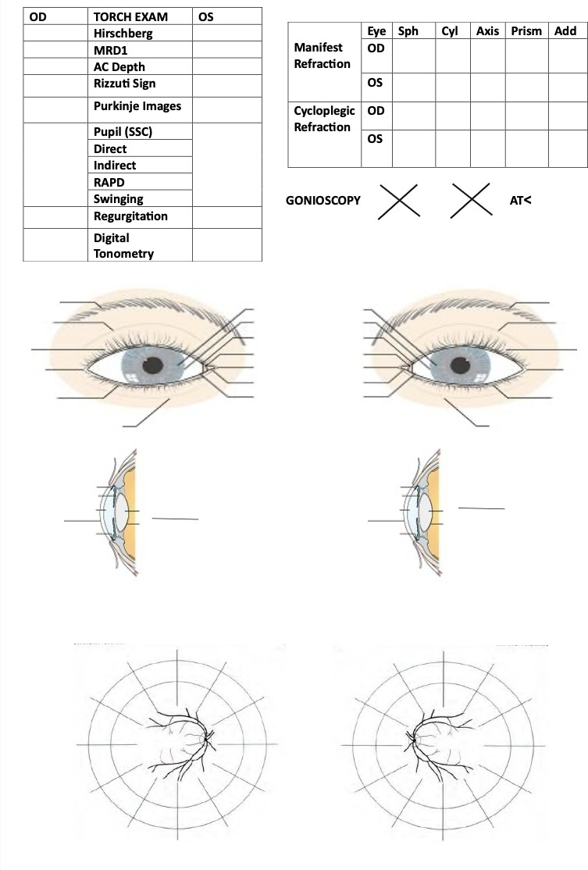

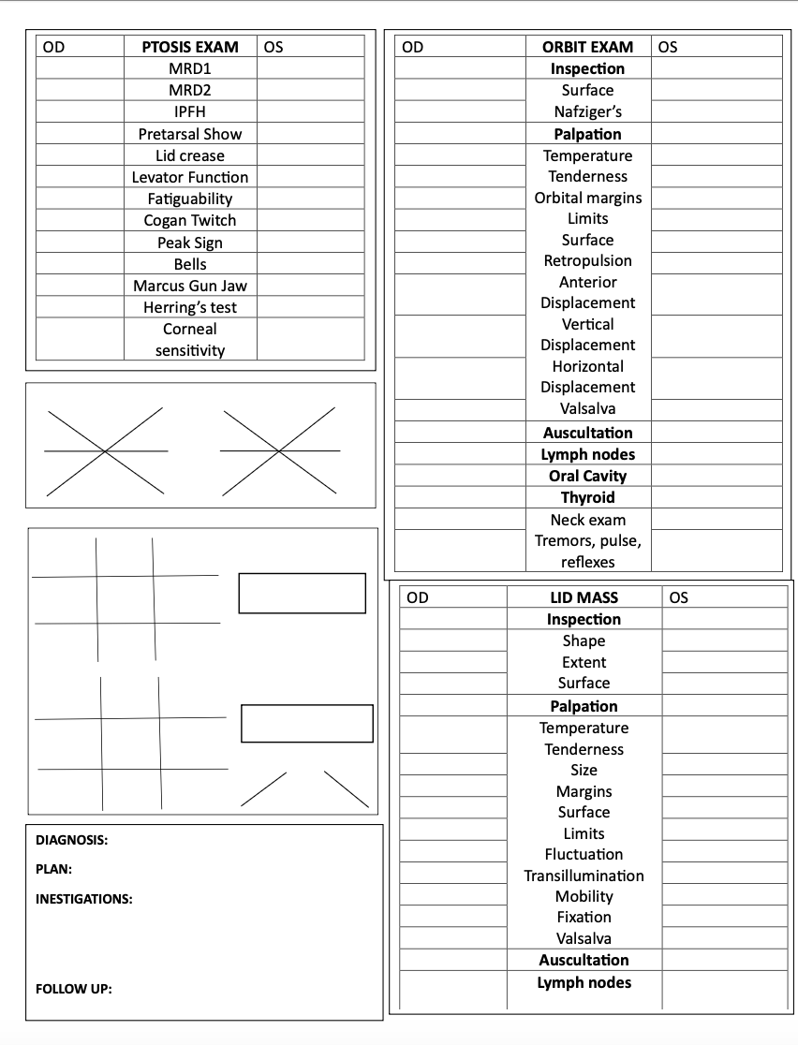

## BACK-UP

* + On call with you at all times is the third or fourth year back-up resident. Do not hesitate to call the back-up resident whenever you have the slightest inkling of a question. There are no excuses for not calling back-up when there is doubt. Any case needing to go to the OR or needing admission requires that you call the back-up in.
  + If for some reason you cannot reach the back-up resident, call the Registrar.
  + It is helpful to keep all home telephone and cell numbers of your fellow residents.

## ADMITTING PATIENTS

There are instances when you will see a patient who needs to be admitted. Oftentimes, this patient will need to go to the OR for repair of a scleral laceration or for a vitrectomy for endophthalmitis.

* + **Any patient needing admission** must be evaluated by your back-up and **must have an attending see the patient within 24 hours (or in the OR)**.
  + Do a brief H&P on the patient and write it either on standard H&P paper or on a short stay form (whichever is appropriate).

## CALLS FROM OUTSIDE ER'S

From time to time, you will be called by doctors in far-flung ERs. If the patient has a problem requiring immediate care, tell the doctor to send the patient to the hospital.

## SOME COMMON SENSE

Call can be frustrating at times.

* + During the course of the year you will receive many "needless" consults,

i.e. those in which patients did not need to be seen emergently, if at all. However, you must remember that these consults are coming from fellow residents, many of whom have not looked at an eye since fourth year of medical school. Also, many of these consults are made at the request of an attending or an upper level resident, who tells the resident to "make

sure to run it by Ophthalmology." The best way to handle these consults is to grin and bear it. Do not take your anger out on the consulting doctor; this will not gain you anything and may make it more likely that you will be called for a refractive error at 3 am.

* + In addition, call provides you an opportunity to teach some simple skills to the consulting doctors. By teaching them how to diagnose and to treat common ER eye problems such as corneal abrasions and conjunctivitis, you may save yourself several calls in the future.
  + A final bit of common sense is to be courteous to the ancillary staff at the hospitals (nurses, secretaries, lab techs, CT techs, etc). A kind word tends

to make paperwork get processed quicker and X-rays done sooner than an angry tirade. Remember, these people have to be at work so they don't care whether you would rather be in bed.

* + Also remember that you are an ophthalmologist; there are times when saving a patient's life will supersede your exam. When this happens let these people do their jobs and, if you so desire, offer to help in any way you can. A little goodwill never goes to waste.

# ON SITE POLICIES

## STAFFING OF GENERAL CLINICS

* + A full-time faculty member is assigned at all the sites. He/She, as well as other full-time faculty members, provides supervision for general clinics on weekdays.
  + For patients needing follow-up from the ER, residents should inform all patients to contact the clinic at +92-42-36311494 to get an appointment for follow-up. If there is a particular date/time that the resident wants the patient to be seen, the resident should make a note on the ER consult.

## POSTOPERATIVE CARE

Postoperative rounds are conducted in-clinic by the resident who performed the surgery. This resident then provides follow-up information to the faculty who staffed the case.

## IN-HOUSE CONSULTATIONS

These consults are to be performed in a timely fashion by the third and

fourth-year residents. SInce there are two residents on call, it is appropriate for the third and fourth year resident to delegate some of the consults to the second year resident, but the bulk of the responsibility shall still remain on the third and fourth year resident.

## OFF-SITE CLINICAL ACTIVITIES

* + The registrar, will make arrangements with area gratis ophthalmology faculty members to assist in cataract surgery or other ophthalmic surgery
  + The resident on will also see patients with both full-time and part-time faculty on specified dates in their private practices.

## POLICY ON CROSS COVERAGE OF DUTIES DURING RESIDENT LEAVE PERIODS

* + When the 4th/3rd year resident is on leave, his or her daytime responsibilities (in clinic, in surgery and of supervision of the first-year resident) pass to the next year resident on the same rotation. During this

time, evening back-up call duties will be covered by one of the senior residents.

* + When the 2nd year resident is on leave, his or her daytime responsibilities (in clinic, in surgery and for supervision of the 1st year resident) will be shared by the 3rd/4th year resident and 1st year resident as determined by the 3rd/4th year resident on the service. In-patient consults during the day will be covered by the 1st year resident on the service.
  + When the 1st year resident is on leave, his or her daytime responsibilities (in clinic and in surgery) will be shared by the 4th year resident, 3rd year resident and 2nd year resident, as determined by the 4th year resident on the service. Daytime ER consults will be covered by the 2nd year resident on the service.

# SUB-SPECIALTY CLINICAL ROTATIONS

## GOALS OF ROTATIONS

Each rotation serves the overall goals of the training program. The faculty who are clinical subspecialists in cornea, glaucoma, neuro-ophthalmology, oculoplastics, pediatric ophthalmology, and retina/vitreous disorders monitor the progress of

residents–working with them in their clinics, and providing formal feedback every three months. Residents should meet with individual attendings and review their educational expectations.

## SUBSPECIALTY CLINICS

The residents on subspecialty rotations will spend some of their time at this site and some at other sites. As a rule, the resident will be the first physician to see some (or all) patients scheduled for the attending, who will then examine the patient and discuss diagnostic and therapeutic considerations with the resident. With some exceptions, the resident will also assist at any surgery performed by the attending.

# GENERAL COMPETENCIES

The goal of this residency program is to graduate physicians that are competent in regards to the 6 general competencies, listed below, in the field of ophthalmology.

## PATIENT CARE

The resident must provide patient care that is compassionate, appropriate, and effective for the treatment of health problems and the promotion of health.

Residents are expected to demonstrate skills related to:

* + Data acquisition of essential and accurate information about their patients;
  + Diagnosis and management of medical and surgical eye disease;
  + Patient and family counseling;
  + Effective utilization of information technology;
  + Sensitivity to socio-cultural circumstances
  + Surgical skills
  + Take responsibility for management of post-operative concerns and complications
  + To treat patients with respect and compassion at all times
  + Hand washing before and after each patient encounter

## MEDICAL KNOWLEDGE

The resident must possess medical knowledge about established and evolving biomedical, clinical, and cognate (e.g., epidemiological and social-behavior) sciences and the application of this knowledge to patient care.

Residents are expected to demonstrate skills related to:

* + understanding of and ability to apply established and evolving biomedical, clinical, and cognate sciences;
  + database acquisition;
  + critical evaluation of new information

## PRACTICE-BASED LEARNING & IMPROVEMENT

This involves investigation and evaluation of the resident’s own patient care, appraisal and assimilation of scientific evidence, and improvements in patient care.

Residents are expected to demonstrate skills related to:

* + investigation and evaluation of their own patient care;
  + appraisal and assimilation of scientific evidence and improvements in patient care;
  + participation in continuous self-improvement through self-analysis, peer-review, and continuing education

## INTERPERSONAL AND COMMUNICATION SKILLS

These skills result in effective information exchange and teaming with patients, their families, and other health professionals.

Residents are expected to demonstrate skills related to:

* + Effective and sensitive information exchange with patients, families, and other health professionals;
  + Proper documentation of medical records;
  + Interaction with referring professionals;
  + Team-work skills with patients, colleagues, and other professionals
  + Communicate effectively with all members of the health care team including consulting physicians, ER doctors and nurses
  + Demonstrate ability to work as a team member
  + Communicate effectively with patients and their families, with sensitivity to the patient’s socioeconomic and cultural background
  + Answer all consults in a responsible and courteous manner
  + To remain visible and available to participate in clinical care throughout the

clinical session. If you leave the clinical care area make sure that other members of the service know where you are and why

* + answer your pager within 10 minutes of being paged.
  + To communicate your name and role on the service to patients and their families.
    - *"Hello, I'm Dr. Resident, I'm a resident working with Dr. Attending today."*
  + To present patients to the attending in a succinct but complete way
  + To maintain timely and legible medical records
  + To talk when you should be talking, listen when you should be listening
  + To learn to recognize feedback from faculty, fellows, fellow residents, patients and students
  + To accept that feedback constructively and work to improve based on it

## PROFESSIONALISM

As manifested through a commitment to carrying out professional responsibilities, adherence to ethical principles, and sensitivity to a diverse patient population.

Residents are expected to demonstrate skills related to:

* + Commitment to professional responsibilities;
  + Consistent demonstration of high standards of ethical behavior;
  + Respect for the physician-patient relationship
  + Arrive on time and prepared for clinic or operating room
  + Respect patient confidentiality
  + Provide sensitive care that is responsive to a patient’s culture, age, race, gender, sexual orientation, and disabilities
  + To prepare in advance for surgical experiences
  + To work to become part of the clinical team
  + To work with the faculty, staff, fellow and other residents on the service to determine your responsibilities
  + To remain flexible and offer to help out with the responsibilities of others when you can

## SYSTEMS-BASED PRACTICE

As manifested by actions that demonstrate an awareness of and responsiveness to the larger context and system of health care and the ability to effectively call on system resources to provide care that is of optimal value.

Residents are expected to demonstrate skills related to:

* + Awareness and responsiveness to the larger context and system of health care;
  + Ability to call on system resources to provide care that is of optimal value;
  + Patient advocacy;
  + Ability to work in a variety of health care settings;
  + Maintaining awareness of cost-effectiveness and risk benefit;
  + Promotion of health care and disease prevention;
  + Efficiency in time management reflected in quality patient care
  + Use information technology to manage information and access/maintain online medical information
  + Maintain an up-to-date surgical log
  + Be conscious of patient flow through clinic
  + Coordinate care with referring doctors, when necessary

# CURRICULUM IN PROFESSIONALISM:

The Residency in Ophthalmology recognizes that although the core training in professionalism resides in the modeling of professional behaviors by the faculty and in the observation and supervision of residents in their daily activities, there is a necessity for a **structured curriculum in professionalism** to give residents a venue for reflection on the core values of our profession, and to establish a foundation for analysis, understanding, and appropriate action in situations of challenging ethical cases. **We define professionalism as a commitment to responsibility to patients and society with understanding of and adherence to the ethical foundational principles of our society.**

Our **goals and objectives** are that our residents to develop a foundational understanding of and adhere to in their daily activities all of the following **principles of professional behavior**:

* + Performance of all responsibilities with integrity and when appropriate, compassion.
  + Priority of patient needs above self-interest.
  + Respect for patient autonomy, including the need for privacy.
  + Recognition of simultaneous responsibility to patients, to other members of the patient care team; to medical organizations such as hospitals, and to society.
  + Recognition of and response with respect for diversity of patients. Diversity includes but is not limited to diversity in age, disability, race, gender identification and orientation, language, culture, and religion.

# COMPETENCY EVALUATION TOOLS

The Ophthalmology Residency Program has chosen the following tools to teach and evaluate the general competencies:

## TOOLS FOR TEACHING THE GENERAL COMPETENCIES:

* + Ophthalmology lecture series
  + Supervised resident clinics
  + Supervised surgical skills laboratory
  + Sub-specialty rotations
  + Journal club
  + Clinical Conferences (Grand Rounds, Fluorescein, Uveitis, Resident Teaching, Pathology)
  + Surgical Outcomes Conferences
  + Profession of Ophthalmology Curriculum
  + Research Curriculum

## TOOLS FOR EVALUATING THE GENERAL COMPETENCIES:

* + Written end-of-rotation evaluation forms
  + Annual in-training examination
  + Oral end-of-rotation examinations
  + Written end-of-rotation examinations
  + Supervised surgical skills laboratory
  + 360 degree evaluations (Attendings, Co-residents, Staff, Patients)
  + Procedure logs
  + Journal Club
  + Evaluation of presentations at conferences, seminars, Grand Rounds
  + Exit exams

## OUTCOME MEASURES:

* + Improvement of residents on written evaluations
  + Resident’s performance on annual in-training examination
  + Performance of former residents on:
    - Written certification examination of the final exit exams
    - Oral certification examination of the final exit exams
  + Results of patient surveys
  + Results of 360 degree evaluations

|  |  |  |
| --- | --- | --- |
| COMPETENCY | TEACHING METHOD | EVALUATION METHOD |
| Patient Care/Surgical Care | Lecture series Supervised clinics Supervised surgeries Surgical skills lab Microsurgery course Clinical conferences Ethics curriculum | Exit exams  Surg Skills Assess Form End-of-Rotation eval Procedure logs  Surg Outcomes Conf Patient Survey |
| Medical Knowledge | Lecture series Supervised clinics Supervised surgeries Journal Club  Clinical conferences Research curriculum | In training examination End-of-Rotation eval End-of-Rotation exam Exit exams |
| Practice-Based Learning  And Improvement | Journal Club Research curriculum Lecture series  Surg Outcomes Conf Resident Teach Conf Clinical Conference | End-of-Rotation eval Research papers Surg Outcomes Conf Peer Evaluation  6-mo & yr-end eval Final dissertation |
| Interpersonal and Communication Skills | Supervised clinics Ethics curriculum | Exit exams  360 degree evaluation End-of-Rotation eval |
| Professionalism | Supervised clinics Ethics curriculum Compliance training | End-of-Rotation Eval Exit exam |
| System-Based Practice | Business curriculum Rotations at different institutions (STEH, TEA, Private Rotations)  Clinical Conferences/Grand Rounds Presentations Profession of Ophthalmology Curriculum | End-of-Rotation eval 360 degree evaluation |

# RESEARCH:

* + There is a fundamental belief in the concepts of the clinician-researcher and the inquisitive physician; the residency program allows the integration of both clinical and research aspects of training. Research experience is an essential element in medical training. **Residents are, therefore, required to participate in a research project and encouraged to develop their own research**

**interests.** This project will be in addition to the mandatory research requirements for residency.

* + Residents are encouraged to present their research at national meetings.
  + They must also complete a research proposal and write a dissertation in requirements for completion of training.

# RESIDENT EVALUATION

There are several mechanisms by which the faculty assess the knowledge and the competency of the residents. The first three mechanisms described below apply to basic knowledge, while the remainder deals with clinical knowledge and competence. Information derived by all of these methods is made part of the

residents' permanent records.

## PARTICIPATION IN DIDACTIC TEACHING

* + In this didactic session, we will review the importance of interpersonal communication and the components of building a good relationship with all groups.
  + Consistent attendance and active participation in lectures and conferences will be weighed heavily in the overall assessment of each resident.
  + All teachers are encouraged to interact with the residents during these sessions. This interaction should be sufficient to determine whether a resident has kept up with assignments and has achieved mastery of each topic commensurate with

level of training.

## IN-TRAINING AND EXIT EXAMS:

These examinations are taken by all residents. Results are made available to each resident, the Program Director, and Chairman of the Department.

## RESIDENT PRESENTATIONS

All Grand Rounds presentations, Journal Club and Teaching Conference Presentations given by residents will be evaluated and will be included in the resident’s personnel record.

## INFORMAL EVALUATION OF CLINICAL PERFORMANCE

This will focus on direct observation of the resident. The residents will be directly observed as they evaluate and then communicate with patients, their families, and other members of the hospital teams. Each interaction in the clinical setting provides an opportunity for the faculty to evaluate resident performance. From their first day of training, residents should be aware of the implications of this process. As patients are presented and discussed, the resident's knowledge, commitment, and integrity are exposed. **This is the most important mechanism by which residents are judged.** To be held in high esteem by faculty, residents should adhere to these.

* + At the time of observation, a written evaluation will be performed and an interactive feedback session will be employed. The direct feedback will be useful for understanding the resident’s current strengths and areas of weakness.
  + Maintain a mastery of basic knowledge appropriate for his or her level of training. Conscientious reading and attendance at didactic sessions are very helpful, but it is also essential to direct a substantial component of his or her reading to specific problems as they arise in the clinical context. A faculty member may overlook deficiencies in knowledge when a resident first encounters a specific clinical entity early in his or her training. On the other hand, if one is responsible for managing a patient with this entity, persistent ignorance will shed a very unattractive light on the resident's commitment to his or her education and to the welfare of the patient.
  + When it comes to long-term relationships, such as those between faculty and residents or among fellow residents, **honesty is the best policy**. While many can conceal ignorance behind a guise of charm and eloquence for a week or two, few can sustain this ruse for a full four years. Thus an honest "I don't know" is, as a long-term policy, much better than evasion. Such honesty is especially important to the patient. A resident who admits ignorance or error and seeks help is much less dangerous than one who forges ahead in an attempt to conceal his or her limitations.

## INFORMAL MID-ROTATION EVALUATION

Mid-way through the rotation, each rotation head meets with the resident(s) and discusses their progress and ways they could improve.

## FORMAL EVALUATION OF PERFORMANCE

At the end of each clinical rotation, resident evaluations are sent electronically, to those faculty members who supervised them, and ancillary staff they worked with during that rotation. The attending and resident both sign and date the form.

These documents are entered into the resident's permanent file.

|  |
| --- |
|  |
| Ophthalmology Residency 2 Monthly Review **Months:** |
| The purpose of this review: |
| Ø To review your clinical and non--‐clinical activity and performance since the beginning of your residency  Ø To reflect on your performance in training  Ø To describe your goals for the remainder of your residency and your future career |
|  |
| Supporting Documents for your review:   * Please complete the cells on the following pages of this document |
| Resident:  PGY:  Completed  Rotation: |
| Appointment Date and Time:  Location:  ***Please email this completed document to Dr Ali, at least 1 week prior to your appointment time with him. *** |

|  |  |  |  |
| --- | --- | --- | --- |
| Patient Care: | Excellent | Good Fair | Poor |
| Medical Knowledge: | Excellent | Good Fair | Poor |

|  |  |  |  |  |
| --- | --- | --- | --- | --- |
| Practice based learning: | Excellent | Good | Fair | Poor |
| Interpersonal and |  |  |  |  |
| Communication skills: | Excellent | Good | Fair | Poor |
| Professionalism: | Excellent | Good | Fair | Poor |
| System based Practice: | Excellent | Good | Fair | Poor |
| Surgical Skill: | Excellent | Good | Fair | Poor |
| Surgical Knowledge: | Excellent | Good | Fair | Poor |
| Comment: |  |  |  |  |

Attending/Consultant name: Designation: Signature:

## END OF ROTATION EXAM

At the end of each rotation, the rotation head gives the resident(s) a written and/or oral exam.

## FORMAL REVIEW OF MEDICAL RECORDS, PATIENT LOGS, SURGERY LOGS, AND SURGICAL VIDEOS

* + Remember that the notes made in the chart of each patient remain as a permanent record of the resident's performance. These records are frequently reviewed by faculty and fellow residents. When a resident's overall performance is called into question, the quality of clinical notes can be the deciding factor in determining what action will be taken. On the positive side, the quality of these notes allows the faculty and residents to judge the excellent physicians within the department.
  + All faculty will assess resident performance by reviewing patient medical records. Additionally, the program director reviews all resident patient logs and surgical logs.
  + The program director and other identified faculty will review resident surgical videotapes. Private attendings will fill out a surgical skills evaluation form. The assessment from these reviews is discussed during the annual review.

## SEMI-ANNUAL REVIEW

Every six months, the faculty collectively reviews the performance of all residents.

* + The file of each resident is available for all faculty to review and to discuss the performance of each resident in turn.
  + An outline which includes didactic lectures attendance record, surgery logs, grades from didactic lecture exams are also reviewed.

Minutes are kept of the meeting and summary of comments are formatted and later reviewed on a one-on-one basis with the Academic supervisor and the

individual resident.

## PERSONAL INTERVIEWS

If any evaluation discloses any significant problems, the resident of concern is invited for a special interview with the Academic supervisor and at least one

additional member of the full-time faculty or the Program Director. Interviews are also held at any time during the year when problems arise concerning the performance of a resident. Following each special interview, a summary is written and submitted to the resident, who may submit a written response. These summaries and any responses are entered into the resident’s permanent file.

## ANNUAL EVALUATION:

* + The Program Director schedules meetings with each resident annually. The residents are asked to prepare a self-evaluation which outlines strengths, weaknesses and goals, in preparation for the meeting. All current faculty evaluations, peer evaluations, staff and patient evaluations, test scores, surgical case logs, and duty hours are available for use and discussion during this session. In addition, the Program Director may have other formative feedback received from faculty and others which may be included in the discussion.
  + The discussion takes approximately one hour. The written faculty evaluations from each rotation are reviewed with the resident. Areas of strengths and weaknesses are identified during this review and are compared with prior evaluations. This comparison allows for the resident’s developmental progress to be assessed over time. Further, action plans are generated from these evaluations in order to address areas which are identified as needing improvement.
  + The completed self-evaluation is reviewed and discussed, paying particular attention to the strengths and weaknesses, and goals and objectives identified by the resident. The self-identified strengths and weaknesses are able to be compared to those identified in the written evaluations. Any areas of discrepancy are discussed. The self-identified goals and objectives are discussed and also compared with prior identified goals and objectives to determine if progress has been made. Any concerns reported on the peer and staff evaluations will be discussed.
  + This session also provides an opportunity to assess the resident’s success in the development of a scholarly project, the compilation of a resident portfolio, and involvement in a quality improvement project. Frank feedback on the resident’s perception of faculty performance and program strengths and weaknesses is solicited during this session with the resident.
  + A letter is drafted which summarizes the significant discussion topics. A copy of the letter is provided to the resident and a copy is placed in the resident file.

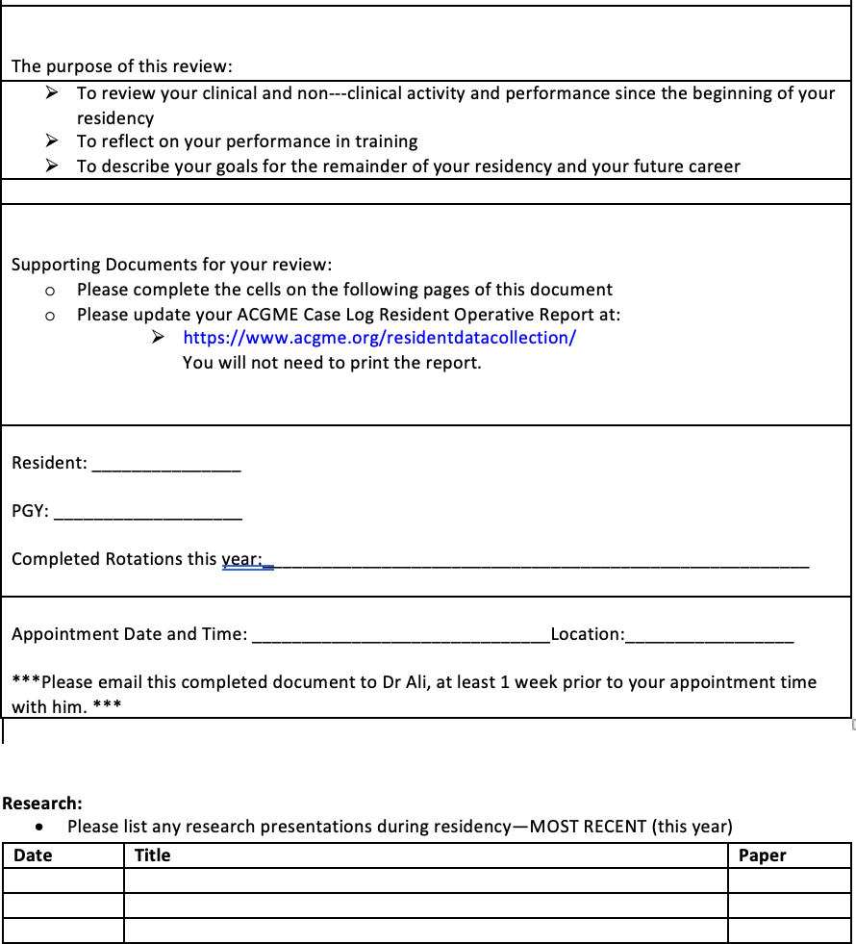**OPHTHALMOLOGY RESIDENCY ANNUAL REVIEW**

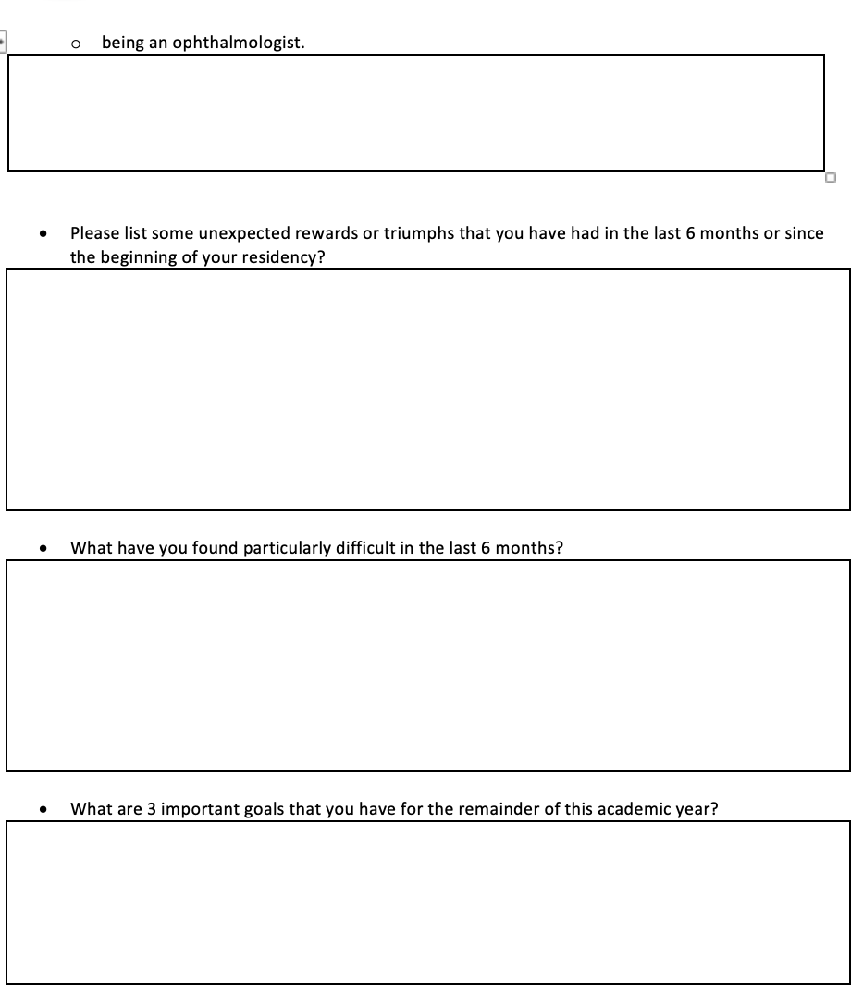

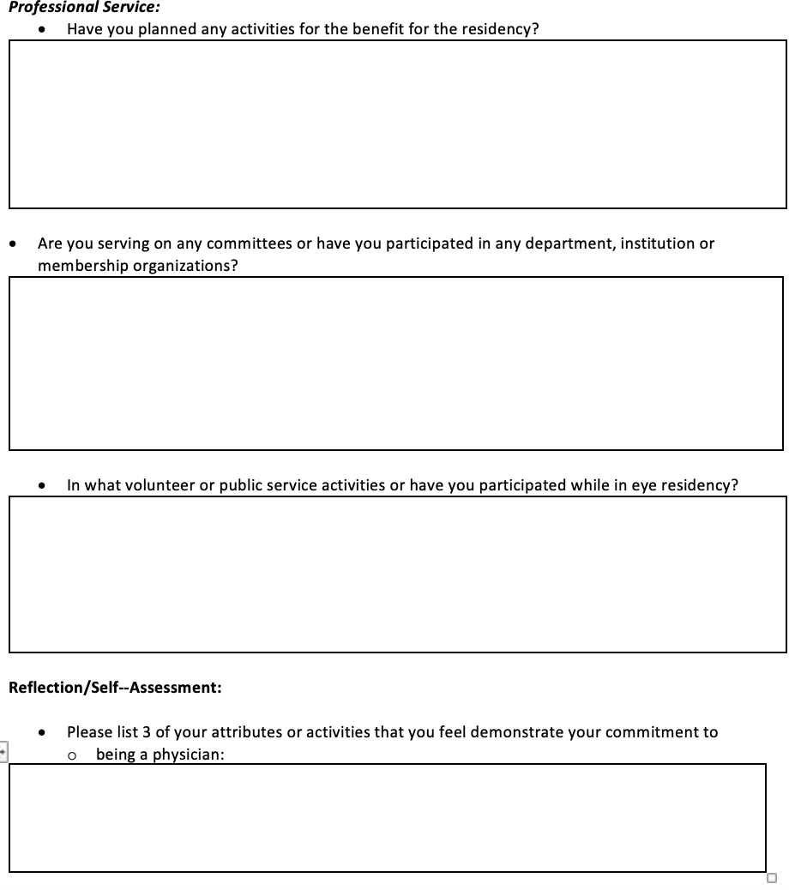

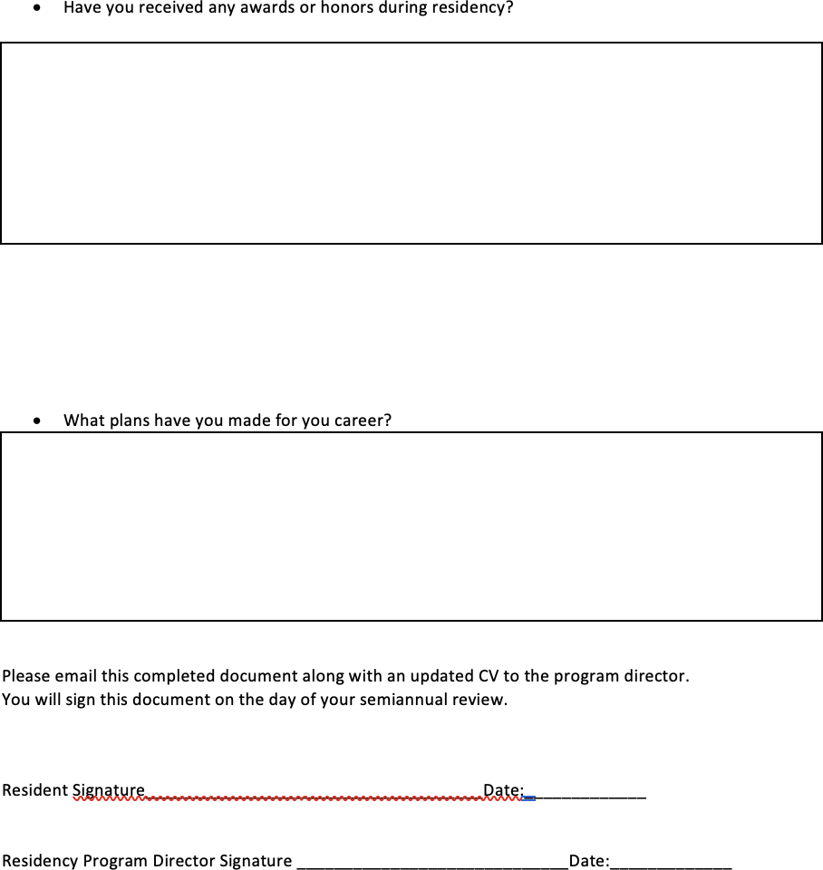

## 360 DEGREE EVALUATION:

The 360 degree evaluation program are the written evaluations that will be provided by the staff, other residents, attendings, and select patients. The resident will also perform a self-evaluation. This process will also be instrumental in assuring the proper evaluation of the residents skills.

In addition to teaching and evaluating our residents in the general competencies, our residency program recognizes the importance of evaluating the reliability of the tools that we have chosen to accomplish these tasks. We anticipate that as we use these tools, we will find that some are more effective methods than others in teaching and evaluating the competencies.

We will use the following procedures to use this information to modify our toolbox and improve our residency program:

* + At least once annually, all of the faculty and residents will discuss the effectiveness of each of the teaching and evaluation tools for each of the competencies.
  + The Residency Program Director will present information that he/she has obtained regarding competency tools from the medical literature and from meetings with other program directors. The Program Director will stay abreast of competency issues by attending annual meetings.
  + The Residency Teaching Committee will consider discontinuing some tools and implementing new tools for the following academic year. Ideas for new tools may come from various sources, including the residents, the faculty, the medical literature, and program directors’ meetings. As more data becomes available from studies of tools to evaluate competencies, priority will be given to tools that have been tested and shown to be effective teaching methods or reliable measures of performance.
  + The Residency Teaching Committee, with the guidance of the Residency Program Director, will utilize this process annually to address each of the following questions:
    - **What do our outcome measures tell us about our effectiveness in teaching and evaluating the general competencies?**
    - **What is the opinion of the faculty and residents of the effectiveness of the tools that we are currently using?**
    - **What data have others generated regarding the effectiveness of tools that we use here? What new tools are being utilized effectively by others?**
    - **How should we change our tools for the upcoming year?**

# EDUCATIONAL TOOLS

The process of didactic education will apply equally to all residents, independent of their stage of training or current clinical assignment. Schedules of all events are distributed monthly to all residents and faculty.

## LECTURE SERIES AND CONFERENCES

* + These are primarily held once a week starting around 8:30 until approximately 9:30.
  + Morning conferences are held once a week (Pathology, Neuro, Surgical Outcomes conference and Retina & Cornea conferences), from 8:30 to 9:15, allowing time for the residents to attend their clinics.
  + Lectures and conferences may also be held in the late afternoon, early evening, or on Saturday mornings.
  + This schedule runs for 12 months. Residents are to be present for all lectures, including evening activities (e.g., journal clubs, wet labs), unless they are on vacation, on an emergency call, in the OR as a primary surgeon, or in the OR as an integral participant in a surgical case. If a resident is present in the OR primarily as an observer, even if you are loading the lens, watering the cornea, etc., that does not count.
  + Lectures will be grouped by topics, and these topics will closely follow the Basic and Clinical Science Course published by the American Academy of Ophthalmology. The series of topics will be repeated every twelve months. Residents are expected to read the relevant material in the BCSC as well as additional references selected by individual lecturers. Relevant reading is to be done **before** each lecture.

## RESIDENT TEACHING CONFERENCES

These are held as weekly morning lecture series. Topics will be clinical in nature and most presentations will be given by residents, though on occasion guest lecturers will be invited. All speakers are encouraged to incorporate clinical slides, photomicrographs, and angiograms into their presentations.

## JOURNAL CLUB

Journal Club is held twice a month after clinic/O.R hours. The residents are required to read monthly, at least the following journals: Ophthalmology, American Journal of Ophthalmology, Archives of Ophthalmology, JOVS & Survey of Ophthalmology.

Everyone is expected to read the articles and participate in the discussion of these articles

The following goals and objectives will be met:

* + Residents will demonstrate that they have carefully read the article they are presenting and understand the structure and content of the article or study.
  + The presenting resident will discuss the references and background resources in such a way as to improve everyone’s understanding of the article
  + The presenting resident will demonstrate comprehension of the article’s strengths and weaknesses by a logical approach to the structure and content of the article
  + The presenting resident will demonstrate effective leadership in discussing the article by asking fellow residents and faculty to participate in discussing the article.
  + The presenting resident will demonstrate ability to draw logical conclusions regarding the relative merit of the article.

## SURGICAL OUTCOMES CONFERENCE

* + Residents have to record all surgeries and present surgery cases at this conference.
  + Each month there will be a one-hour Surgical Case Conference during the hour reserved for Grand Rounds. Nearly all faculty members attend this meeting, as attendance is required to maintain surgical privileges at the hospital. In addition residents, medical students, and others who are rotating through the department also attend.
  + In this activity one of the senior residents presents a challenging surgical case, complicated by serious disease, poor outcome, diagnostic and/or management dilemma, and/or socioeconomic issues. This responsibility is rotated through the senior resident roster.

## CLINICAL GRAND ROUNDS

* + These are held once a month.
  + For the first half hour of each session, attendees examine a series of selected patients in one of the clinics. These patients are referred in from various sources, including from the sites within the residency program and from private offices. It is hoped that each patient will present a diagnostic or therapeutic challenge or

will illustrate important clinical findings.

* + At approximately 8:30 A.M., residents and faculty proceed to the Conference/Lecture Room, where each case is presented by a resident.
  + All Powerpoint presentations at Grand Rounds should follow the following format. They should be reviewed with the physician directly involved in the care of that patient.

# PRESENTATION GUIDELINES

It is suggested that you follow these guidelines in giving a PowerPoint presentation – be it a lecture or seminar.

## PREPARATION OF POWERPOINT SLIDES:

* + **Slide Colors**

Please use a black/white/blue background and white/black/yellow type on all your slides.

* + **Overview Slide**

After the title slide, your second slide should be entitled “Overview/Learning Objectives.” On that slide you should have three to five bullet points identifying the sub-topics you plan to discuss. Prior to each sub-topic (bullet point) you should have the same title that you used in your overview for the bullet point. You need to let the audience know what you are going to cover in a very brief overview.

* + **20 Size Font Minimum**

Slides should be easy for the audience to read. Do not use less than 20 size font and do not put too much information on a slide.

* + **Number of slides**

As a general rule, you should have no more than 1 slide for each minute of your presentation. Therefore, if you have a ten-minute presentation you should have about 10 slides. It is always better to end your presentation early rather than late. However this can vary depending on your subject and material.

## PRESENTING THE SLIDES:

* + **Title of Presentation**

Always start by stating what is on your title slide so that the audience focuses on your presentation.

* + **Never look at the screen**

There is no need to ever look at the screen behind you. Everything on the screen is in front of you on the video display. When you look at the screen and use a red or green pointer you are talking to a wall and not your audience. It is a habit that should be avoided.

* + **Speak slowly**

It is always better to speak slowly rather than quickly. At most, an audience will only retain two or three major points in an entire presentation. When you provide too much information in a lecture the audience drifts off and comes away with less than if you just emphasize two or three points.

* + **End with a Thank You!**

At the end of your presentation you should always say thank you or have a slide that says “Thank You.” It lets the audience know that you have finished talking and that they can then applaud. **Otherwise, an embarrassing pause usually results.**

## FORMAT:

* + Every patient should be presented in the **SOAP format**;
    - Only pertinent past and current history should be included under S(subjective);
    - Only pertinent clinical information should be included under O (objective), and photographs should always be included of either the anterior segment and/or posterior segment;
    - Every presentation should have an A (assessment) - specifically, what is your diagnosis, including a differential diagnosis if appropriate;
    - Under P, your plan for management should be specified. The audience and our guest speaker can then always expound upon your proposed plan;
  + At the end of your presentation, a slide listing all of the literature references is needed.
  + All photographs need to have a legend.

## RUN-THROUGH:

* + As the case is presented, key decision points along the line are identified by the resident.
  + It is expected that current research and investigation pertinent to the case will have been investigated and is presented as part of the case. This information may include alternate treatment or surgical care strategies, methods to stratify risk, novel surgical interventions, etc. This information is discussed at the conference with faculty who typically are cognizant of the latest research in the subspecialty area.
  + The objective of the ensuing discussion, which is led by the senior resident, is to determine how this information can be used to improve patient care, either the care of the current patient, or the care of future patients who may have similar problems. Particular attention is paid to a critical analysis of the information source, i.e. whether the information is evidence-based.
  + The presenting resident will make appropriate use of audio/visual materials, and present the case in a style conducive to effective conveyance of the material to the audience.
  + The presenting resident will demonstrate effective leadership in discussing the article by asking fellow residents and faculty to participate in discussing the article.
  + The presenting resident will lead a discussion as to how this case addresses the competencies of Medical Knowledge, Patient Care, Practice-Based Learning and Improvement, Interpersonal and Communication Skills, Professionalism and Systems-based Practice.
  + All PowerPoint presentations need to be sent electronically to be up-loaded to the departmental database.

# DISCIPLINARY MEASURES

There are occasions when the performance of a resident is consistently deficient, leading the faculty to fear that he or she will not become an acceptably competent ophthalmologist by the end of the training period. In such instances, a number of disciplinary measures are possible.

## ENTRIES INTO PERMANENT FILE

As noted above, any deficiencies in resident performance are recorded in the appropriate document and this document is made part of the resident's permanent file. This file is used as a source of information for all recommendations, including those related to fellowships, hospital privileges, and future employment.

1. ACADEMIC WARNING

A resident whose performance is below standard may be given an "academic warning". This time frame may be up to three months at the discretion of the faculty.

* + At the time the academic warning is issued, (a) faculty member(s) will meet with the resident to discuss the resident's weaknesses.
  + The resident will be given in writing a list of the perceived problems. The document will contain a list of actions to be taken by the Department to help correct these weaknesses or problems.
  + It will also clearly define how the resident will be evaluated at the end of the warning period.
  + The options available to the Department and resident at the end of the warning period will be given to the resident in writing.
  + Failure to fulfill the requirements of the academic warning period may be grounds for the issuance of probationary status. These documents will be placed in the resident's file.
  + The resident has a right to appeal the issuance of warning status, by submitting a written request to the Program Director.

## PROBATION

For severe deficiencies in performance, or for those that persist despite appropriate and timely counseling, the resident will be placed on academic probation. This official action is taken in concert with the Chief Consultant’s office. This includes **repealing all surgical and clinical privileges**. A resident who is placed on academic probation can assume that he or she will be dismissed from the program if the specified deficiencies are not properly remedied.

## EXTENSION OF RESIDENCY TRAINING

In response to certain patterns of deficiency, the faculty may conclude that a resident is of sufficient moral and intellectual caliber to become a competent ophthalmologist but requires additional time to achieve this goal. After appropriate discussion among the faculty and after counseling with the resident, it may be decided to extend his or her training beyond the usual 48 months required. Such extensions will generally vary. Extensions of any length must be cleared in advance by the Residency Review Committee.

## NON-RENEWAL OF CONTRACT

Contracts for residency training are renewed on an annual basis. There is no assurance that a resident will be offered a new annual contract at the end of the first, second or third years of training. If the faculty determines that a resident is not capable of satisfying the standards of this program, he or she may not be offered a new contract at the end of the year.

## DISMISSAL FROM RESIDENCY TRAINING

Those residents who fail to satisfy the conditions of academic probation will be dismissed from the training program. For extremely serious offenses, residents may be dismissed without a probationary period. Dismissals will always be conducted so as to remain within departmental guidelines.

# PROMOTION

The decision whether to promote a resident from one year to next and to graduation shall be determined by the program director with the advice of the academic supervisor and department.

* + It is expected that residents will participate in all aspects of the curriculum, as well as in the periodic evaluation of educational experiences and teachers.
  + It is further expected that residents will complete all administrative responsibilities of a resident, including licensure, credentialing, etc. in a timely fashion.
  + The criteria for advancement shall be based upon the 6 general competencies, all of which need to be judged as competent for each level of advancement.
  + In addition, absence of impaired function due to mental or emotional illness, personality disorder, or substance abuse is important.
  + Additionally, the resident must be judged competent to supervise others and to act with increasing independence. In the graduation step, the resident must be judged competent to act independently.

# PORTFOLIO

By the end of their training, each resident will establish a portfolio containing and reflecting all of their educational achievements.

This will include, but is not limited to, Grand Rounds, Journal Club and conference presentations, research papers and publications, awards and honors, and recordings of surgical cases.

# ALL YEARS GOALS & OBJECTIVES

## MEDICAL KNOWLEDGE

* + Establish good reading habits early. Plan to read every day. Stick to your plan.
  + Apply what you've read as you talk to, examine, diagnose and treat your patients.
  + When you are exposed to a new diagnosis in a clinical situation, read about it as soon as possible.

## PATIENT CARE

* + Take complete histories in an efficient, respectful manner
  + Perform thorough examinations in an efficient manner
  + Think through and formulate possible differential diagnoses
  + Develop an appropriate management plan; in appropriate circumstances initiate it
  + Demonstrate appropriate hygiene by washing before and after every patient contact

## PROFESSIONALISM

* + To treat patients with respect and compassion at all times
  + To treat clinical and administrative staff with respect
  + To treat medical students with respect and strive to create an atmosphere conducive to education
  + To arrive on-time for clinical experiences
  + To work to become part of the clinical team
    - To work with the faculty, staff, fellow and other residents on the service to determine your responsibilities
    - To remain flexible and offer to help out with the responsibilities of others when you can
  + To remain visible and available to participate in clinical care throughout the

clinical session. If you leave the clinical care area make sure that other members of the service know where you are and why.

## INTERPERSONAL AND COMMUNICATION SKILLS

* + To communicate your name and role on the service to patients and their families
  + To communicate effectively with patients and their families across a broad range of socioeconomic and cultural backgrounds
  + To present patients to the attending in a succinct but complete way
  + To maintain timely and legible medical records
  + To talk when you should be talking, listen when you should be listening

## PRACTICE-BASED LEARNING AND IMPROVEMENT

* + To learn to recognize feedback from faculty, fellow residents, patients and students
  + To accept that feedback constructively and work to improve based on it
  + To accept your role as a teacher as well as a learner. Work to educate students, fellow residents, faculty, staff and patients

## SYSTEMS BASED PRACTICE

* + To work for the benefit of your patients to communicate with other health care provider
  + To act as an advocate for your patient within the healthcare system
  + To become aware of the costs of diagnostic and therapeutic interventions. Consider these costs as you recommend and prescribe these interventions.

# FIRST YEAR

The first year of residency introduces the physician-in-training to the care of the ophthalmic patients.

* + The first year resident examines new and follow-up patients in the clinics, wards, and emergency rooms.
  + The first year resident documents the findings on examination and formulates a treatment plan. These are then reviewed either by an attending ophthalmologist, or – in on-call situations – by a more senior resident as needed.
  + The first year resident will do
* Screening Clinics – 6 months with and without ophthalmic technician assistance
* Comprehensive Ophthalmology – 2 months
* Oculoplastics and Orbit – 2 months
* Neuro-ophthalmology – 2 months

## SCREENING CLINIC

### GENERAL CLINICAL SKILLS

* + Review of medical records for relevant information
  + History taking
  + Assessment of the lids and adnexae, ocular motility, digital tonometry, and pupillary reactions
  + Torchlight examination of the anterior segment
  + Visualization of the fundus through the undilated and dilated pupil using an ophthalmoscope
  + Acquire information efficiently and to communicate the management plan effectively to the patient or other caregivers as appropriate

### OPTICS AND REFRACTION

* + To describe the basic principles of optics and refraction.
  + To list the indications for and to prescribe the most common low vision aids.
  + Measurement of visual acuity
  + Performing other tests of visual function
  + To identify the principles and indications for retinoscopy.
  + To describe the major types of refractive errors.
  + To describe the indications for and to use trial lenses.
  + To describe the basic principles of a keratometer.
  + To identify and describe the mechanisms of the following instruments in the evaluation of cataracts, including:
* Lensometer
* Autorefractor
* Retinoscope
* Phoropter
* Keratometer
  + To identify media opacities with retinoscopy.
  + To perform an integrated refraction based upon retinoscopic results.
  + To perform elementary refraction techniques (e.g., for myopia, hyperopia, accommodative add)
  + To perform objective and subjective refraction techniques for simple refractive error.
  + Understanding of the different types of contact lenses including: hydrogel, rigid gas permeable, torics, PMMA, bifocal, disposable, planed replacement, conventional, daily wear, and extended wear.
  + Knowledge of the contact lens patient evaluation including: history, visual acuity, over-refraction, evaluation of the contact lens (centration, coverage, lag, surface quality, fluorescein patterns), evaluation of the external adnexa (lid position and movement), evaluation of the ocular surface and cornea (pannus, neovascularization, corneal integrity, papillae, tear BUT, etc.), and scheduling.
  + Understanding proper insertion, removal, and recentering of all types of contact lenses.
  + Knowledge of patient education information (i.e., handling, care, wear time, hygiene, adaptive symptoms, cosmetics, etc.).
  + Basic knowledge of contact lens care systems including the different disinfection methods (thermal, chemical, oxidative). In addition, instruction of the proper use of the leading care systems including: cleaners, disinfectants, enzymes, salines and rewetting drops.
  + Basic knowledge of verification and inspection of rigid gas permeable lenses including measuring the base curve radius with the radiuscope, power with the lensometer and the overall diameter with the V-channel gauge.
  + Thorough knowledge of hydrogel contact lens fitting and problem solving.
  + Ability to determine the appropriate contact lens and its parameters for most contact lens candidates.
  + Understanding of the potential risks of contact lens wear (abrasion, infection, corneal vascularization) and how to minimize or avoid them.
  + Basic knowledge of rigid gas permeable fitting and evaluation including determination of the base curve radius based on the amount of corneal astigmatism, the power based on the vertexed refraction and the tear lens power, the overall diameter, peripheral curve designs, center thickness, edge designs, materials, Dk values, and fluorescein patterns.
  + Understanding of how to solve common rigid gas permeable problems including: decentration, 3 & 9 staining, lens adherence, lens flexure, dimple veiling, lens warpage and poor wettability.
  + Basic knowledge of the fitting and evaluation of hydrogel torics.
  + Basic knowledge of the fitting of rigid gas permeable bi-torics.
  + Comprehension of the key problems with PMMA lenses as well as the benefits of RGP lenses. Basic knowledge of refitting PMMA wearers into RGP lenses.
  + Basic knowledge of keratoconus and the rigid gas permeable lens designs needed to fit these challenging patients.
  + Very basic knowledge of bifocal contact lens designs with emphasis on translating rigid gas permeable bifocals.

### LOW VISION REHABILITATION

The primary goal of this curriculum is to integrate essential concepts from Low Vision Practice into the general and subspecialty practice of ophthalmology.

Specific goals include:

* + To understand the role of ophthalmology in low vision care.
  + To identify low vision patients appropriately and quantify their visual loss.
  + To assess a patient’s functional impairment and correlate it to their disease.
  + To understand the functional effects of common eye diseases, and of medical and surgical treatments.
  + To understand the components of low vision care & rehabilitation.
  + To be aware of available resources in the community for the patient.
  + To be aware of available educational resources for the ophthalmologist interested in practicing low vision and the physicians involved in teaching low vision to residents.

Residents will develop skills necessary to perform all basic examination procedures for a low vision rehabilitation examination including but not necessarily limited to the following:

* + **Case History**

The resident will develop skills in eliciting the history of a low vision patient including the chief complaint and secondary concerns of the patient especially as these relate to specific effects of the vision loss on the

patient’s functional limitations. Emphasis will be placed on discovering and clarifying those vision related functional problems that are of most importance and concern to the patient. The aspects of the history as it relates to the non-ocular significance of systemic disease and its effect on the low vision rehabilitation and documentation requirements will also be taught.

* **Distance Visual Acuity**

Distance visual acuity measurement and recording of distance visual acuity with special low vision charts such as the Designs for Vision and ETDRS series including conversion to Snellen Equivalent scores. The definition and determination of legal blindness is taught.

* **Lensometry**

Lensometry and trial lens neutralization of current and previous

conventional glasses and analysis of low vision devices including determination of true equivalent power and other clinically important parameters and aspects of spectacle lenses and low vision devices is taught.

* **Distance Refraction**

Distance refraction using the phoropter as well as trial frame refractive techniques using hand held trial lenses, cross cylinders, and stenopaic slits. Special retinoscopy techniques useful in determining the refractive error of the low vision patient are taught.

* **Near Visual Acuity**

Near visual acuity measurement with patient’s glasses and existing low vision devices as well as those devices and Rxs used during the examination using conventional as well as preferred low vision charts. Residents will become familiar with the most commonly used and recognized notation systems for specifying near visual acuity including the M (Metric) system, Point (printer’s), Reduced Snellen, and Jaeger.

* **Ocular Motility**

Ocular motility evaluation and binocular status with emphasis on the

functional significance and remediation strategies of EOM restrictions,

cranial nerve and gaze palsies, nystagmus, and strabismus / heterophoria.

* **Pupillary Testing**

Pupillary testing and its significance to underlying disease processes as well as glare and illumination control for the symptomatic low vision patient.

* **Physical Examination and Mental Status Assessment**

Physical examination and mental status assessment with emphasis on conditions that affect ability of patient to adapt to low vision devices physically and/or psychologically.

* **External Examination**

External examination with particular emphasis on identifying conditions that relate to a patient's functional vision problems and concerns. Develop skills to effectively communicate the nature of pertinent underlying conditions, in lay terms, to increase a patient's understanding of basis for vision impairment.

* **Fundus Examination**

Fundus examination to identify findings present at the time of low vision evaluation that are currently responsible for visual impairment. This shall include consideration of the prognosis for improved, stable or declining

visual function in the foreseeable future especially as it relates to suitability of low vision devices that are being considered for use by patients.

* **Visual Fields**

Visual fields to include careful confrontational field of peripheral and intermediate regions of visual field as well as Amsler grid assessment of central vision. Formal visual fields will normally be requested to be performed by the ophthalmologist or optometrist who referred the patient for low vision care or who is currently providing eye care to the patient.

* **Assessment with Low Vision Devices and Other Aids**
  + The resident will obtain hands-on experience in the selection and testing of low vision devices appropriate for each patient’s specific goals and vision-related needs as determined by the case history and patient interview. The main categories of such devices are as follows:
    - High add bifocals / trifocals and microscopic reading lenses
    - Hand held magnifiers
    - Stand magnifiers
    - Hand held monocular and bioptic telescopic systems
    - Telemicroscopic lens systems - both binocular and monocular
    - Closed circuit TV systems
    - Headborne vision enhancement systems such as the VMAX
    - Non-optical devices such as signature guides
    - Illumination controls including lighting and filter lenses / tints
  + The residents will also become familiar with other rehabilitation strategies including adaptive computer technologies for the visually impaired, devices for activities of daily living, and agencies and services for the blind and visually impaired.
  + Following the initial clinical assessment, the resident will present the most appropriate options to the patient and provide information on how to obtain such devices. Verbal and written instructions in the use of the devices will be provided to the patient and follow-up care in the low vision as well as on-going care by the referring ophthalmologist or optometrist office will be emphasized.

### SURGICAL SKILLS

* Medical assessment of the patient for surgery
* Knowledge of ophthalmic surgical instruments and their use. Become familiar with cataract surgery and its general basic steps, gradually learning the different instruments and their purpose. It is expected that a first year resident help in handling instruments to the surgeon, cut sutures, irrigate the eye surface, and actively participate in the surgical procedure through questions and suggestions.
* After having observed a large number of procedures and under the direct supervision of the faculty member and senior resident, it is expected that the first year resident acquire the following skills:
  + Provide regional anesthesia
    - Retrobulbar
    - Peribulbar
  + Participate in the surgical act as first or second assistant. The first year resident will assist at least 20 major ophthalmic surgery before performing minor, and parts of major, surgical procedures as appropriate
  + Aseptic technique including positioning and draping of the patient

|  |  |  |  |  |  |  |  |  |  |
| --- | --- | --- | --- | --- | --- | --- | --- | --- | --- |
| **SKILLS** | **1-2 MONTHS** | | **3rd MONTH** | | **4th MONTH** | | **5-6 MONTHS** | | **TOTAL CASES** |
| Level | Cases | Level | Cases | Level | Cases | Level | Cases |
| **TORCH EXAMINATION:** | I | 10 | II | 10 | III | 10 | IV | 10 | 40 |
| Gross Exam |  |  |  |  |  |  |  |  |  |
| Hirschberg Test |  |  |  |  |  |  |  |  |  |
| MRD1 Test |  |  |  |  |  |  |  |  |  |
| Anterior Chamber Depth |  |  |  |  |  |  |  |  |  |
| Purkinje Images |  |  |  |  |  |  |  |  |  |
| **VISUAL ASSESSMENT:** | I | 10 | II | 10 | III | 10 | IV | 10 | 40 |
| Visual Acuity |  |  |  |  |  |  |  |  |  |
| Color Vision |  |  |  |  |  |  |  |  |  |
| Contrast Vision |  |  |  |  |  |  |  |  |  |
| Confrontation VF |  |  |  |  |  |  |  |  |  |
| Retinoscopy Streak |  |  |  |  |  |  |  |  |  |
| Cycloplegic Refraction |  |  |  |  |  |  |  |  |  |
| Subjective Refraction |  |  |  |  |  |  |  |  |  |
| Cross cylinder |  |  |  |  |  |  |  |  |  |
| Duochrome Test |  |  |  |  |  |  |  |  |  |
| Interpupillary Diameter |  |  |  |  |  |  |  |  |  |

|  |  |  |  |  |  |  |  |  |  |
| --- | --- | --- | --- | --- | --- | --- | --- | --- | --- |
| Back Vertex Distance |  |  |  |  |  |  |  |  |  |
| Spectacle Prescription |  |  |  |  |  |  |  |  |  |
| Automated Refraction |  |  |  |  |  |  |  |  |  |
| Focimetry |  |  |  |  |  |  |  |  |  |
| **FUNDUS EXAMINATION:** | I | 10 | II | 10 | III | 10 | IV | 10 | 40 |
| Direct Ophthalmoscopy |  |  |  |  |  |  |  |  |  |
| **LOW VISION AIDS:** | I | 5 | II | 5 | III | 5 | IV | 5 | 20 |
| Types and Indications |  |  |  |  |  |  |  |  |  |
| Prescription |  |  |  |  |  |  |  |  |  |
| **ANAESTHESIA:** | I | 5 | I | 5 | II | 5 | II | 5 | 20 |
| Topical, Local, Peribulbar |  |  |  |  |  |  |  |  |  |
| General Anesthesia Ocular Associations &  Complications |  |  |  |  |  |  |  |  |  |
| Examination Under  Anesthesia |  |  |  |  |  |  |  |  |  |
| **EQUIPMENT IN**  **OPERATION THEATRE:** | I | 5 | I | 5 | II | 5 | II | 5 | 20 |
| Operating microscope |  |  |  |  |  |  |  |  |  |
| **SURGICAL SKILLS:** | I | 5 | II | 5 | II | 5 | II | 5 | 20 |
| Removal of concretion |  |  |  |  |  |  |  |  |  |
| Lid laceration |  |  |  |  |  |  |  |  |  |
| Canalicular laceration |  |  |  |  |  |  |  |  |  |

|  |  |  |  |  |  |  |  |  |  |
| --- | --- | --- | --- | --- | --- | --- | --- | --- | --- |
| Corneal laceration |  |  |  |  |  |  |  |  |  |
| Scleral laceration |  |  |  |  |  |  |  |  |  |

## COMPREHENSIVE OPHTHALMOLOGY

* Review of medical records for relevant information
* History taking
* Assessment of the lids and adnexae, ocular motility, and pupillary reactions
* Slit lamp examination of the anterior segment
* Visualization of the fundus through the undilated and dilated pupil
* Acquire information efficiently and to communicate the management plan effectively to the patient or other caregivers as appropriate
* Access the medical literature and apply the information found there to the care of the patient.
* To identify and describe the mechanisms of the slit lamp biomicroscope in the evaluation of cataracts.
* To identify the key examination techniques of basic and most common medical problems in the subspecialty areas of
  + glaucoma (e.g., primary open angle glaucoma)
  + cornea (e.g., dry eye, microbial keratitis)
  + orbit and oculoplastics (e.g., common lid lesions, ptosis)
  + retina (e.g., macular disorders, retinal detachment, diabetic retinopathy)
  + neuro-ophthalmology (e.g., optic neuropathy, ocular motor neuropathy, pupillary abnormalities, visual field defects).
* To describe the common but serious genetic ocular disorders (e.g., retinal and macular dystrophies).
* To perform the basic anterior segment (e.g., slit lamp biomicroscopy) and posterior segment examination skills (e.g., dilated fundus examination, use of magnification and lenses, Hruby lens, 90 Diopter lens, three mirror Goldmann contact lens) and to understand and use basic ophthalmic instruments (e.g., tonometer).
* To triage and manage ocular emergencies (e.g, central retinal artery occlusion, giant cell arteritis, chemical burn, acute angle closure glaucoma, endophthalmitis, traumatically open globe).
* To recognize the most common ophthalmic histopathology findings and to recognize basic histopathology of common ocular lesions (e.g., retinal detachment, pterygium, corneal button removed at keratoplasty).
* To describe the fundamentals and principles of medical ethics in ophthalmology (e.g., patient care decision-making, informed consent, competency issues, ethics of inter-collegial relations, risk management, privacy issues).
* To describe the basics of ophthalmic practice management (e.g., contractual negotiations, hiring and supervising employees, financial management, working with associates, billing/collecting).

### LENS AND CATARACT

* Embryology of the lens
* Anatomy & Histology of the lens
* Physiology of the lens
* The basics of *common* lens disorders with emphasis on cataracts
* Classification of cataracts by etiology (congenital, traumatic, metabolic, etc.)
* Classification of cataracts by morphology (nuclear, cortical, subcapsular, etc.)
* Basics of surgical anatomy of the conjunctiva and corneo-scleral limbus
* Basics of suturing techniques and microsurgical principles
* General understanding of different cataract surgical procedures
* Theoretical basis of the various types of regional periocular anesthesia and facial akinesia used during cataract surgery. In addition it is expected that the resident has adequate knowledge of orbital anatomy, the different anesthetic agents available, common doses, effects and side effects.
* Obtain a complete ophthalmic history with emphasis on symptoms related to the presence of cataracts. Detailing the types of daily activities affected by the cataract is an important part of history taking and its documentation is an important part of the evaluation.
* To perform the complete pre-operative ophthalmologic examination of cataract patients.
* Slit-lamp examination of the lens in order to recognize:
  + Abnormal lens position
  + Phacodonesis
  + Pseudoexfoliation
  + Cataracts (morphology, location, severity)
  + Associated anterior segment anomalies such as:
    - Shallow anterior chamber
    - Pupillary membranes
    - Synechiae
    - Iris transillumination defects
* Other means of assessing the severity of a cataract:
  + Retinoscope
  + Direct Ophthalmoscope
* To describe the indications, evaluation and management, and intra- and post-operative complications of cataract surgery and other anterior segment procedures.
* To formulate the differential diagnoses of cataract and evaluate the normal and abnormal lens.
* To identify the most common causes and types of cataract (e.g., anterior polar, cortical nuclear sclerotic, posterior subcapsular).
* To perform direct and indirect ophthalmoscopy pre- and post-cataract surgery.
* To describe the steps in cataract surgical procedures.
* To define the elementary refraction or contact lens fitting techniques prior to considering cataract extraction to obtain best corrected vision.
* To be familiar with the techniques of intracapsular cataract extraction, extracapsular cataract extraction, and phacoemulsification.
* To describe the following:
  + Basic ophthalmic optics as related to cataracts
  + Types of IOLs
  + Types of refractive error in cataract
  + Retinoscopy techniques for cataracts
  + Subjective refraction techniques for cataract patients. Perform a careful refraction and document the **Best Corrected Visual Acuity** for each eye. It is expected that continuous help from more experienced residents and faculty members will be needed in the beginning.
* To perform optimum refraction of the post-cataract surgery patient.
* To develop and exercise clinical and ethical decision-making in cataract patients.
* To develop good patient communication techniques regarding cataract surgery.

### CORNEA AND EXTERNAL EYE DISEASE

* Basic examination skills
  + History taking with emphasis on differential diagnosis of anterior segment pathology
  + Understanding normal anterior segment anatomy
  + Systematic eye examination including topography analysis
* Common anterior segment problems (differential diagnosis and treatment)
  + Blepharitis
  + Hordeolum and chalazion
  + Conjunctivitis, viral, bacterial, chemical, toxic
  + Corneal abrasions and foreign bodies; recurrent corneal erosion
  + Dry eye syndrome
  + Uveitis
* To describe the basic anatomy, embryology, physiology, pathology, microbiology, immunology, genetics, epidemiology, and pharmacology of the cornea, conjunctiva, sclera, eyelids, lacrimal apparatus, ocular adnexa, and lens.
* To describe congenital abnormalities of the cornea, sclera, and globe (e.g., Peters’ anomaly,microphthalmos, birth trauma, buphthalmos).
* To describe characteristic corneal and conjunctival degenerations (e.g., pterygium, pinguecula, Salzmann, senile plaques of the sclera, keratoconus).
* To describe, recognize, and evaluate peripheral corneal thinning (e.g., inflammatory, degenerative, dellen-related, infectious, allergic).
* To recognize the common corneal inflammations and infections (e.g., herpes simplex, syphilis, interstitial keratitis).
* To understand the fundamentals of corneal optics and refraction (e.g., keratoconus).
* To describe the fundamentals of ocular microbiology and recognize corneal and conjunctival inflammations and infections (e.g., Staphylococcal hypersensitivity, simple microbial keratitis, simple conjunctivitis, trachoma, ophthalmia neonatorum, herpes zoster ophthalmicus, herpes simplex keratitis and conjunctivitis).
* To recognize the basic presentations of ocular allergy (e.g., phlyctenules,

seasonal hay fever, vernal conjunctivitis, allergic and atopic conjunctivitis, giant papillary conjunctivitis).

* To recognize and treat lid margin disease (e.g., Staphylococcal blepharitis, meibomian gland dysfunction).
* To describe the basic differential diagnosis of the acute and chronic conjunctivitis or “red eye” (e.g., scleritis, episcleritis, conjunctivitis, orbital cellitus, gonococcal and chlamydial conjunctivitis).
* To describe the basic mechanisms of traumatic and toxic injury to the anterior segment (e.g., alkali burn, lid laceration, orbital fracture, etc.). To recognize and describe the treatment for a chemical burn (e.g., types of agents, medical therapy).
* To describe the basic principles of ocular pharmacology of anti-infective, anti-inflammatory and immune modulating agents (e.g., indications and

contraindications for topical corticosteroids and antibiotics). To describe the more complex principles of ocular pharmacology of anti-infective, antiinflammatory and immune modulating agents (e.g., use of topical non-steroidal agent, topical cyclosporine).

* To recognize corneal lacerations (perforating and non-perforating). To describe more complex mechanisms of traumatic and toxic injury to the anterior segment (e.g., long-term sequelae of acid and alkali burn, complex lid laceration involving the lacrimal system, full-thickness laceration).
* To diagnose and treat corneal exposure (e.g., lubrication, temporary tarsorrhaphy).
* To describe the epidemiology, classification, pathology, indications for surgery, and prognosis of common malpositions of the eyelids (e.g., blepharoptosis, trichiasis, distichiasis, essential blepharospasm, entropion, ectropion) and understand their relationship to secondary diseases of the cornea and conjunctiva (e.g., exposure keratopathy).
* To describe the etiologies and treatment of superficial punctate keratitis (e.g., dry eye, Thygeson’s superficial punctate keratopathy, blepharitis, toxicity, ultraviolet photokeratopathy, contact lens related).
* To describe the symptoms and signs, testing and evaluation for, and treatment of exposure keratopathy and dry eye (e.g. Schirmer testing).
* To describe key features of trachoma, including epidemiology, clinical features and staging, complications (e.g, cicatrisation), prevention (e.g., facial hygiene), and topical and systemic antibiotic treatment (especially in hyperendemic regions) and surgery (e.g., tarsal rotation).
* To describe the differential diagnosis and the external manifestations of more complex anterior segment inflammation (e.g., acute and chronic iritis). The resident should be able to take a complete history relevant to various etiologies in uveitis, as well as a thorough physical examination. To identify and quantitate cells and flare in the anterior chamber.
* To recognize and treat large or atypical pterygia that may require surgery.
* To describe and treat corneal and conjunctival foreign bodies.
* To perform external examination (illuminated and magnified) and slit lamp biomicroscopy, including drawing of anterior segment findings.
* To administer topical anesthesia, as well as special topical stains of the cornea (e.g., fluorescein dye and Rose Bengal).
* To perform simple tests for dry eye (e.g., Schirmer test)
* To perform simple corneal sensation testing (e.g., cotton tip swab)

### GLAUCOMA

* Understanding of the classification of the glaucomas: primary, secondary, developmental, open-angle and closed-angle
* Understanding of aqueous humor dynamics, intraocular pressure and its measurement, outflow facility and its measurement
* Knowledge of the evaluation, diagnosis, and therapy for primary open-angle glaucoma and acute angle-closure glaucoma
* Knowledge of medical therapy including appropriate dosages and frequency of dosages.
* Thorough knowledge of the pharmacology, contraindications, and adverse effects of medical therapy of glaucoma
* Understanding of the epidemiology of glaucoma
* Comprehension of the key problems in compliance as well as basic strategies to improve compliance
* To perform tonometry (e.g., applanation, tonopen, Schiotz, pneumotonometry).

### SURGICAL SKILLS

Surgical cases must be entered into the logbook. Timely completion of appropriate documentation—including signing of operative and other notes—is expected. Residents who have not made an entry in more than a month may not go to the operating room except in emergencies.

* To describe indications for performance of, and complications of common anterior segment surgery, (e.g., cataract extraction, trabeculectomy, peripheral iridectomy). Knowledge of ophthalmic surgical procedures, including indications and management of complications.
* To perform minor external and adnexal surgical procedures (e.g., chalazion excision, corneal foreign body removal, removal of a rust ring, corneal scraping, lash epilation, conjunctival peritomy and flap)
* Perform planned extracapsular cataract extractions.
* Manage postoperative care with the appropriate supervision of the attending physician.
* Dexterity adequate to perform microsurgical manipulations skillfully.
  + To perform basic steps of cataract surgery (e.g., incision, wound closure) in the practice lab. This will be a gradual process and should occur when the resident has demonstrated adequate theoretical knowledge of the anatomy of the globe and suturing techniques.
  + To begin to perform the following steps of cataract surgery in the practice lab or under direct supervision, including any or all of the following:
    - Wound construction
    - Anterior capsulotomy
    - Instillation and removal of viscoelastics
    - Nucleus removal
    - Irrigation and aspiration
    - IOL implantation
* Observe at least 10 laser procedures
* **By the end of rotation:** should be able to do Extracapsular cataract extraction

|  |  |  |  |  |  |  |  |  |  |
| --- | --- | --- | --- | --- | --- | --- | --- | --- | --- |
| **SKILLS** | **1st WEEK** | | **2nd WEEK** | | **3rd WEEK** | | **4th WEEK** | | **TOTAL CASES** |
| Level | Cases | Level | Cases | Level | Cases | Level | Cases |
| **ANTERIOR SEGMENT EXAMINATION:** | I | 10 | II | 10 | III | 10 | IV | 10 | 40 |
| Slit Lamp Examination |  |  |  |  |  |  |  |  |  |
| Tests for Dry Eye |  |  |  |  |  |  |  |  |  |
| Corneal Stains |  |  |  |  |  |  |  |  |  |
| Anterior Chamber  Reaction and Depth |  |  |  |  |  |  |  |  |  |
| Iris Nodules, Neo-vessels,  Atrophy |  |  |  |  |  |  |  |  |  |
| Cataract Grading |  |  |  |  |  |  |  |  |  |
| Applanation Tonometry |  |  |  |  |  |  |  |  |  |
| Gonioscopy |  |  |  |  |  |  |  |  |  |
| Anterior Segment Imaging |  |  |  |  |  |  |  |  |  |
| Corneal Topography |  |  |  |  |  |  |  |  |  |
| Specular Microscopy |  |  |  |  |  |  |  |  |  |
| **POSTERIOR SEGMENT EXAMINATION:** | I | 10 | II | 10 | III | 10 | IV | 10 | 40 |
| Indirect Ophthalmoscopy  (90 & 20D) |  |  |  |  |  |  |  |  |  |
| Retinal Diagram |  |  |  |  |  |  |  |  |  |
| Fundus Photograph |  |  |  |  |  |  |  |  |  |
| FFA, FAF, ICGA |  |  |  |  |  |  |  |  |  |

|  |  |  |  |  |  |  |  |  |  |
| --- | --- | --- | --- | --- | --- | --- | --- | --- | --- |
| B Scan |  |  |  |  |  |  |  |  |  |
| Macular Function Tests |  |  |  |  |  |  |  |  |  |
| Visual evoked Potential |  |  |  |  |  |  |  |  |  |
| Electroretinogram |  |  |  |  |  |  |  |  |  |
| Electrooculogram |  |  |  |  |  |  |  |  |  |
| **GLAUCOMA ASSESSMENT:** | I | 5 | II | 5 | III | 5 | IV | 5 | 20 |
| Intraocular Pressure  (Contact, Non-Contact) |  |  |  |  |  |  |  |  |  |
| Visual Field (Bjerrum’s  Screen, Automated & Goldman) |  |  |  |  |  |  |  |  |  |
| OCT/HRT |  |  |  |  |  |  |  |  |  |
| Gonioscopy |  |  |  |  |  |  |  |  |  |
| **CATARACT ASSESSMENT:** | I | 5 | II | 5 | III | 5 | III | 5 | 20 |
| Grading on Slit Lamp |  |  |  |  |  |  |  |  |  |
| Keratometry |  |  |  |  |  |  |  |  |  |
| A-Scan |  |  |  |  |  |  |  |  |  |
| IOL Calculation |  |  |  |  |  |  |  |  |  |
| **LASERS:** | I | 5 | I | 5 | II | 5 | II | 5 | 20 |
| Yag Capsulotomy |  |  |  |  |  |  |  |  |  |
| Yag Peripheral Iridotomy |  |  |  |  |  |  |  |  |  |
| Pan Retinal  Photocoagulation |  |  |  |  |  |  |  |  |  |

|  |  |  |  |  |  |  |  |  |  |
| --- | --- | --- | --- | --- | --- | --- | --- | --- | --- |
| **EQUIPMENT IN**  **OPERATION THEATRE:** | I | 5 | I | 5 | I | 5 | I | 5 | 20 |
| Phaco Machine |  |  |  |  |  |  |  |  |  |
| Vitrectomy |  |  |  |  |  |  |  |  |  |
| Cryo/Diathermy |  |  |  |  |  |  |  |  |  |
| **SURGICAL SKILLS:** | I | 5 | II | 5 | III | 5 | III | 5 | 20 |
| Wet Chamber Formation |  |  |  |  |  |  |  |  |  |
| Incision and Curettage of  Chalazion |  |  |  |  |  |  |  |  |  |
| Electrolysis of Trichiasis |  |  |  |  |  |  |  |  |  |
| DCR Tube Removal |  |  |  |  |  |  |  |  |  |
| Removal of Sutures |  |  |  |  |  |  |  |  |  |
| Removal of Foreign body |  |  |  |  |  |  |  |  |  |
| Corneal Scraping |  |  |  |  |  |  |  |  |  |
| Conjunctival Flap |  |  |  |  |  |  |  |  |  |
| Pterygium Excision with  MMC/Stem cell graft |  |  |  |  |  |  |  |  |  |
| Bandage Contact Lens |  |  |  |  |  |  |  |  |  |
| Intrastromal Injections |  |  |  |  |  |  |  |  |  |
| Subconjunctival Injections |  |  |  |  |  |  |  |  |  |
| **CORNEAL SURGERY:** | I | 2 | I | 2 | I | 2 | I | 2 | 8 |
| Keratoplasty |  |  |  |  |  |  |  |  |  |
| Amniotic Membrane Graft |  |  |  |  |  |  |  |  |  |
| Tectonic Graft |  |  |  |  |  |  |  |  |  |

|  |  |  |  |  |  |  |  |  |  |
| --- | --- | --- | --- | --- | --- | --- | --- | --- | --- |
| **CATARACT SURGERY:** | I | 10 | I | 10 | II | 10 | II | 19 | 40 |
| Intracapsular Cataract Extraction and Anterior  Vitrectomy |  |  |  |  |  |  |  |  |  |
| Extracapsular Cataract  Extraction |  |  |  |  |  |  |  |  |  |
| Phacoemulsification |  |  |  |  |  |  |  |  |  |
| Irrigation Aspiration |  |  |  |  |  |  |  |  |  |
| Lensectomy |  |  |  |  |  |  |  |  |  |
| **GLAUCOMA SURGERY:** | I | 2 | I | 2 | I | 2 | II | 2 | 8 |
| Peripheral Iridectomy |  |  |  |  |  |  |  |  |  |
| Trabeculoplasty |  |  |  |  |  |  |  |  |  |
| Goniotomy |  |  |  |  |  |  |  |  |  |
| Trabeculotomy |  |  |  |  |  |  |  |  |  |
| Trabeculectomy |  |  |  |  |  |  |  |  |  |
| Glaucoma valves & other  Filtration Procedures |  |  |  |  |  |  |  |  |  |

## OCULOPLASTICS AND ORBIT

The objectives of the oculoplastic portion of our residency program are to provide an opportunity for acquisition of evaluation and surgical skills relevant to the

general practice of ophthalmology.

A foundation of basic surgical fundamentals will be acquired to enhance the surgeon’s ability to learn new surgical techniques during subsequent independent practice.

* Taking and preparation of a refined history and system review is taught by the case presentation method.
* Understanding of normal eyelid, anterior segment, orbital, sinus and central nervous system anatomy will be developed by basic reading, patient examination, independent cadaver dissection, operative experience and individual instruction during clinical sessions.
* Gross Examination of specimens:
  + Globes: orientation, description, measurement, transillumination, sectioning
  + Corneas: orientation, description, measurement, sectioning
  + Biopsies: orientation, description, measurement, sectioning
* Special Stains - Indications for and staining characteristics of:
  + Standard Hematoxylin and Eosin
  + Masson Trichrome
  + Periodic Acid Schiff
  + Antimicrobial stains
* Radiological scan interpretation: MRI and C.T scans
* External examination
  + Orbit examination
  + Exophthalmometry
  + Lids examination
  + Lid measurements, including levator function

### SURGICAL SKILLS

* Evisceration/enucleation
* Lid laceration repair
* Probing and irrigation of the lacrimal drainage system

|  |  |  |  |  |  |  |  |  |  |
| --- | --- | --- | --- | --- | --- | --- | --- | --- | --- |
| **SKILLS** | **1st WEEK** | | **2nd WEEK** | | **3rd WEEK** | | **4th WEEK** | | **TOTAL CASES** |
| Level | Cases | Level | Cases | Level | Cases | Level | Cases |
| **ORBIT AND ADENEXA EXAMINATION:** | I | 10 | II | 10 | III | 10 | IV | 10 | 40 |
| Orbital Exam |  |  |  |  |  |  |  |  |  |
| Adnexal Exam |  |  |  |  |  |  |  |  |  |
| Ptosis exam |  |  |  |  |  |  |  |  |  |
| Ectropion/Entropion Exam |  |  |  |  |  |  |  |  |  |
| Lacrimal system Exam |  |  |  |  |  |  |  |  |  |
| **SURGICAL SKILLS:** | I | 2 | II | 2 | II | 2 | II | 2 | 8 |
| Ptosis Correction |  |  |  |  |  |  |  |  |  |
| Ectropion Correction |  |  |  |  |  |  |  |  |  |
| Entropion Correction |  |  |  |  |  |  |  |  |  |
| Lacrimal Irrigation |  |  |  |  |  |  |  |  |  |
| Probing & Syringing |  |  |  |  |  |  |  |  |  |
| Punctoplasty |  |  |  |  |  |  |  |  |  |
| Punctal Plugs |  |  |  |  |  |  |  |  |  |
| Dacryocystorhinostomy |  |  |  |  |  |  |  |  |  |

## NEURO-OPHTHALMOLOGY

The general goals of resident training in neuro-ophthalmology are the same as in other subspecialty areas. The success of the training experience is in great part determined by the nature of the resident’s interaction with the patient and the faculty member.

Under direct supervision of the faculty member, this interaction should be characterized by:

* Ethical, professional and compassionate behavior at all times.
* Complete and detailed medical history.
* Systematic and thorough examination, paying attention to patient’s comfort.
* Accurate assessment of the patient’s problem and differential diagnosis.
* Appropriate treatment and follow-up plan under current standards of care. It is likely that after the first clinical encounter a number of ancillary tests, procedures and/or consultations may be requested. The importance of proper follow-up of this additional workup cannot be overemphasized. The results should be actively retrieved and discussed with the faculty member in a timely fashion.

This is a cumulative process closely supervised by the faculty member. It is therefore expected that as the resident moves from one year to the next he or she will build on the knowledge and skills obtained the previous year.

* Systematic and complete ophthalmic history that should include a detailed Present Illness, Past Ocular History, Family History, and a General

Medical History with information about all significant medical conditions. Regardless of the resident’s level of experience, it is expected that the history obtained be detailed, thorough and comprehensive. Good history taking is a major cornerstone of the neuro-ophthalmic evaluation and should follow a systematic approach. Some of the information obtained may not appear initially relevant, but with time and experience the resident will be able to focus on the important components of the history without missing crucial information.

* Anatomy and physiology of the afferent visual system
  + Visual pathway
  + Visual fields: anatomic basis
  + Sympathetic pathway
  + Parasympathetic pathway
* Anatomy and physiology of the efferent visual system
  + Sympathetic pathway
  + Parasympathetic pathway
  + Basics of extraocular motility
* Recognition of the various *patterns of visual loss* and common entities that cause them
  + Monocular vs. Binocular
  + Transient (intermittent) visual loss
  + Sudden visual loss
  + Gradual visual loss
  + Associated sign/symptoms
* Become familiar with *diplopia* as a symptom
  + Monocular vs. Binocular
  + Modifying factors
  + Basic work-up and measurements
  + Differential diagnosis
  + Various common entities that cause diplopia
* Basics of cranial nerve anatomy, physiology and clinical syndromes
* Examination of the afferent visual system
  + Visual acuity: distance and near
  + Refraction: cycloplegia and pinhole vision
  + Confrontation visual fields and Amsler Grid
  + Tangent screen
  + Stereoscopic visual angle
  + Light brightness and color comparison
  + Color vision testing
* Examination of the pupils
  + Pupillary size: in light and darkness
  + Direct, consensual and near reaction
  + Relative afferent pupillary defect
* Extraocular motility
  + Cover test, cover/uncover test
  + Alternate cover test
  + Simultaneous prism/cover test
  + Hirschberg Test
  + Ductions and versions
  + Saccades and pursuit
  + OKN testing
  + Convergence
* Cranial nerve examination
  + III, IV, and VI
  + V, including corneal sensation
  + VII and VIII
* Fundus examination
  + Direct and indirect ophthalmoscope
* Oriented basic neurological examination, according to the case
  + Mental status
  + Motor function and sensory function
  + Coordination and reflexes
  + Other cranial nerves

|  |  |  |  |  |  |  |  |  |  |
| --- | --- | --- | --- | --- | --- | --- | --- | --- | --- |
| **SKILLS** | **1st WEEK** | | **2nd WEEK** | | **3rd WEEK** | | **4th WEEK** | | **TOTAL CASES** |
| Level | Cases | Level | Cases | Level | Cases | Level | Cases |
| **NEUROLOGICAL EXAMINATION:** | I | 10 | II | 10 | III | 10 | IV | 10 | 40 |
| Extraocular motility |  |  |  |  |  |  |  |  |  |
| Pupillary Examination |  |  |  |  |  |  |  |  |  |
| Cover, Uncover &  Alternate Cover Test |  |  |  |  |  |  |  |  |  |
| Maddox Rod & Double  Maddox Rod Test |  |  |  |  |  |  |  |  |  |
| Maddox Wing Test |  |  |  |  |  |  |  |  |  |
| Worth 4 Dot Test |  |  |  |  |  |  |  |  |  |
| TNO, Titmus, Lang Test |  |  |  |  |  |  |  |  |  |
| Hess Chart/ Lees Screen |  |  |  |  |  |  |  |  |  |
| AC/A Ratio |  |  |  |  |  |  |  |  |  |
| Corneal sensitivity |  |  |  |  |  |  |  |  |  |

# SECOND YEAR RESIDENT

The second year resident continues to refine the skills noted in the first year and, in addition, performs increasing complex surgery including strabismus and intraocular surgery.

* In the second year, the resident will spend time examining patients in
  + Diagnostics — 2 months
  + Comprehensive ophthalmology — 2 months
  + Pediatric ophthalmology and strabismus — 2 months
  + Neuro-ophthalmology — 2 months
  + Oculoplastics and orbit — 2 months
  + Retina — 2 months
* They will also provide care for in-house patients in the Hospital with the appropriate supervision of the attending physician.
* They will have primary responsibility for the inpatient consultation service.

## DIAGNOSTIC OPHTHALMOLOGY

* + Learn and Be familiar with all ancillary ophthalmic procedures including
    - A-scan
    - B-scan
    - Keratometry
    - Biometry
    - Basic understanding and ability to perform common perimetric techniques (Goldmann and Humphrey perimeter) and identification of visual field defects
    - Optical Coherence Tomography — Macula, Optic nerve head, and Anterior segment
    - Pachymetry
    - Specular microscopy
    - Confocal microscopy
    - Corneal topography
    - Non-contact tonometry
    - Fundus photography
    - Basic Fluorescein and Indocyanine Green angiography
    - Techniques of recording electrical potentials of photoreceptors, retinal pigment epithelial cells and visual pathway potentials, as they are reflected in the components of the electroretinogram. Knowledge gained in these areas will be useful in discovering various disorders of the ERG and VEP waveforms in hereditary and acquired disorders of the retina, optic nerves and visual pathways.
      * Full field flash, focal, multifocal, and pattern ERG
      * Electro-oculogram
      * Visually evoked potential (VEP)
  + To identify and describe the mechanisms of the following instruments in the evaluation of cataracts, including
    - Glare and contrast testing device
    - Potential acuity meter
  + Examination of the afferent visual system
    - Tangent screen
    - Light brightness and color comparison
    - Color vision testing

|  |  |  |  |  |  |  |  |  |  |
| --- | --- | --- | --- | --- | --- | --- | --- | --- | --- |
| **SKILLS** | **1-2 MONTHS** | | **3rd MONTH** | | **4th MONTH** | | **5-6 MONTHS** | | **TOTAL CASES** |
| Level | Cases | Level | Cases | Level | Cases | Level | Cases |
| **VISUAL ASSESSMENT:** | IV | 10 | IV | 10 | IV | 10 | IV | 10 | 40 |
| Visual Acuity |  |  |  |  |  |  |  |  |  |
| Color Vision |  |  |  |  |  |  |  |  |  |
| Contrast Vision |  |  |  |  |  |  |  |  |  |
| Confrontation VF |  |  |  |  |  |  |  |  |  |
| Retinoscopy Streak |  |  |  |  |  |  |  |  |  |
| Cycloplegic Refraction |  |  |  |  |  |  |  |  |  |
| Subjective Refraction |  |  |  |  |  |  |  |  |  |
| Cross cylinder |  |  |  |  |  |  |  |  |  |
| Duochrome Test |  |  |  |  |  |  |  |  |  |
| Interpupillary Diameter |  |  |  |  |  |  |  |  |  |
| Back Vertex Distance |  |  |  |  |  |  |  |  |  |
| Spectacle Prescription |  |  |  |  |  |  |  |  |  |
| Automated Refraction |  |  |  |  |  |  |  |  |  |
| Focimetry |  |  |  |  |  |  |  |  |  |
| **ANTERIOR SEGMENT**  **EXAMINATION:** | IV | 5 | IV | 5 | IV | 5 | IV | 5 | 20 |
| Tests for Dry Eye |  |  |  |  |  |  |  |  |  |

|  |  |  |  |  |  |  |  |  |  |
| --- | --- | --- | --- | --- | --- | --- | --- | --- | --- |
| Corneal Stains |  |  |  |  |  |  |  |  |  |
| Applanation Tonometry |  |  |  |  |  |  |  |  |  |
| Gonioscopy |  |  |  |  |  |  |  |  |  |
| Visual Field (Bjerrum’s Screen, Automated &  Goldman) |  |  |  |  |  |  |  |  |  |
| OCT/HRT |  |  |  |  |  |  |  |  |  |
| Anterior Segment Imaging |  |  |  |  |  |  |  |  |  |
| Corneal Topography |  |  |  |  |  |  |  |  |  |
| Specular Microscopy |  |  |  |  |  |  |  |  |  |
| Keratometry |  |  |  |  |  |  |  |  |  |
| A-Scan |  |  |  |  |  |  |  |  |  |
| IOL Calculation |  |  |  |  |  |  |  |  |  |
| **FUNDUS EXAMINATION:** | I | 5 | II | 5 | III | 5 | IV | 5 | 20 |
| Fundus Photograph |  |  |  |  |  |  |  |  |  |
| FFA, FAF, ICGA |  |  |  |  |  |  |  |  |  |
| B Scan |  |  |  |  |  |  |  |  |  |
| Visual evoked Potential |  |  |  |  |  |  |  |  |  |
| Electroretinogram |  |  |  |  |  |  |  |  |  |
| Electrooculogram |  |  |  |  |  |  |  |  |  |
| Direct Ophthalmoscopy |  |  |  |  |  |  |  |  |  |

|  |  |  |  |  |  |  |  |  |  |
| --- | --- | --- | --- | --- | --- | --- | --- | --- | --- |
| **LOW VISION AIDS:** | IV | 5 | IV | 5 | IV | 5 | IV | 5 | 20 |
| Types and Indications |  |  |  |  |  |  |  |  |  |
| Prescription |  |  |  |  |  |  |  |  |  |
| **ANAESTHESIA:** | II | 5 | III | 5 | III | 5 | III | 5 | 20 |
| Topical, Local, Peribulbar |  |  |  |  |  |  |  |  |  |
| General Anesthesia Ocular Associations &  Complications |  |  |  |  |  |  |  |  |  |
| Examination Under  Anesthesia |  |  |  |  |  |  |  |  |  |
| **EQUIPMENT IN**  **OPERATION THEATRE:** | III | 5 | IV | 5 | IV | 5 | IV | 5 | 20 |
| Operating microscope |  |  |  |  |  |  |  |  |  |
| **SURGICAL SKILLS:** | III | 5 | IV | 5 | IV | 5 | IV | 5 | 20 |
| Removal of concretion |  |  |  |  |  |  |  |  |  |
| Wet Chamber Formation |  |  |  |  |  |  |  |  |  |
| Incision and Curettage of  Chalazion |  |  |  |  |  |  |  |  |  |
| Electrolysis of Trichiasis |  |  |  |  |  |  |  |  |  |
| DCR Tube Removal |  |  |  |  |  |  |  |  |  |
| Removal of Sutures |  |  |  |  |  |  |  |  |  |
| Removal of Foreign body |  |  |  |  |  |  |  |  |  |

## COMPREHENSIVE OPHTHALMOLOGY

The goal of the second year is to be efficient at the diagnosis and management of various kinds of ocular pathology.

### CORNEA AND EXTERNAL EYE DISEASE

* + To describe the more complex congenital abnormalities of the cornea, sclera, and globe (e.g.,hamartomas and choristomas).
  + To describe, recognize, evaluate, and treat peripheral corneal thinning (e.g., inflammatory, degenerative, dellen-related, infectious, allergic).
  + To recognize the common conjunctival neoplasms (e.g., benign, malignant tumors).
  + To recognize and treat less common corneal or conjunctival presentations of degenerations (e.g., inflamed or atypical pterygium, band keratopathy).
  + To describe the epidemiology, differential diagnosis, evaluation, and management of Bitot’s spots.
  + To understand more complex corneal optics and refraction (e.g., irregular astigmatism).
  + To correlate the concordance of the visual acuity with the density of media opacity (e.g., cataract) and to evaluate the etiology of discordance between acuity and media examination findings.
  + To perform more advanced techniques of keratometry.
  + To perform more advanced tests for dry eye (e.g., modified Schirmer tests, assessment of tear break up time, fluorescein dye testing, Rose Bengal dye, Lissamine green dye).
  + To recognize the common corneal dystrophies and degenerations (e.g.,

map-dot-fingerprint dystrophy, Meesman’s dystrophy, Reiss-Buckler dystrophy, Francois dystrophy, Schnyder dystrophy, congenital hereditary stromal dystrophy, lattice dystrophy, granular dystrophy, macular dystrophy, congenital hereditary

endothelial dystrophy, Fuchs’ dystrophy, posterior polymorphous dystrophy, Salzmann’s degeneration).

* + To describe the features of, diagnose, and treat (or refer) vitamin A deficiency (e.g., Bitot spots, dry eye, slowed dark adaptation) and neurotrophic corneal disease.
  + To understand the mechanisms of ocular immunology and recognize the external manifestations of anterior segment inflammation (e.g., red eye associated with acute and chronic iritis).
  + To describe the epidemiology, differential diagnosis, evaluation and management of common benign and malignant lid lesions, including pigmented lesions of the conjunctiva and lid (e.g., nevi, melanoma, primary acquired melanosis.
  + To recognize the anterior segment manifestations of systemic disease (e.g., Wilson’s disease) and pharmacologic side effects (e.g., amiodarone vortex keratopathy).
  + To recognize, list the differential diagnosis, and evaluate aniridia and other

developmental anterior segment abnormalities (e.g., Axenfeld’s, Rieger’s, Peters’ anomalies and related syndromes).

* + To understand the surgical indications (e.g., Fuchs’ dystrophy, aphakic/pseudophakic bullous keratopathy), surgical techniques, and recognition and management of postoperative complications (especially

immunologically-mediated rejection) of corneal transplantation (e.g, penetrating, lamellar).

* + To understand the basic principles of a refractive surgery evaluation
  + Less common anterior segment problems
* Ulcerative keratitis
* Corneal lacerations
* Hyphemas
* Neurotrophic keratopathy
* Herpes simplex and zoster
* Corneal dystrophies
* Pterygium and phlyctenule
* Corneal Transplantation
* Scleritis/Episcleritis
  + Postoperative management
* Graft rejection
* Conjunctival/corneal neoplasia
* Anterior segment in systemic disease
* Chemical burns and trauma
* Refractive surgery
  + Diagnostic procedures
* Applanation
* Refraction of post-operative patients
* Basic RGP fitting for keratoconus fitting
* Scrapings and stains for corneal/conjunctival infections
  + Understand the management principles in uveitis.
  + Develop a basic understanding of immunologic principles and cooperation with other physicians such as internists and rheumatologists. Residents will be able to understand how the cutting-edge diagnostic methods, i.e. PCR can be employed to diagnose the etiology of several uveitis entities.
* A more complete understanding of variables involved in uveitis
* Management of more complicated cases of uveitis
* The ability to manage complications of uveitis, such as cataracts and glaucoma;
* The resident will be expected to understand and identify anterior and posterior uveitis, grade the degree of inflammation, and perform necessary work-up.

### LENS AND CATARACT

In addition to the knowledge and skills obtained during the first year of residency, the second year resident is expected to reach the following goals:

* + A more thorough and wide understanding of lens embryology, anatomy, histology and physiology, this time with emphasis on their clinical applications.
  + A more thorough and detailed understanding of the most common lens disorders found in clinical practice. The Lens section of the AAO Basic and Clinical Science Course is a good starting point. Emphasis is placed on the pathophysiology, histopathology, clinical features, diagnosis and treatment of these disorders.
  + Assessment of the visual significance of the different types of lens opacities as well as clinical correlation of the different types of cataract with the patient’s symptoms.
  + A more sound knowledge of the different surgical procedures to treat cataracts, their indications and common complications. These include:
    - Intra capsular cataract extraction
    - Extracapsular extraction
      * Standard, planned
      * Phacoemulsification
  + An understanding of the physiology of intraocular lenses (IOLs), their common types and the principles related to IOL calculation and selection.
  + Know the theoretical basis of the technique, indications and complications of the use of laser surgery in pseudophakic patients (i.e., Neodymium-YAG laser capsulotomy).
  + To describe the major etiologies of dislocated or subluxated lens (e.g., trauma, Marfan’s syndrome, homocystinuria, Weill-Marchesani syndrome, syphilis).

### GLAUCOMA

* + Basic understanding of laser, filtering and drainage implant surgery: their indications and potential complications
  + Gonioscopy with a Zeiss four-mirrored lens and a Goldmann three-mirrored lens
  + Ability to evaluate carefully and diagram accurately optic nerve head using slit-lamp biomicroscope (using Goldmann lens, Hruby lens, Gonio lens, or

78 or 90 diopter lens. Proficiency in evaluating and diagramming optic nerve head.

* + Tonometry by Schiotz, Goldmann instruments, and Tonopen
  + Basic understanding of optic nerve head analyses (HRT and OCT)
  + Thorough knowledge of anterior chamber angle anatomy, variations and proficiency with gonioscopy.
  + Theoretical and practical understanding of all current perimetric techniques.
  + Understanding of automated visual field defects and understanding of visual field indices.
  + Proficiency in the diagnosis and treatment of open and angle closure glaucoma.
  + In depth understanding of the mechanisms of action, indications, contraindications and the adverse effects of specific pharmacologic agents.

### SURGICAL SKILLS

* + Provide lid akinesia via Van Lint and variations
  + A gradual transition will result in the second year resident being able to perform isolated surgical steps during cataract operations in addition to conjunctival preparation and wound closure. This will take place at the

discretion of the faculty member on an individual case basis. It is expected that at this point a microsurgery practical course has been completed and ideally wet-labs or repeated practice on bank or animal eyes have made the resident familiar with the use of the microscope, pedals and basic

surgical instruments and techniques. Thus the various steps in cataract surgery will be learned in a smoother manner.

* + It is expected that the second year resident is able to perform standard extracapsular cataract extraction procedures before entering the third year of residency.
  + Perform all retina, glaucoma laser procedures and YAG laser capsulotomies with appropriate supervision of the attending physician and/or senior resident. The second year resident should be facile at completing Argon and YAG lasers with some exposure to focal and grid lasers.
  + Appropriate preoperative and postoperative management must also be closely supervised. The resident will complete perioperative management of the patients while completing an average of one cataract extractions per week. The resident will see an adequate number of patients including the

resident’s post-ops.

* + To perform punctal occlusion (temporary or permanent) or insert plugs.
  + To perform techniques of sampling for viral, bacterial, fungal, and protozoal ocular infections (e.g., corneal scraping and appropriate culture techniques)
  + To manage corneal epithelial defects (e.g., pressure patching and bandage contact lenses)
  + Assist with penetrating keratoplasty
  + To understand the indications for and techniques for application of corneal glue.
  + Pterygium exam and management
  + Conjunctival flaps
  + Tarsorrhaphy
  + Chelation for band keratopathy
  + AMT (Amniotic Membrane Transplantation)
  + Anterior chamber paracentesis
  + The development of procedural skills such as sub-Tenon’s injection

|  |  |  |  |  |  |  |  |  |  |
| --- | --- | --- | --- | --- | --- | --- | --- | --- | --- |
| **SKILLS** | **1st WEEK** | | **2nd WEEK** | | **3rd WEEK** | | **4th WEEK** | | **TOTAL CASES** |
| Level | Cases | Level | Cases | Level | Cases | Level | Cases |
| **ANTERIOR SEGMENT EXAMINATION:** | I | 10 | II | 10 | III | 10 | IV | 10 | 40 |
| Slit Lamp Examination |  |  |  |  |  |  |  |  |  |
| Anterior Chamber  Reaction and Depth |  |  |  |  |  |  |  |  |  |
| Iris Nodules, Neo-vessels,  Atrophy |  |  |  |  |  |  |  |  |  |
| Cataract Grading |  |  |  |  |  |  |  |  |  |
| Gross Exam |  |  |  |  |  |  |  |  |  |
| Hirschberg Test |  |  |  |  |  |  |  |  |  |
| MRD1 Test |  |  |  |  |  |  |  |  |  |
| Anterior Chamber Depth |  |  |  |  |  |  |  |  |  |
| Purkinje Images |  |  |  |  |  |  |  |  |  |
| **GLAUCOMA ASSESSMENT:** | I | 5 | II | 5 | III | 5 | IV | 5 | 20 |
| Intraocular Pressure  (Contact, Non-Contact) |  |  |  |  |  |  |  |  |  |
| **CATARACT ASSESSMENT:** | I | 5 | II | 5 | III | 5 | III | 5 | 20 |
| Grading on Slit Lamp |  |  |  |  |  |  |  |  |  |
| **LASERS:** | I | 5 | I | 5 | II | 5 | II | 5 | 20 |
| Yag Capsulotomy |  |  |  |  |  |  |  |  |  |

|  |  |  |  |  |  |  |  |  |  |
| --- | --- | --- | --- | --- | --- | --- | --- | --- | --- |
| Yag Peripheral Iridotomy |  |  |  |  |  |  |  |  |  |
| **EQUIPMENT IN**  **OPERATION THEATRE:** | I | 5 | I | 5 | I | 5 | I | 5 | 20 |
| Phaco Machine |  |  |  |  |  |  |  |  |  |
| Vitrectomy |  |  |  |  |  |  |  |  |  |
| Cryo/Diathermy |  |  |  |  |  |  |  |  |  |
| **SURGICAL SKILLS:** | I | 5 | II | 5 | III | 5 | III | 5 | 20 |
| Corneal Scraping |  |  |  |  |  |  |  |  |  |
| Conjunctival Flap |  |  |  |  |  |  |  |  |  |
| Pterygium Excision with  MMC/Stem cell graft |  |  |  |  |  |  |  |  |  |
| Bandage Contact Lens |  |  |  |  |  |  |  |  |  |
| Intrastromal Injections |  |  |  |  |  |  |  |  |  |
| Subconjunctival Injections |  |  |  |  |  |  |  |  |  |
| **CORNEAL SURGERY:** | I | 2 | I | 2 | I | 2 | I | 2 | 8 |
| Keratoplasty |  |  |  |  |  |  |  |  |  |
| Corneal laceration |  |  |  |  |  |  |  |  |  |
| Scleral laceration |  |  |  |  |  |  |  |  |  |
| Amniotic Membrane Graft |  |  |  |  |  |  |  |  |  |
| Tectonic Graft |  |  |  |  |  |  |  |  |  |
| **CATARACT SURGERY:** | I | 10 | I | 10 | II | 10 | II | 10 | 40 |
| Intracapsular Cataract  Extraction and Anterior Vitrectomy |  |  |  |  |  |  |  |  |  |

|  |  |  |  |  |  |  |  |  |  |
| --- | --- | --- | --- | --- | --- | --- | --- | --- | --- |
| Extracapsular Cataract  Extraction |  |  |  |  |  |  |  |  |  |
| Phacoemulsification |  |  |  |  |  |  |  |  |  |
| Irrigation Aspiration |  |  |  |  |  |  |  |  |  |
| Lensectomy |  |  |  |  |  |  |  |  |  |
| **GLAUCOMA SURGERY:** | I | 2 | I | 2 | I | 2 | II | 2 | 8 |
| Peripheral Iridectomy |  |  |  |  |  |  |  |  |  |
| Trabeculoplasty |  |  |  |  |  |  |  |  |  |
| Goniotomy |  |  |  |  |  |  |  |  |  |
| Trabeculotomy |  |  |  |  |  |  |  |  |  |
| Trabeculectomy |  |  |  |  |  |  |  |  |  |
| Glaucoma valves & other  Filtration Procedures |  |  |  |  |  |  |  |  |  |

## PAEDIATRIC OPHTHALMOLOGY AND STRABISMUS

During the Pediatric Ophthalmology rotation, resident activities include:

* + Patient care in the eye clinic (every patient encounter is reviewed with an Attending)
  + Surgery
  + Inpatient consultations
  + Emergency room coverage on an on-call basis
  + Retinopathy of prematurity rounds (with an Attending)

The goals of this rotation are to:

* + Become proficient in the clinical examination of children.
* How to approach the pediatric patient
* Refraction, including manifest, cycloplegic, and dynamic retinoscopy
* Measurement of ocular deviations
  + Develop surgical skills, especially in the area of strabismus surgery
  + Learn comprehensive pediatric ophthalmology based on the extensive inpatient and outpatient population
  + Become proficient in taking an appropriate history. Obtain and document key elements of the patient history (see below) from a new patient or his/her parents. Review and confirm history in follow-up patients. Document interval changes. Access medical records and computerized databases to obtain appropriate data relevant to a patient's medical history.
* Chief complaint
* History of present illness
* Past ocular history
* Review of systems
* Medications
* Allergies
* Birth history
* Developmental history including recognizing age-appropriate milestones
* Document a pedigree if applicable
  + Become proficient in the clinical examination of children and of adults with strabismus.
* Demonstrate knowledge and facility with sensory testing including near and distance stereopsis, Worth-4-Dot test, and vectograph
* Perform age appropriate vision tests, including the preferential looking test and recognition tests using, LEA or HOTV symbols, standard Snellen testing. To describe basic visual development and visual assessment of the pediatric ophthalmology patient (e.g., central, steady, maintained fixation; illiterate E, Allen cards, Landolt C rings).
* Perform accurate retinoscopy, within 0.5D of the Attending’s result, on pediatric patients
* Measure ocular deviations in the 9 positions of gaze; verify measurements with Attending or Orthoptist
* Measure ocular deviation, when indicated, using the Hirschberg or Krimsky method
* Distinguish pseudostrabismus from true strabismus
* Perform double Maddox rod test to assess subjective torsion
* Assess retinal correspondence using the double image test
* Adequately assess the anterior segment using the hand-held or standard slit lamp
* Adequately assess intraocular pressure measurements with handheld tonometers (such as Perkins, TonoPen, or iCare)
* Perform a dye disappearance test in the clinic
* Determine if glasses contain prism and how to neutralize prism (ground-in and Fresnel)
  + Recognize and understand the types, pathophysiology, differential diagnosis, and treatment options for:
* Refractive error – know what prescription to give to children based on the amount of ametropia and strabismus
* Congenital cataracts
* Strabismus – intermittent exotropia, basic exotropia, congenital esotropia, accommodative esotropia, dissociated strabismus complex
  + Nasolacrimal duct obstruction
  + Amblyopia – strabismic, refractive, deprivation
  + Retinoblastoma
  + Congenital glaucoma
  + Cerebral visual impairment
  + Leukocoria/Leukocornea
  + To describe basic examination techniques for strabismus (e.g., ductions and versions, cover and uncover testing, alternate cover testing, prism cover testing).
  + To describe basic anatomy and physiology of strabismus (e.g., innervation of extraocular muscles,primary actions, comitant and incomitant deviations, overaction and underaction, restrictive and paretic, saccades and pursuit movements).
  + To describe basic sensory adaptations for binocular vision (e.g., normal and anomalous retinal correspondence, suppression, horopter, Panum’s area, fusion, stereopsis).
  + To describe basics of binocular sensory testing (e.g., Titmus stereo testing, Randot stereo testing, Worth 4-dot, Bagolini lenses, afterimage testing).
  + To describe different etiologies of amblyopia (e.g., deprivation, ametropic, strabismic, anisometropic, organic).
  + To describe non-surgical treatment of strabismus.
  + To describe etiologies and types of pediatric cataracts.
  + To describe and recognize ocular findings in child abuse (e.g., retinal hemorrhages) and appropriately refer to child protective services or other authorities
  + To describe typical features of retinoblastoma.
  + To describe basic features of dyslexia.
  + To describe basic evaluation of decreased vision in infants and children (e.g., retinopathy of prematurity, hereditary retinal disorders, congenital glaucoma, measles, vitamin A deficiency).
  + To describe identifiable congenital ocular anomalies (e.g., microphthalmia, persistent fetal vasculature).
  + To describe etiology, evaluation, and management of congenital infections (e.g., toxoplasmosis, rubella, cytomegalovirus, syphilis, herpes).
  + To perform an extraocular muscle examination based on knowledge of the anatomy and physiology of ocular motility.
  + To assess ocular motility using ductions and versions testing.
  + To apply Hering’s and Sherrington’s laws.
  + To perform basic measurement of strabismus (e.g., Hirschberg, Krimsky, cover testing, prism cover testing, simultaneous prism cover test, alternate cover testing, Parks-Bielschowsky three-step test, Maddox rod testing, double Maddox rod testing).
  + To perform assessment of vision in the neonate, infant, and child.
  + To recognize and apply in a clinical setting the following skills in the ocular motility examination (simple, advanced)
* Stereoacuity testing
* Accommodative convergence/accommodation ratio (e.g., heterophoria method, gradient method)
* Tests of binocularity and retinal correspondence
* Cycloplegic refraction (retinoscopy)
* Anterior and posterior segment examination
* Basic and advanced measurement of strabismus
* Cover test measurement
* Assessment of vision
  + Teller acuity cards
  + Fixation preference test
  + Standard subjective visual acuity tests
  + Induced tropia test
  + To perform the most advanced techniques for assessment of visual development in complicated or non-cooperative pediatric ophthalmology patients (e.g., less common objective measures of visual acuity, electrophysiologic testing).
  + To apply the most advanced knowledge of strabismus anatomy and physiology (e.g., spiral of Tillaux, secondary and tertiary actions, spread of comitance) in evaluation of patients.
  + To describe clinical application of the most advanced sensory adaptations (e.g., anomalous head position, anomalous retinal correspondence).
  + To recognize and treat the most complicated etiologies of amblyopia (e.g., refraction noncompliance, patching failures, pharmacologic penalization).
  + To apply non-surgical treatment (e.g., patching, atropine penalization) of more complicated forms of amblyopia (e.g., non-compliant, patching failures).
  + To recognize and treat (or refer for treatment) uncommon etiologies and types of pediatric cataracts (e.g., congenital, traumatic).
  + To apply the most advanced principles of binocular vision and amblyopia (e.g., physiology of binocular vision, diplopia, confusion and suppression, normal and abnormal retinal correspondence, classification and characteristics of amblyopia).
  + To perform a more advanced extraocular muscle examination based on knowledge of the anatomy and physiology of ocular motility.
  + To assess more advanced ocular motility problems (e.g., bilateral or multiple cranial neuropathy, myasthenia gravis, thyroid eye disease).
  + To apply Hering’s and Sherrington’s laws in more advanced cases (e.g., pseudoparesis of the contralateral antagonist, enhancement of ptosis in myasthenia gravis)
  + To perform more advanced measurements of strabismus (e.g., double Maddox rod testing, Lancaster red green testing, synoptophore or amblyoscope).
  + To perform assessment of vision in more difficult strabismus patients (e.g, uncooperative child, mentally impaired, nonverbal or preverbal).

### SURGICAL SKILLS

* + Develop skills in common pediatric surgical procedures.
  + Examination under anesthesia including intraocular pressure measurement, dilated fundus examination, and determination of refractive error with skiascopy racks and/or free lenses.
  + Nasolacrimal duct probe and irrigation of the nasolacrimal system with placement of silicone stents or balloon dilatation when appropriate
  + Become proficient at the pre-operative strabismus and nasolacrimal duct obstruction evaluation
  + Understand the indications for surgery and how to formulate the surgical plan for common forms of comitant esotropia and exotropia.
  + Learn how to discuss the risks/benefits/alternatives of surgery and obtain appropriate informed consents
  + Learn the pre-operative and post-operative care of surgical disease
  + Promptly write operative notes of patients
  + To exercise surgical judgement for the indications and contraindications for strabismus surgery
  + To perform pre-operative assessment, intraoperative techniques and to describe intraoperative and post-operative complications of strabismus surgery

|  |  |  |  |  |  |  |  |  |  |
| --- | --- | --- | --- | --- | --- | --- | --- | --- | --- |
| **SKILLS** | **1st WEEK** | | **2nd WEEK** | | **3rd WEEK** | | **4th WEEK** | | **TOTAL CASES** |
| Level | Cases | Level | Cases | Level | Cases | Level | Cases |
| **EXAMINATION SKILLS:** | IV | 5 | IV | 5 | IV | 5 | IV | 5 | 20 |
| Extraocular motility |  |  |  |  |  |  |  |  |  |
| Pupillary Examination |  |  |  |  |  |  |  |  |  |
| Cover, Uncover & Alternate Cover Test |  |  |  |  |  |  |  |  |  |
| Maddox Rod & Double Maddox Rod Test |  |  |  |  |  |  |  |  |  |
| Maddox Wing Test |  |  |  |  |  |  |  |  |  |
| Worth 4 Dot Test |  |  |  |  |  |  |  |  |  |
| TNO, Titmus, Lang Test |  |  |  |  |  |  |  |  |  |
| Hess Chart/ Lees Screen |  |  |  |  |  |  |  |  |  |
| AC/A Ratio |  |  |  |  |  |  |  |  |  |
| Corneal sensitivity |  |  |  |  |  |  |  |  |  |
| **STRABISMUS SURGERY:** | II | 5 | II | 5 | II | 5 | II | 5 | 20 |
| Horizontal Muscle Surgery |  |  |  |  |  |  |  |  |  |
| Vertical Muscle Surgery |  |  |  |  |  |  |  |  |  |

|  |  |  |  |  |  |  |  |  |  |
| --- | --- | --- | --- | --- | --- | --- | --- | --- | --- |
| Adjustable Sutures |  |  |  |  |  |  |  |  |  |
| Botulinum Toxin Injection |  |  |  |  |  |  |  |  |  |

## OCULOPLASTICS AND ORBIT

This portion of the oculoplastic curriculum is a preceptorship with uninterrupted one on one instruction for 8 weeks.

* + Clinical Entities
    - Chalazion, hordeolum
    - Basal cell carcinoma
    - Squamous cell carcinoma
    - Masquerade syndromes
    - Seborrheic and actinic keratosis
    - Blepharitis
    - Involutional entropion and ectropion
    - Conjunctival shrinkage disorders and the secondary eyelid sequelae
    - Congenital and involutional ptosis and its differential diagnoses
    - Traumatic eyelid disorders
    - Facial nerve palsy
    - Lacrimal excretory disorders
  + Differential diagnosis and management
    - Adnexal tumors and neoplastic disorders of contiguous anatomic functional units (e.g. sinuses, central nervous system)
    - Optic nerve disorders including chronic papilledema, and compressive neuropathy
    - Primary and secondary orbital fracture syndromes
    - Traumatic optic neuropathy
    - Nonspecific orbital inflammatory syndromes
    - Orbital cellulitis
    - Congenital orbital anomalies
    - Secondary orbital disorders arising in paranasal sinuses and central nervous system
    - Autoimmune disorders of the orbit
  + Diagnostic procedures
    - Nasolacrimal duct irrigation
    - CT and MR scan interpretation
  + Histologic Examination - Basic histopathologic features of:
    - Intraocular tumors: retinoblastoma, malignant melanoma
    - Lid lesions: chalazion, nevus, basal cell carcinoma, squamous cell carcinoma, verruca vulgaris
    - Conjunctival lesions: pingueculum, squamous cell carcinoma, molluscum contagiosum, nevus
    - Corneal lesions: pterygium, pannus, epithelial and stromal edema, ulceration, interstitial keratitis, keratoconus
    - Orbital lesions: pseudo tumor, hemangioma

### SURGICAL SKILLS

* + Tarsorrhaphy (reversible, tarsal pillar, conventional)
  + Laser treatment of trichiasis and selected pigmented lesions of the eyelid skin
  + Oculinum injection for blepharospasm, hemifacial spasm, and other facial dyskinesias
  + Punctal occlusion and reopening
  + Chalazion excision
  + Regional anesthetic techniques
  + Eyelid repair
  + Temporal artery biopsy
  + Pterygium excision and limbal stem cell/conjunctival autograft

|  |  |  |  |  |  |  |  |  |  |
| --- | --- | --- | --- | --- | --- | --- | --- | --- | --- |
| **SKILLS** | **1st WEEK** | | **2nd WEEK** | | **3rd WEEK** | | **4th WEEK** | | **TOTAL CASES** |
| Level | Cases | Level | Cases | Level | Cases | Level | Cases |
| **ORBIT AND ADENEXA**  **EXAMINATION:** | IV | 10 | IV | 10 | IV | 10 | IV | 10 | 40 |
| Orbital Exam |  |  |  |  |  |  |  |  |  |
| Adnexal Exam |  |  |  |  |  |  |  |  |  |
| Ptosis exam |  |  |  |  |  |  |  |  |  |
| Ectropion/Entropion Exam |  |  |  |  |  |  |  |  |  |
| Lacrimal system Exam |  |  |  |  |  |  |  |  |  |
| **SURGICAL SKILLS:** | II | 5 | II | 5 | III | 5 | III | 5 | 20 |
| Ptosis Correction |  |  |  |  |  |  |  |  |  |
| Ectropion Correction |  |  |  |  |  |  |  |  |  |
| Entropion Correction |  |  |  |  |  |  |  |  |  |
| Lacrimal Irrigation |  |  |  |  |  |  |  |  |  |
| Probing & Syringing |  |  |  |  |  |  |  |  |  |
| Punctoplasty |  |  |  |  |  |  |  |  |  |
| Lid laceration |  |  |  |  |  |  |  |  |  |
| Canalicular laceration |  |  |  |  |  |  |  |  |  |
| Punctal Plugs |  |  |  |  |  |  |  |  |  |
| Dacryocystorhinostomy |  |  |  |  |  |  |  |  |  |

## NEURO-OPHTHALMOLOGY

In addition to the knowledge and skills acquired during the first year of training, the Second Year Resident is expected to reach the following goals:

* + Basics of supra-nuclear and inter-nuclear anatomy, physiology and clinical Syndromes
  + Common neuro-ophthalmic diseases of systemic importance and neuro-ophthalmic manifestations of systemic diseases
  + Pathology of the afferent visual system
    - Common optic nerve diseases
    - Chiasmal syndromes
    - Retrochiasmal syndromes
    - Cortical syndromes
    - Associated neurologic features
    - Pupillary abnormalities
    - Visual fields interpretation
    - Diplopia work-up
      * Tests
      * Measurements
      * Interpretation
  + Pathology of the efferent visual system
    - Pupillary disorders
    - Physiology of extraocular motility and common disorders
      * Supranuclear
      * Nuclear
      * Infra nuclear
    - Associated neurologic syndromes
    - Neuro-muscular disorders and myopathies
  + Ancillary testing: Basics of indications & interpretation
    - Laboratory exams
    - Pharmacological testing
    - Neuro-radiological exams
    - Vascular evaluations
  + Perform the following examinations:
    - Tangent screen
    - Goldmann perimetry
    - Measurement of ocular deviations
    - Photo-stress Test
    - Amblyopia evaluation
  + Read and interpret radiological studies in conjunction with the faculty member or radiologist
  + Formulate management options based on all available information

|  |  |  |  |  |  |  |  |  |  |
| --- | --- | --- | --- | --- | --- | --- | --- | --- | --- |
| **SKILLS** | **1st WEEK** | | **2nd WEEK** | | **3rd WEEK** | | **4th WEEK** | | **TOTAL CASES** |
| Level | Cases | Level | Cases | Level | Cases | Level | Cases |
| **EXAMINATION SKILLS:** | IV | 5 | IV | 5 | IV | 5 | IV | 5 | 20 |
| Extraocular motility |  |  |  |  |  |  |  |  |  |
| Pupillary Examination |  |  |  |  |  |  |  |  |  |
| Cover, Uncover & Alternate Cover Test |  |  |  |  |  |  |  |  |  |
| Maddox Rod & Double Maddox Rod Test |  |  |  |  |  |  |  |  |  |
| Maddox Wing Test |  |  |  |  |  |  |  |  |  |
| Worth 4 Dot Test |  |  |  |  |  |  |  |  |  |
| TNO, Titmus, Lang Test |  |  |  |  |  |  |  |  |  |
| Confrontational visual field |  |  |  |  |  |  |  |  |  |
| Hess Chart/ Lees Screen |  |  |  |  |  |  |  |  |  |
| AC/A Ratio |  |  |  |  |  |  |  |  |  |
| Corneal sensitivity |  |  |  |  |  |  |  |  |  |

## RETINA

* + Retinal anatomy and physiology
  + Diagnostic Procedures
    - Indirect ophthalmoscopy with 20 and 2.2 diopter lenses
    - Acquiring the ability to draw and interpret retinal charts
    - Indirect ophthalmoscopy with slit lamp plus 78/90 diopter lenses, as well as with wide-field lenses such as the Volk Superquad lens
    - Direct ophthalmoscopy with Zeiss 4 mirror, Hruby land Goldmann
  + Common Retinal Problems - Diagnosis & Indications for Treatment
    - Rhegmatogenous detachment and posterior vitreous detachment
    - Age-related macular degeneration
    - Diabetic and hypertensive retinopathy
    - Ocular trauma
    - Intraocular foreign bodies
    - Presumed Ocular Histoplasmosis Syndrome (POHS)
    - Central and branch artery/vein obstruction
    - Idiopathic uveitis
    - Vitreoretinal proliferation with traction
  + Complications of cataract surgery, including cystoid edema, epithelial down growth, and retained lens fragments.
  + Miscellaneous disorders, including asteroid hyalosis, perifoveal telangiectasis and idiopathic macular holes.
  + Advanced Fluorescein angiography - diagnosis of specific entities.
  + Interpreting electrophysiologic studies (EEG, ERG, dark adaptation)
  + Interpretation of ocular coherence tomograms
  + Scleral depression

### SURGICAL SKILLS

* + Pan-Retinal Photocoagulation (PRP) of uncomplicated PDR, focal laser photocoagulation.
  + The development of procedural skills such as intravitreal injections, vitreous biopsy

|  |  |  |  |  |  |  |  |  |  |
| --- | --- | --- | --- | --- | --- | --- | --- | --- | --- |
| **SKILLS** | **1st WEEK** | | **2nd WEEK** | | **3rd WEEK** | | **4th WEEK** | | **TOTAL CASES** |
| Level | Cases | Level | Cases | Level | Cases | Level | Cases |
| **EXAMINATION SKILLS:** | IV | 10 | IV | 10 | IV | 10 | IV | 10 | 40 |
| Indirect Ophthalmoscopy (90 & 20D) |  |  |  |  |  |  |  |  |  |
| Macular Function Tests |  |  |  |  |  |  |  |  |  |
| Retinal Diagram |  |  |  |  |  |  |  |  |  |
| **VITREO-RETINAL SURGERY:** | I | 5 | II | 5 | II | 5 | II | 5 | 20 |
| Pan Retinal Photocoagulation |  |  |  |  |  |  |  |  |  |
| Intra-Vitreal Injections |  |  |  |  |  |  |  |  |  |
| Pars Plana Vitrectomy |  |  |  |  |  |  |  |  |  |
| Scleral Buckling |  |  |  |  |  |  |  |  |  |
| Pneumo-Retinopexy |  |  |  |  |  |  |  |  |  |
| Intraocular Foreign Body Removal |  |  |  |  |  |  |  |  |  |

# THIRD YEAR RESIDENT

The third year resident should:

* + Serve as a mentor and model for the first and second year residents and exercise supervisory responsibility over them
  + Develop increasing independence of judgement in the care of patients
  + Develop high skills and efficiency in diagnosis and treatment of patients with eye diseases.
  + Excel in basic eye examination skills.
  + Develop high skills and efficiency in interpretation of ancillary testing
  + Rotate through
* Comprehensive ophthalmology — 2 months
* Retina — 2 months
* Paediatric Ophthalmology and Strabismus — 2 months
* Neurology — 2 months
* Radiology — 2 months
* Pathology — 2 months

## COMPREHENSIVE OPHTHALMOLOGY

### CORNEA AND EXTERNAL EYE DISEASE

* + To identify the key examination techniques and management of complex but common medical and surgical problems in the subspecialty areas of cornea (e.g., unusual or rare types of microbial keratitis).
  + To perform the most advanced anterior segment (e.g., complex refractions, advanced retinoscopy,advanced slit lamp biomicroscopy) and posterior segment examination skills (e.g., drawings of retinal detachments; interpretation of macular disorders with slit lamp biomicroscopy).
  + To recognize and evaluate the major genetic ocular disorders (e.g., neurofibromatosis I and II, tuberous sclerosis, von Hippel Lindau syndrome, retinoblastoma, retinitis pigmentosa).
  + To recognize uncommon or rare but classic ophthalmic histopathology findings.
  + To list the indications for and uses of advanced low vision aids.
  + To describe the most complex types of refractive errors, including post-operative refractive errors , post-keratoplasty, and refractive surgery.
  + To describe the most advanced ophthalmic optics and optical principles of refraction and retinoscopy, including higher order aberrations.
  + To perform the most advanced refraction techniques (e.g., irregular astigmatism, pre- and postrefractive surgery).
  + To perform objective and subjective refraction techniques in the most complex refractive error, including astigmatism and post-operative refractive error.
  + To utilize the most advanced ophthalmic optics and optical principles for refraction and retinoscopy, including higher order aberrations.
  + To perform the most advanced techniques using trial lenses or the phoropter for more complex refractive errors, including modification and refinement of subjective manifest refractive error, cycloplegic retinoscopy and refraction, and post-cycloplegic refraction, irregular astigmatism, post-keratoplasty, and refractive surgery cases.
  + To use the keratometer for detection of subtle or complex advanced refractive error.
  + To use more advanced refraction instruments and techniques (e.g., distometer, automated refractor, corneal topography).
  + To describe the epidemiology, differential diagnosis, evaluation, and management of Thygeson’s superficial punctate keratopathy.
  + To describe more complex ocular microbiology and describe the differential diagnosis of more complicated corneal and conjunctival infections (e.g., complex or atypical bacterial fungal, Acanthamoeba, viral, or parasitic keratitis).
  + To describe differential diagnosis, evaluation, and treatment of interstitial keratitis (e.g., syphilis, viral diseases, inflammation).
  + To recognize and treat common malpositions of the eyelids (e.g., entropion, ectropion, and ptosis) as they apply to secondary corneal disease.
  + To recognize and treat recurrent corneal erosions.
  + To recognize and treat foreign body, animal, and plant substance injuries.
  + To recognize, evaluate, and treat chronic conjunctivitis (e.g., chlamydia, trachoma, molluscum contagiosum, Parinaud’s oculoglandular syndrome, ocular rosacea).
  + To describe the epidemiology, clinical features, pathology, evaluation, and treatment of ocular cicatricial pemphigoid.
  + To recognize, evaluate, and treat the ocular complications of severe diseases, such as chronic exposure keratopathy, contact dermatitis, and Stevens-Johnson syndrome.
  + To describe the epidemiology, clinical features, pathology, evaluation, and treatment of peripheral corneal thinning or ulceration (e.g., Terrien’s marginal degeneration, Mooren’s ulcer, rheumatoid arthritis-related corneal melt).

### LENS AND CATARACT

* + The senior resident should be thoroughly familiar with the pathophysiology, clinical features, diagnosis, treatment and complications of all types of cataracts including those secondary to systemic diseases and pediatric cataracts.
  + To describe indications for and instrumentation and techniques used to implant foldable and nonfoldable IOLs.
  + To describe the evaluation and management of common and uncommon causes of post-operative endophthalmitis.
  + To describe the indications for, mechanics of, and performance of A scan ultrasonography and calculation of IOL power.

### GLAUCOMA

* + Thorough knowledge of laser and filtering surgery.
  + Familiarity with secondary glaucomas including developmental glaucomas, glaucomas associated with disorders of the corneal endothelium, glaucomas associated with disorders of the iris, glaucomas associated with disorders of the lens, glaucomas associated with disorders of the retina, vitreous, and choroid, glaucomas associated with elevated episcleral venous pressure, glaucomas associated with intraocular tumors, glaucomas associated with ocular inflammation, steroid induced glaucoma, glaucomas associated with intraocular hemorrhage, glaucomas associated with ocular trauma, glaucomas following ocular surgery.

### SURGICAL SKILLS

* + The third year resident will complete cataract extractions, glaucoma, corneal, and vitreoretinal surgery, and participate in the management of the postoperative period.
  + The resident will complete surgery in the mornings and see post- operative patients at 1:30 p.m., or 15 minutes after the last case.
  + If the resident is not in the preoperative area at the scheduled time of surgery, the second year resident with the attending will complete the cases.
  + The surgical success is the result of an adequate pre-operative evaluation, a proper surgical technique and post-operative management. It is strongly enforced that the resident in charge of the case performs a comprehensive pre-operative evaluation. After this evaluation has been completed the resident must discuss the case with the faculty member who will examine the patient and discuss the surgical plan. Under no circumstances should a patient go to surgery without the completion of this process. It is the responsibility of the resident in charge of the case to make sure that this is done in a timely fashion.
  + To understand ocular surface transplantation, including conjunctival autograft/flap, amniotic membrane transplantation, limbal stem cell transplantation.
  + To understand the surgical indications (e.g., Fuchs’ dystrophy, aphakic/pseudophakic bullous keratopathy), surgical techniques, and recognition and management of postoperative complications (especially

immunologically-mediated rejection) of corneal transplantation (e.g, penetrating, lamellar).

* + To understand the preoperative assessment, patient selection, surgical management, and postoperative care of refractive surgical techniques, including keratotomy (radial, astigmatic), photoablation (photorefractive, phototherapeutic, LASIK), corneal wedge resection, thermokeratoplasty, intracorneal rings, phakic intraocular lens and clear lens extraction.
  + Become competent and efficient in pre-, intra-, and postoperative management of cataract and glaucoma surgeries. A thorough knowledge of the complications of cataract surgery, their recognition and management are essential. Having the faculty member available will make this experience less stressful and more productive. Appropriate follow-up of surgical patients will only take place after this knowledge has been achieved.
  + A detailed surgical knowledge of the various techniques available to remove cataracts is expected. This should be obtained through continuous reading, lectures, video watching, and practical sessions on animal or bank eyes.
  + To describe the instruments and techniques of cataract extraction including extracapsular surgery and phacoemulsification (e.g.,

trouble-shooting the phacoemulsification machine, altering the machine parameters).

* + Primary intra-ocular lens implantation
    - In-the-bag
    - In the ciliary sulcus
  + Goal of lasers: 15
  + Goal of surgery: 40 phacoemulsion cataract extractions
  + 1 corneal transplant

|  |  |  |  |  |  |  |  |  |  |
| --- | --- | --- | --- | --- | --- | --- | --- | --- | --- |
| **SKILLS** | **1st WEEK** | | **2nd WEEK** | | **3rd WEEK** | | **4th WEEK** | | **TOTAL CASES** |
| Level | Cases | Level | Cases | Level | Cases | Level | Cases |
| **CATARACT SURGERY:** | III | 10 | III | 10 | III | 10 | III | 10 | 40 |
| Intracapsular Cataract Extraction and Anterior  Vitrectomy |  |  |  |  |  |  |  |  |  |
| Extracapsular Cataract Extraction |  |  |  |  |  |  |  |  |  |
| Phacoemulsification |  |  |  |  |  |  |  |  |  |
| Irrigation Aspiration |  |  |  |  |  |  |  |  |  |
| Lensectomy |  |  |  |  |  |  |  |  |  |
| **LASERS:** | III | 2 | III | 2 | III | 2 | III | 2 | 8 |
| Yag Capsulotomy |  |  |  |  |  |  |  |  |  |
| Yag Peripheral Iridotomy |  |  |  |  |  |  |  |  |  |
| Diode laser trabeculoplasty |  |  |  |  |  |  |  |  |  |
| **SURGICAL SKILLS:** | III | 2 | III | 2 | III | 2 | III | 3 | 8 |
| Corneal Scraping |  |  |  |  |  |  |  |  |  |
| Conjunctival Flap |  |  |  |  |  |  |  |  |  |

|  |  |  |  |  |  |  |  |  |  |
| --- | --- | --- | --- | --- | --- | --- | --- | --- | --- |
| Pterygium Excision with MMC/Stem cell graft |  |  |  |  |  |  |  |  |  |
| Bandage Contact Lens |  |  |  |  |  |  |  |  |  |
| Intrastromal Injections |  |  |  |  |  |  |  |  |  |
| Subconjunctival Injections |  |  |  |  |  |  |  |  |  |
| **CORNEAL SURGERY:** | III | 2 | III | 2 | III | 2 | III | 2 | 8 |
| Keratoplasty |  |  |  |  |  |  |  |  |  |
| Corneal laceration |  |  |  |  |  |  |  |  |  |
| Scleral laceration |  |  |  |  |  |  |  |  |  |
| Amniotic Membrane Graft |  |  |  |  |  |  |  |  |  |
| Tectonic Graft |  |  |  |  |  |  |  |  |  |
| **GLAUCOMA SURGERY:** | III | 2 | III | 2 | III | 2 | III | 2 | 8 |
| Peripheral Iridectomy |  |  |  |  |  |  |  |  |  |
| Trabeculoplasty |  |  |  |  |  |  |  |  |  |
| Goniotomy |  |  |  |  |  |  |  |  |  |
| Trabeculotomy |  |  |  |  |  |  |  |  |  |

|  |  |  |  |  |  |  |  |  |  |
| --- | --- | --- | --- | --- | --- | --- | --- | --- | --- |
| Trabeculectomy |  |  |  |  |  |  |  |  |  |
| Glaucoma valves & other Filtration Procedures |  |  |  |  |  |  |  |  |  |

## RETINA

* Less Common Retinal Problems - Diagnosis & Indications for Treatment
  + Degenerative conditions, including myopia, angioid streaks, retinoschisis, and lattice.
  + Inherited disorders and dystrophies, including retinitis pigmentosa, X-linked retinoschisis, flecked retina syndromes, albinism, color blindness, and choroideremia
* Intraocular tumors, including retinoblastoma, melanoma, RPE hamartoma, nevus, osteoma, hemangioma, metastasis to the choroid, melanocytoma and lymphoma.

|  |  |  |  |  |  |  |  |  |  |
| --- | --- | --- | --- | --- | --- | --- | --- | --- | --- |
| **SKILLS** | **1st WEEK** | | **2nd WEEK** | | **3rd WEEK** | | **4th WEEK** | | **TOTAL CASES** |
| Level | Cases | Level | Cases | Level | Cases | Level | Cases |
| **VITREO-RETINAL SURGERY:** | III | 3 | III | 3 | III | 3 | III | 3 | 12 |
| Pan Retinal Photocoagulation |  |  |  |  |  |  |  |  |  |
| Intra-Vitreal Injections |  |  |  |  |  |  |  |  |  |
| Pars Plana Vitrectomy |  |  |  |  |  |  |  |  |  |
| Scleral Buckling |  |  |  |  |  |  |  |  |  |
| Pneumo-Retinopexy |  |  |  |  |  |  |  |  |  |
| Intraocular Foreign Body Removal |  |  |  |  |  |  |  |  |  |

## PAEDIATRIC OPHTHALMOLOGY AND STRABISMUS

* Cranial nerve palsies
* Mechanical strabismus
  + Thyroid associated orbitopathy
  + Orbital fractures
  + After retinal detachment repair, glaucoma, and cataract surgery
* Evaluation of ocular torsion
* To describe etiologies of esotropia (e.g., congenital, comitant and incomitant, accommodative and non-accommodative, decompensated, sensory, neurogenic, myogenic, neuromuscular junction, restrictive, nystagmus blockage syndrome, spasm of the near, monofixation syndrome, consecutive).
* To describe etiologies of exotropia (e.g., congenital, comitant and incomitant, decompensated, sensory, neurogenic, myogenic, neuromuscular junction, restrictive, basic, divergence excess, exophoria, convergence insufficiency).
* To describe various strabismus patterns (e.g., A or V pattern)
* To describe recognizable causes of blindness in infants (e.g., albinism, optic nerve hypoplasia, achromatopsia, Leber’s congenital amaurosis, retinal dystrophy, congenital optic atrophy).
* To describe and recognize the common causes of pediatric uveitis.
* To describe and perform the most advanced strabismus examination techniques (e.g., complicated prism cover testing in multiple cranial neuropathy, patients with nystagmus, dissociated vertical deviation, double Maddox rod testing).
* To recognize and treat the most complex etiologies of esotropia (e.g., optical, prism-induced, postsurgical/consecutive).
* To recognize and treat the most complex etiologies of exotropia (e.g., supranuclear, paralytic pontine exotropia, consecutive).
* To recognize and treat the most complex strabismus patterns (e.g., aberrant regeneration, postsurgical, thyroid ophthalmopathy and myasthenia gravis)
* To recognize, evaluate, and treat the most complex forms of childhood nystagmus (e.g., sensory, spasmus nutans, associated with neurologic or systemic disease) and its association with albinism.
* To recognize and treat (or refer for treatment) complex retinopathy of prematurity (e.g., stages, treatment indications, retinal detachment).
* To recognize and treat complex pediatric eyelid disorders (e.g., lid lacerations, lid tumors).
* To recognize and treat (or refer) pediatric orbital disease (e.g., orbital tumors, orbital fractures, rhabdomyosarcoma, severe congenital orbital malformations).
* Pediatric glaucoma
* Uveitis in children
* Corneal abnormalities
* Aniridia
* Ocular tumours such as Retinoblastoma and the differential diagnoses (Leucocoria)
* Cortical visual impairment
* The Phakomatoses
* Craniofacial Malformations

### SURGICAL SKILLS

* Horizontal muscle strabismus surgery for esotropia and exotropia
* Learn and perform the steps of strabismus surgery including resections, recessions, and myectomies
* To perform extraocular muscle surgery including:
  + Recession
  + Resection
* To assist a primary surgeon performing
  + Muscle weakening (e.g., tenotomy) and strengthening (e.g., tuck) procedures
  + Transposition
* Follow and treat chronic sequelae of strabismus surgery

|  |  |  |  |  |  |  |  |  |  |
| --- | --- | --- | --- | --- | --- | --- | --- | --- | --- |
| **SKILLS** | **1st WEEK** | | **2nd WEEK** | | **3rd WEEK** | | **4th WEEK** | | **TOTAL CASES** |
| Level | Cases | Level | Cases | Level | Cases | Level | Cases |
| **STRABISMUS SURGERY:** | III | 3 | III | 3 | III | 3 | III | 3 | 12 |
| Horizontal Muscle Surgery |  |  |  |  |  |  |  |  |  |
| Vertical Muscle Surgery |  |  |  |  |  |  |  |  |  |
| Adjustable Sutures |  |  |  |  |  |  |  |  |  |
| Botulinum Toxin Injection |  |  |  |  |  |  |  |  |  |

# FOURTH YEAR RESIDENT

Senior residents are expected to

* Play an active role in educating other team members and mentoring
* Develop organizational and leadership skills as a team leader
* Treat medical students with respect and strive to create an atmosphere conducive to education
* Accept your role as a teacher as well as a learner. Work to educate students, fellow residents, faculty, staff and patients
* Rotate through
* Comprehensive Ophthalmology - 4 months
* Neuro-ophthalmology - 2 months
* Oculoplastics and orbit - 2 months
* Retina - 2 months
* Paediatric Ophthalmology and Strabismus - 2 months

## COMPREHENSIVE OPHTHALMOLOGY

### LENS AND CATARACT

* To identify the key examination techniques and management of complex but common medical and surgical problems in the subspecialty areas of glaucoma (e.g., complicated or post-operative primary and secondary open and closed angle glaucoma).
* To manage or supervise the more junior trainees (e.g., medical students or

medical residents) in the management of ocular emergencies (e.g, central retinal artery occlusion, giant cell arteritis, chemical burn, angle closure glaucoma, endophthalmitis).

* To demonstrate proficiency in more advanced principles of medical ethics (e.g., informed consent in children, the mentally ill or disabled, or the demented patient; physician and industry relationships; acceptance and disclosure of gifts or consultation fees).
* To utilize in clinical practice the principles of practice management (e.g., starting a practice, economics of starting a practice, licensing and credentialing applications).
* To describe the advanced principles of optics and refraction (e.g., pre- and post-refractive surgery,higher order aberrations).
* The resident should become familiar with the various methods of IOL calculation, the different types of IOL available in the market, their indications and contraindications.It is expected that the knowledge on this area reach its highest level during this year. The senior resident should be able to perform the complete IOL power determination. This must include the A-Scan measurements and the interpretation of the results. He or she should be familiar with the most updated calculation formulas and

software. The determination of the appropriate IOL power must be discussed with the faculty member in a timely manner.

* To define the more complex indications for cataract surgery (e.g. better

view of posterior segment), describe the performance of and describe the complications of more advanced anterior segment surgery (e.g., pseudoexfoliation, small pupils, mature cataract, hard nucleus, black cataract, posttraumatic, zonular dehiscence), including more advanced procedures (e.g., secondary IOLs and indications for specialized IOLs, capsular tension rings, iris hooks, use of capsular staining).

* To describe the indications for, techniques of, and complications of cataract extraction in the context of the subspecialty disciplines of glaucoma (e.g., combined cataract and glaucoma procedures, glaucoma in cataractous eyes, cataract surgery in patients with prior glaucoma surgery), retina (e.g., cataract surgery in patients with scleral buckles or prior vitrectomy), cornea (e.g., cataract extraction in patients with corneal opacities), ophthalmic plastic surgery (e.g., ptosis following cataract surgery), and refractive surgery (e.g., cataract surgery in eyes that have undergone refractive surgery).
* The resident should be very efficient at management of clinic patients.

### GLAUCOMA

* Thorough knowledge of the classifications and mechanisms of glaucoma
* Proficiency in all diagnostic techniques for glaucoma.
* Competency in the evaluation and medical management of the glaucomas.

### SURGICAL SKILLS

* To assist in more complex corneal surgery (e.g., penetrating keratoplasty,

Descemets’ Stripping Endothelial Keratoplasty, Deep anterior lamellar surgery, and phototherapeutic keratectomy).

* To perform basic and complex pterygium excision, including conjunctival grafting, amniotic membrane, and fibrin glue.
* To perform basic and advanced cataract surgery, including the use of trypan blue and advanced pharmaceuticals.
* To assist in other anterior segment surgery, including suture fixated intraocular lenses, ocular surface tumor resection, and pupil reconstruction.
* To perform and treat complications of common anterior segment surgery, (e.g., cataract extraction, trabeculectomy).
* Assist in refractive procedures entailing astigmatic keratotomy and radial keratotomy, PRK, LASIK
* The performance of cataract surgery in more difficult cases, such as those with small pupils and weak zonules with pupil expanding rings.
* Strong emphasis is placed on the selection of the appropriate surgical procedure for each patient. In addition to a thorough knowledge of the

surgical technique a meticulous examination and appropriate treatment selection are the basis for a successful cataract surgery.

* As the senior resident performs more cases, it is expected that he or she becomes familiar with the various complications of cataract surgery. Learning to recognize and manage minor and major complications during the entire surgical procedure is a crucial part of a resident’s surgical training. The faculty member plays an important role in this regard through a constant supervision of the procedure
* Use of viscoelastic materials
* Management of the iris: iridectomy, re-positioning
* Conversion to unplanned extracapsular extraction
* Anterior vitrectomy: manual and mechanical
* Manual cortical aspiration
* Placement of anterior chamber IOL
* Suturing of posterior chamber IOL, at the discretion of the faculty member.
* To perform intraoperative and postoperative management of any event that may occur during or as a result of cataract surgery, including:
  + Vitreous loss
  + Capsular rupture
  + Anterior or posterior segment bleeding
  + Positive posterior pressure
  + Choroidal detachments
  + Expulsive hemorrhage
  + Elevated intraocular pressure
  + Use of topical and systemic medications
  + Astigmatism
  + Post operative refraction (simple and complex)
  + Corneal edema
  + Wound dehiscence
  + Hyphema
  + Residual cortex
  + Dropped nucleus
  + Uveitis and cystoid macular edema (CME)
  + Elevated intraocular pressure and glaucoma
* Demonstrated competency in laser surgery and basic skills in filtering and drainage implant surgery.
* Goal of lasers: 45
* Goal of surgery:
  + 75 cataract extractions
  + 1 corneal transplant
  + 7 glaucoma procedures

|  |  |  |  |  |  |  |  |  |  |
| --- | --- | --- | --- | --- | --- | --- | --- | --- | --- |
| **SKILLS** | **1st WEEK** | | **2nd WEEK** | | **3rd WEEK** | | **4th WEEK** | | **TOTAL CASES** |
| Level | Cases | Level | Cases | Level | Cases | Level | Cases |
| **CATARACT SURGERY:** | IV | 10 | IV | 10 | IV | 10 | IV | 10 | 40 |
| Intracapsular Cataract Extraction and Anterior  Vitrectomy |  |  |  |  |  |  |  |  |  |
| Extracapsular Cataract Extraction |  |  |  |  |  |  |  |  |  |
| Phacoemulsification |  |  |  |  |  |  |  |  |  |
| Irrigation Aspiration |  |  |  |  |  |  |  |  |  |
| Lensectomy |  |  |  |  |  |  |  |  |  |
| **LASERS:** | IV | 2 | IV | 2 | IV | 2 | IV | 2 | 8 |
| Yag Capsulotomy |  |  |  |  |  |  |  |  |  |
| Yag Peripheral Iridotomy |  |  |  |  |  |  |  |  |  |
| Diode laser trabeculoplasty |  |  |  |  |  |  |  |  |  |
| **SURGICAL SKILLS:** | IV | 2 | IV | 2 | IV | 2 | IV | 3 | 8 |
| Corneal Scraping |  |  |  |  |  |  |  |  |  |
| Conjunctival Flap |  |  |  |  |  |  |  |  |  |

|  |  |  |  |  |  |  |  |  |  |
| --- | --- | --- | --- | --- | --- | --- | --- | --- | --- |
| Pterygium Excision with MMC/Stem cell graft |  |  |  |  |  |  |  |  |  |
| Bandage Contact Lens |  |  |  |  |  |  |  |  |  |
| Intrastromal Injections |  |  |  |  |  |  |  |  |  |
| Subconjunctival Injections |  |  |  |  |  |  |  |  |  |
| **CORNEAL SURGERY:** | III | 2 | III | 2 | IV | 2 | IV | 2 | 8 |
| Keratoplasty |  |  |  |  |  |  |  |  |  |
| Corneal laceration |  |  |  |  |  |  |  |  |  |
| Scleral laceration |  |  |  |  |  |  |  |  |  |
| Amniotic Membrane Graft |  |  |  |  |  |  |  |  |  |
| Tectonic Graft |  |  |  |  |  |  |  |  |  |
| **GLAUCOMA SURGERY:** | IV | 2 | IV | 2 | IV | 2 | IV | 2 | 8 |
| Peripheral Iridectomy |  |  |  |  |  |  |  |  |  |
| Trabeculoplasty |  |  |  |  |  |  |  |  |  |
| Goniotomy |  |  |  |  |  |  |  |  |  |
| Trabeculotomy |  |  |  |  |  |  |  |  |  |

|  |  |  |  |  |  |  |  |  |  |
| --- | --- | --- | --- | --- | --- | --- | --- | --- | --- |
| Trabeculectomy |  |  |  |  |  |  |  |  |  |
| Glaucoma valves & other Filtration Procedures |  |  |  |  |  |  |  |  |  |

## NEURO-OPHTHALMOLOGY

* It is likely that after the first clinical encounter a number of ancillary tests, procedures and/or consultations may be requested. The importance of proper follow-up of this additional workup cannot be overemphasized. The results should be actively retrieved and discussed with the faculty member in a timely fashion.
* Regardless of the resident’s level of experience, it is expected that the history obtained be detailed, thorough and comprehensive. Good history taking is a major cornerstone of the neuro-ophthalmic evaluation and should follow a systematic approach. Some of the information obtained may not appear initially relevant, but with time and experience the resident will be able to focus on the important components of the history without missing crucial information. It is expected that after two years of examining and assessing neuro-ophthalmic patients a senior resident must be able to obtain a pertinent, more focused history and perform a comprehensive neuro-ophthalmic examination.
* At this point the emphasis is placed on "putting the pieces together" so that a diagnostic impression can be reached. In addition, a *differential diagnosis* of the patient’s complaints becomes an important part of the clinical experience. The faculty member directly supervises this process and encourages participation and input from the first and second year residents in the discussion.
* In addition to having a thorough knowledge of the common

neuro-ophthalmic entities, their diagnosis and management, the senior resident is expected to expand his or her scope to include less common diseases. A thorough knowledge of the systemic manifestations of neuro-ophthalmic diseases is expected.

* All diagnostic tools of neuro-ophthalmic significance should be familiar to the third year resident. He or she should know how these tests are performed, their indications, clinical relevance and interpretation. When feasible, the resident should actively participate while the test is performed. These test include but are not limited to:
  + Tensilon Test
  + Forced-duction Testing
  + Electroretinogram
  + Visual Evoked Response
  + Spatial Contrast Sensitivity
  + Automated Perimetry
  + Temporal Artery Biopsy
  + Horner’s Syndrome Evaluation
  + Tonic Pupil Evaluation
* He or she should be familiar with every neuro-ophthalmic disease mentioned in the Neuro-Ophthalmology Section of the Basic and Clinical Science Course published by the American Academy of Ophthalmology.
* It is expected that more thorough and complete textbooks be consulted in order to expand the sometimes-limited amount of information presented on the mentioned source.

## OCULOPLASTICS AND ORBIT

* Intraocular tumors: medulloepithelioma, melanocytoma
* Lid lesions: sebaceous carcinoma, malignant melanoma, adnexal tumors
* Conjunctival lesions: mucoepidermoid carcinoma, malignant melanoma, lymphoma, pseudo epitheliomatous hyperplasia
* Corneal lesions: granular, macular, and lattice dystrophy, herpetic keratitis, retro corneal membrane
* Orbital lesions: lymphoma, metastatic tumors, Graves ophthalmopathy
* Vascular: Coats disease, Sturge-Weber, retinal angiomatosis, retinal hemangioma, Wyburn-Mason
* Congenital: Coloboma, cystic eye, microphthalmia, persistent hyperplastic primary vitreous, tunica vasculosa lentis, aniridia, anterior segment dysgenesis

### SURGICAL SKILLS

* Excision of lid neoplasm
  + Less than ½ lid
  + 1//2 lid or more
* Ptosis
* Ophthalmic plastic surgery (e.g., less common and more complex lid lesions, re-operation or complex or recurrent ptosis
* Orbitotomy, anterior
* Orbital blow-out fracture repair
* Dacryocystorhinostomy
* Entropion/Ectropion repair
* Blepharoplasty
* To perform more advanced external and adnexal surgical procedures (e.g.,

lacrimal gland procedures,complex lid laceration repair, e.g., canalicular and lacrimal apparatus involvement).

|  |  |  |  |  |  |  |  |  |  |
| --- | --- | --- | --- | --- | --- | --- | --- | --- | --- |
| **SKILLS** | **1st WEEK** | | **2nd WEEK** | | **3rd WEEK** | | **4th WEEK** | | **TOTAL CASES** |
| Level | Cases | Level | Cases | Level | Cases | Level | Cases |
| **SURGICAL SKILLS:** | IV | 3 | IV | 3 | IV | 3 | IV | 3 | 12 |
| Ptosis Correction |  |  |  |  |  |  |  |  |  |
| Ectropion Correction |  |  |  |  |  |  |  |  |  |
| Entropion Correction |  |  |  |  |  |  |  |  |  |
| Lacrimal Irrigation |  |  |  |  |  |  |  |  |  |
| Probing & Syringing |  |  |  |  |  |  |  |  |  |
| Punctoplasty |  |  |  |  |  |  |  |  |  |
| Lid laceration |  |  |  |  |  |  |  |  |  |
| Canalicular laceration |  |  |  |  |  |  |  |  |  |
| Punctal Plugs |  |  |  |  |  |  |  |  |  |
| Dacryocystorhinostomy |  |  |  |  |  |  |  |  |  |

## RETINA

* Acquired vascular disorders, including Eale's, sickle-cell, Retinopathy of Prematurity (ROP) and radiation retinopathy.
* Idiopathic inflammatory disease of the retina and RPE, including Acute Multi focal Placoid Pigment Epitheliopathy (AMPPE), serpiginous, bird shot choroidopathy, and pars planitis.
* Inflammatory diseases with known etiology, including sarcoid, sympathetic ophthalmia, toxoplasmosis, toxocariasis, endogenous and exogenous endophthalmitis (bacterial and fungal), acute retinal necrosis, CMV retinitis, and AIDS retinopathy.
* Injuries to the retina and vitreous, including solar retinopathy, commotio retinae, sclopeteria, Purtscher's, and valsalva retinopathy.
* Toxins of the retina and optic nerve, including chloroquine and hydroxychloroquin retinopathy, quinine neuropathy, and tobacco-alcohol amblyopia.
* Storage disorders, including amyloidosis, Tay-Sachs, oxalosis, Fabry's disease, and the mucopolysaccharidoses.

### SURGICAL SKILLS

* Basic surgical maneuvers associated with scleral buckling and vitrectomy
* Indications for macular photocoagulation and photodynamic therapy.
* Management of complex retinal detachment, tractional retinal detachments and severe proliferative diabetic retinopathy, proliferative vitreoretinopathy

|  |  |  |  |  |  |  |  |  |  |
| --- | --- | --- | --- | --- | --- | --- | --- | --- | --- |
| **SKILLS** | **1st WEEK** | | **2nd WEEK** | | **3rd WEEK** | | **4th WEEK** | | **TOTAL CASES** |
| Level | Cases | Level | Cases | Level | Cases | Level | Cases |
| **VITREO-RETINAL SURGERY:** | III | 3 | III | 3 | IV | 3 | IV | 3 | 12 |
| Pan Retinal Photocoagulation |  |  |  |  |  |  |  |  |  |
| Intra-Vitreal Injections |  |  |  |  |  |  |  |  |  |
| Pars Plana Vitrectomy |  |  |  |  |  |  |  |  |  |
| Scleral Buckling |  |  |  |  |  |  |  |  |  |
| Pneumo-Retinopexy |  |  |  |  |  |  |  |  |  |
| Intraocular Foreign Body Removal |  |  |  |  |  |  |  |  |  |

## PAEDIATRIC OPHTHALMOLOGY AND STRABISMUS

* Nystagmus
* Retinopathy of prematurity
* Metabolic, genetic, and systemic diseases with ocular manifestations
* Role of vision in learning disability/dyslexia evaluation
* Familiarity with adjustable suture technique
* Understand how deviations in positions of gaze influence the surgical plan for strabismus
* Understand how previous eye muscle surgery affects the current surgical plan
* Understand how refractive error influences ocular deviations
* Review the patient’s chart in advance and understand the surgical plan
* Complete all necessary computer orders/paperwork for surgery
* Learn various techniques including hangback sutures, scleral fixation, adjustable sutures, limbal conjunctival peritomies, and fornix conjunctival incisions for strabismus surgery
* Be familiar with indications for Botox use in strabismus surgery
* Use of adjustable sutures
* Provide constructive feedback, both verbal and written, to members of the health care team
* Use evidence based medicine in patient management
* Consider risks/benefits/alternatives in clinical decision making, involving the patient and family preferences
* To describe different forms of childhood nystagmus.
* To describe etiologies, evaluation, and management of vertical strabismus (e.g., neurogenic, myogenic, neuromuscular junction, oblique overaction, dissociated vertical deviation, restrictive).
* To describe features, classification, and treatment indications for retinopathy of prematurity.
* To describe common hereditary or congenital ocular motility or lid syndromes (e.g., Duane syndrome, Marcus Gunn jaw winking, Brown syndrome).
* To describe ocular findings in inherited, metabolic disorders
  + Mucopolysaccharidoses (e.g., Hurler syndrome, Scheie syndrome, Hunter syndrome, San Fillipo syndrome, Morquio syndrome, Sly syndrome).
  + Lipidoses (e.g., Tay-Sachs disease, Sandhoff, Niemann-Pick, Krabbe’s, Gaucher’s, Fabry’s, metachromatic leukodystrophy).
  + Aminoacidurias (e.g., homocystinuria, cystinosis, Lowe, Zellweger).
* To describe ocular findings in chromosomal abnormalities (e.g., Trisomy 21, Trisomy 13, Trisomy 18, Short arm 11 deletion, Long arm 13 deletion, Cri du Chat, Turner).
* To recognize and treat the most complex etiologies of vertical strabismus (e.g, skew deviation, postsurgical, restrictive).
* To recognize and appropriately evaluate the more complex hereditary ocular syndromes (e.g., bilateral Duane syndrome, Mobius syndrome).
* To recognize and treat (or refer for treatment) patients with complicated retinoblastoma (e.g., bilateral cases, monocular patient, treatment failure, pineal involvement).
* To recognize and evaluate the less common congenital ocular anomalies (e.g., unusual genetic syndromes).
* To recognize and treat complex pediatric retinal disease (e.g., inherited retinopathies, retinopathy of prematurity).
* To recognize and treat complex pediatric glaucoma.
* To recognize and treat complex pediatric cataracts and anterior segment abnormalities (including surgical implications, techniques, and complications).

### SURGICAL SKILLS

* Muscle weakening (e.g., tenotomy) and strengthening (e.g., tuck) procedures
* Transposition
* Use of adjustable sutures
* anage the complications of strabismus surgery (e.g., slipped muscle, anterior segment ischemia).

|  |  |  |  |  |  |  |  |  |  |
| --- | --- | --- | --- | --- | --- | --- | --- | --- | --- |
| **SKILLS** | **1st WEEK** | | **2nd WEEK** | | **3rd WEEK** | | **4th WEEK** | | **TOTAL CASES** |
| Level | Cases | Level | Cases | Level | Cases | Level | Cases |
| **STRABISMUS SURGERY:** | IV | 3 | IV | 3 | IV | 3 | IV | 3 | 12 |
| Horizontal Muscle Surgery |  |  |  |  |  |  |  |  |  |
| Vertical Muscle Surgery |  |  |  |  |  |  |  |  |  |
| Adjustable Sutures |  |  |  |  |  |  |  |  |  |
| Botulinum Toxin Injection |  |  |  |  |  |  |  |  |  |

# COMMUNITY OPHTHALMOLOGY

* To work within an alternative medical system.
* To develop understanding of social, geographic, and environmental factors that influence ophthalmic disease and treatment in the community.
* To gain insight about and through resource organizations that promote vision care on a regional scale.
* To gain exposure to leading causes of visual loss in the adult and pediatric population around the world.
* Promote underserved healthcare.
* To help individuals in underserved societies suffering with visual loss through our training and expertise in eye care.
* To gain a better understanding of cultural differences and their impact on medicine.
* To identify clinical research opportunities in a community setting.
* Three months before the resident leaves, a formal request for an offsite rotation must be sent to the Program Director’s Office for approval.
* The rotation is mandatory.
* The regular salary with benefits will continue during the rotation.
* When: During the 2nd, 3rd and 4th year
* On return, the resident has to submit a progress report and give a presentation to the department, which will be included in the resident’s portfolio.

# PROFESSION OF OPHTHALMOLOGY

## BUSINESS CURRICULUM

Ophthalmology is a specialized field in the healthcare industry, focused on prevention, maintenance and treatment of eye conditions. It is under the service sector with knowledge and technical skills being the major entities sold. Every ophthalmologist should have a basic understanding of business principles, as outlined below:

* + Economics - the study of the allocation of scarce resources among competitors:
    - The resident should understand the principle of supply and demand
    - The resident should have a basic understanding of setting up and expanding a practice
  + Marketing - the study of the promotion of a product, person, or an entity:
    - The resident should learn acceptable ways of promoting him/herself as a physician/ophthalmologist/subspecialist
    - The resident should learn how to promote the practice
    - Learn the differences between external and internal marketing
    - Learn the importance of and tools for maintaining satisfied/happy patients/customers
  + Finance - the science of managing money
    - The resident should understand money flow in his/her ophthalmology practice
    - The resident should understand personal finance, including balancing his/her accounts and retirement planning
    - A key concept to understand is the time value of money
  + Accounting
    - The resident should learn basic book keeping techniques, backup up records
    - The resident should develop an understanding of the costs of doing business and cash flow issues
    - There are four basic statements important in any business:
      * Balance sheet
      * Income statement
      * Statement of retained earnings
      * Statement of cash flow
  + Management - the art of directing/handling employees and customers (patients)
    - The resident should learn the basics of hiring and firing office staff
    - The resident should understand the role of an office manager
  + Computer Information Systems
    - The resident should be familiar with basic computer skills, including word processing, internet searching, e-mail, powerpoint
    - The resident should understand and be exposed to electronic medical records
    - The resident should have a basic understanding of telemedicine
    - The resident should be exposed to electronic billing
  + Legal Issues, Risk Management
    - The resident should have knowledge of malpractice laws, rulings and basic prevention skills
    - The resident should be exposed to state labor laws
    - The resident should understand HIPAA
    - The resident should understand OSHA
  + Coding & Compliance
  + Career Planning

## ETHICS CURRICULUM

Ethical considerations will be incorporated wherever appropriate during all clinical activities, including conferences as well as hands-on activities in the clinic and operating room.

* + The resident will become familiar with basic concepts underlying creeds and codes of ethics. These are derived from the concepts of altruism, autonomy, and justice. Fundamental codes in medicine will be reviewed, including the Hippocratic Oath, in its several variations, up to the most recent AMA code. The definition of patient - one who suffers - will be

emphasized with the role being clearly explained from the physician perspective, as well as from the patient perspective.

* + What’s best for the patient
    - Physician-patient relationship
    - Communication
  + Informed consent: The process
  + Codes of Ethics: Ethical versus legal
    - Governmental
    - Institutional
    - Professional associations
  + Representations
    - Credentials
    - Advertising
    - Conflicts of interest
    - Disclosures
  + Financial arrangements
    - Co-management issues
    - Fee determination
    - Interest in another financial entity
      * Interactions
      * Disclosure
  + Collegial relationships
    - Collegiality
    - Professionalism
    - Expert witness testimony
    - Optometrists/opticians
    - Impaired ophthalmologist
    - Corporate/industry relationships
  + New technologies and research
  + Terminally ill patients
    - Communication
    - Compassionate care
    - Euthanasia
  + Common ethical problems:
    - gifts from industry
    - sponsorship of event
    - conflict of interest in research
    - informed consent
    - privacy issues (HIPPA)
  + Less common problems:
    - Unanticipated fire or death in the operating room
    - Professional relationship to non-physicians, such as acupuncturists, optometrists, chiropractors, herbal doctors, and the likes
  + Procedures in analysis and evaluation:
    - Face to face and verbal review of uncertainties where feasible and applicable
    - Review of hospital documents, clinic or hospital charts, as available through referral practices, patient consent, or formal request of licensing authorities
    - Subpoena of records, where necessary.
    - Analysis and non-binding grievance type committee activities of county medical societies, and less frequently, state medical societies or professional societies
    - For fundamentally technical ophthalmic questions, the Ethics Committee receives inquiries, challenges, complaints, and the like. They will handle inquiries by providing an opinion, or will review an incident and may decline to render a judgment if the facts are unclear. Generally, the full committee schedules hearings several times a year for significant problems. The Ethics Committee reports to the Board of Directors for recommended sanctions.
  + Corrective Procedures:
    - Informal discussion and face to face open review of problem areas are always the best in the immediate line of restitution
    - Formal complaints, or challenges, may be brought for hearing. Infrequently, city and state ophthalmic societies in large communities will have grievance or complaint groups which will hear matters of ethical breach, and will make decisions.
    - For a potential penalty to remove licensure from an offending physician, the Medical Licensure Board must be petitioned. Their maximum penalty is removal of license, and withdrawal of the individual's ability to practice medicine.
    - Civil courts. When all other restitution fails, any citizen may take a matter of legal concern to the appropriate state court, or to district federal court. For such activity it is best always to have materials prepared by a qualified attorney.
  + Empathy/Compassion/Altruism
    - Demonstrate appropriate affect to patient & family
    - Listen to patient & family and elicit concerns
    - Maximize patient comfort through all means not just drugs
    - Puts the patient’s safety and interests first
    - Explain anesthetic risk at a level appropriate to patient & family
    - Subjugates self interest to that of patient and society
    - Establishes balance of personal and professional life
  + Honesty & Integrity
    - Admits mistakes
    - Doesn’t withhold, falsify, or omit essential information
    - Can say I don’t know or I am not sure, doesn’t bluff
    - Doesn’t lie, cheat, or plagiarize
    - Is ethical in dealing with patients and coworkers
    - Comment only on those topics within your area of expertise
    - Consults experts on topics beyond area of expertise
    - Avoids conflict of interest
  + Respect
    - Acquire available patient data before meeting patient
    - Introduces self & team members (acknowledging level of training) to patient & family
    - Uses appropriate form of patient address
    - Recognizes patient autonomy
    - Facilitate patient’s informed decision making
    - Uses terminology that the patient can understand
    - Understands & maintains privacy & confidentiality
    - Demonstrates sensitivity to cultural, gender, and religious differences
    - Gives constructive feedback
    - Is assertive when necessary but doesn’t cross the line to aggression
    - Recognizes contributions made by others
    - Observes etiquette/ is respectful regardless of perceived hierarchal differences
    - Exhibits a clean, neat, appropriate appearance
  + Departmental Milieu
    - Cleans up after self
    - Seeks conflict resolution
    - Follows departmental protocols
    - Meets departmental deadlines
    - Offers praise & constructive criticism rather than whining or bragging
    - Asks questions/challenge ideas without offending
  + Institutional Integration
    - Participates on committees
    - Represents department well within the institution
    - Represents institution fairly at conferences or off-site
    - Collaborates with other departments
    - Promotes colleagues accomplishments in public forums
    - Meets institutional deadlines (certification, licensure, immunization etc)
    - Maintains security of controlled substances
    - Report potentially hazardous or negligent procedures that they observe
  + Community Obligations
    - Facilitates access to care
    - Participates in peer-review
    - Avoids exploitive financial relationships
    - Advocates for patient’s rights and health care
  + Work Ethic
    - Does not disappear when there is work to be done
    - Avoid excessively long breaks
    - Does not manipulate schedule (daily or call) for own benefit
    - Follows protocol for time off requests (doesn't no-show/call-in

*sick*)

* + Team Player
    - Shares all aspects of work fairly with peers
    - Volunteerism when someone else is not able to perform their duties
    - Looks for work to do and does it (lends a hand)
    - Treats all personnel with respect
    - Offers skills as a consultant
    - Follows the leadership
    - Leads when indicated
  + Self-Awareness
    - Appreciates own strengths
    - Understands own limitations
    - Recognizes own weaknesses
    - Assess physical & mental health
  + Self-Improvement
    - Actively seeks feedback
    - Changes behavior/practice based on feed-back
    - Takes responsibility for own education
    - Attends lectures and other structured learning opportunities
    - Strives for excellence, maturity and independence
    - Seeks opportunities to share knowledge/ educate others
    - Matures from team member to team leader
  + Accountability/Dependability
    - Takes responsibility for own actions
    - Absence of finger-pointing or blame shifting
    - Collaborates with faculty supervisor to develop anesthetic plan
    - Implements anesthetic plan as discussed
    - Consults faculty about changes in plan or patient condition
    - Exhibits professional behavior at all times in all environments
    - Confronts unethical/unprofessional behavior by others with faculty support
  + Reliability & Responsibility
    - Is punctual
    - Is prepared: pre-op, OR, homework, didactic
    - Completes post-op follow-up
    - Completes case logs
    - Answers pages
    - Establishes continuity of care
    - Avoids substance abuse

## SURGICAL CURRICULUM

To make sure residents attain surgical competence, the curriculum below was developed. The procedure logs will be monitored regularly to assure that all residents

graduating from this program will meet the minimum surgical numbers required for completion of residency.

### UNITS OF TRAINING

* + Pre-operative Assessment & Responsibilities
  + Instrumentation and Sutures
  + Anesthesia
  + Prepping and Scrubbing
  + Microscope and Phaco-machine
  + Wetlabs
  + Surgeries and Complications
  + Post-operative Care & Responsibilities
  + Post-operative Complications
  + Operative Note

### RULES:

* + No instrument or piece of equipment is allowed to leave the premises.
  + Handle instruments with care. They are EXPENSIVE.
  + All used sharps have to be put into appropriate "sharps" container.
  + All waste (tissue, gloves, paper towels, etc.) has to be put into the hazardous waste box/bag.
  + A good rapport with OR-personnel will make things possible.